
In the name of God, Most Gracious, Most Merciful

ABC of Sufism

Presence of God
Soul
Angel
Jinn
Human and Fate
Sufism in the Quran

Zakaria Kamal



www.alqurantafsir.com

_{Notice}
Any that will not claim any right can do the followings:
- Can print, publish, distribute and sale the book.
- Can translate in any language and can print, publish, distribute and sale this book.
- Can correct spelling and grammatical mistakes before publishing, except in cases of Arabic words written in English alphabets.
- Can use parts of this book in own writings with or without referring the book.
- Can quote parts of this book with or without referring the book.
No permission will ever be required to do the above.
A Publisher may remove the Notice while publishing the book.

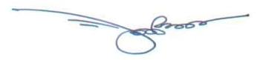

Zakaria Kamal (Author)

Ph: 8801913960069

zakaria.kamal@gmail.com

Present Address: HA-27, East Merul, Badda,

Dhaka-1212, Bangladesh.

Permanent Address: Village- Hoglakandi,

P.O.- Jhitka, P.S.- Horirumpur, District- Manikganj,

Bangladesh
CONTENT

CHAPTER | SUBJECT | PAGE
1 | Soul | 5
2 | Presence of Allah | 22
3 | Allah and His Creations | 47
4 | Angel | 73
5 | The Jinns | 126
6 | Human | 162
7 | Sufism in the Quran | 209

Note

The Chapters are not independent; please read sequentially from the beginning.

INTRODUCTION

The information about Allah are scattered throughout the Quran. One should put the information together and think methodically to know Him better. It is done in this book.
I have discussed the Universes in short and identified the domains of humans, jinns and angels.
I have discussed how our fates were predicted, and how angels monitor and act in the materialization of fates. The empire of angels is automated with a huge cybernetic system. The system is deliberately discussed in this book.
I have defined nafs (soul), ruhh (soul) and qalb (mind) and discussed how these act. How a nafs develops, and how it can be preserved?
Finally, I have discussed humans as the Vicegerents of God.
In this book, things are explained with general idea of science. It is for general idea only; you have the Quran with you to build your Faith.
CHAPTER 1: Soul

The basic knowledge of the soul is given in this Chapter. It will enable a reader to understand the presence of God.
We know a few kinds of souls, but fail to recognize those as souls?
What is a soul?

1. Soul and Force Field

We feel that a soul determines one’s shape and nature, and sustains one’s body as a living entity. A soul does these in case of a human. But if we try to understand the human soul directly, we will fail to understand. The human soul is discussed in Chapter-6. This Chapter gives only the basic knowledge of soul.
According to the Hadith, matter too has soul. Several kinds of force fields sustain the natural systems. These force fields work like souls. One of such force fields is magnetic field. We may discuss the magnetic field to assess the idea that a force field and a soul may be the same thing.

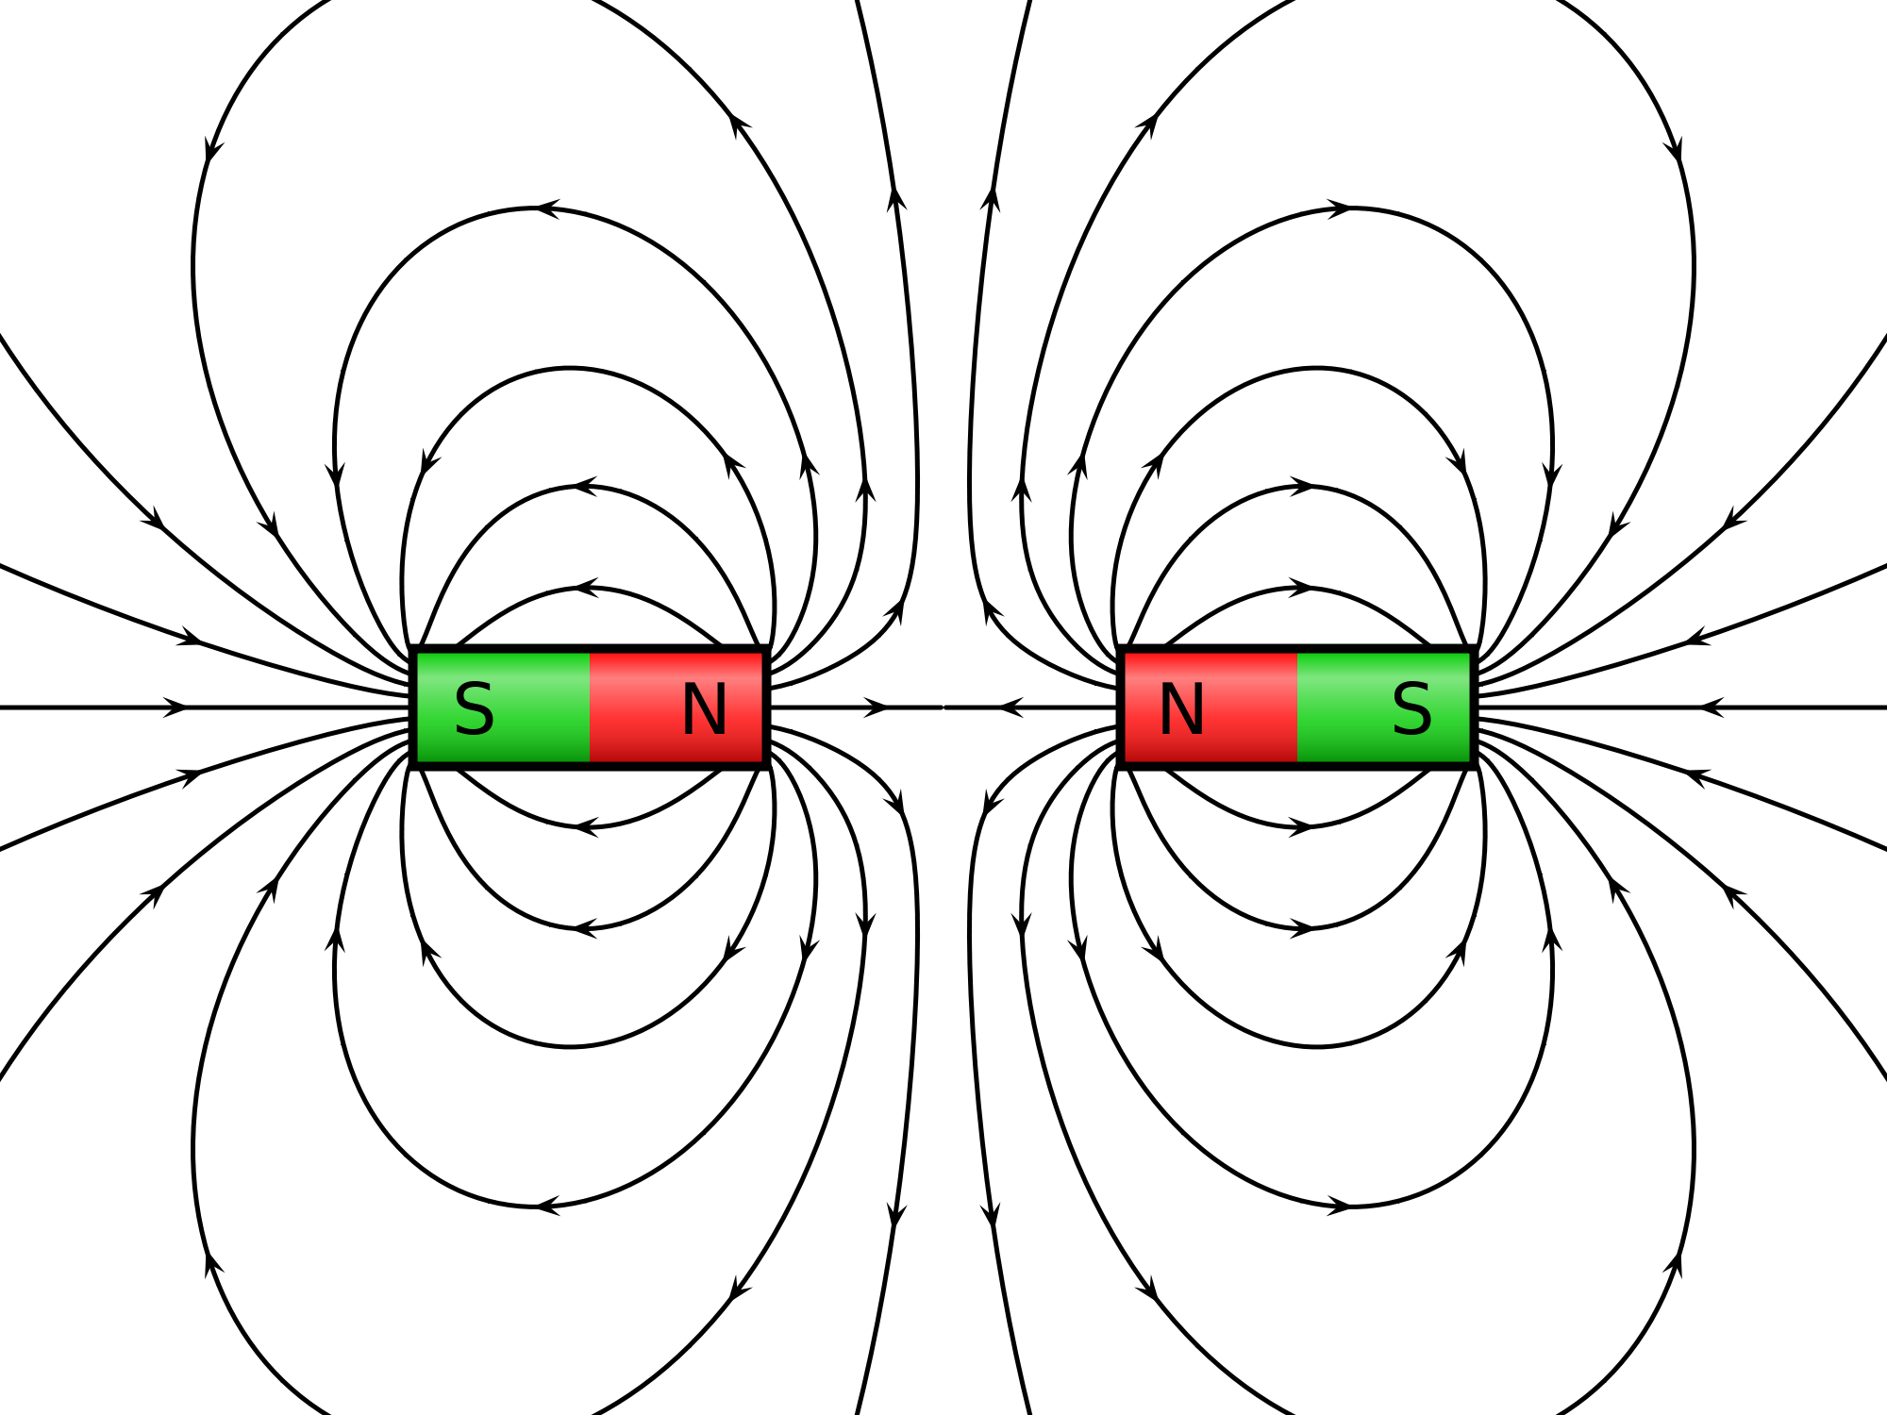

FIGURE 1.1: Magnetic Field

1a. Soul in the Quran

In the Quran, a soul (ruhh) is expressed as a Command of God:

“They ask thee concerning the ruhh (soul). Say: “The ruhh is Command of my Lord.” Of knowledge, it is only a little that is communicated to you.”
[Al Quran 17: 85]

In the following, I have discussed two cases where the magnetic fields work like commands:

Case-1

The Earth has a huge magnetic field. It resists the Solar Wind from entering the Earth. Figure 1.2 shows how the Earth’s Magnetic Field is acting against the Solar Wind as a command to the effect: “Do not enter the Earth.”

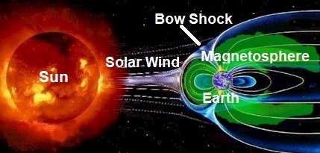

FIGURE 1.2: “Do not enter the Earth”

What is the origin of the Earth’s Magnetic Field? How the Earth can have such a huge magnetic field? Scientists say that rotating, convecting and electrically conducting fluid can develop magnetic field. And in case of gaseous objects, like the Sun, they say that the ionized gas too can develop magnetic field. They are to say something (as they are scientists). Actually, it is a force field invested by God as command. Land living creatures could not survive without this magnificent magnetic field.

Case-2

Magnetism is caused by electromagnetic force that is one of the fundamental forces of nature. A moving electric charge generates a magnetic field perpendicular to it. It seems that the magnetic field is sustaining and directing the electrons.

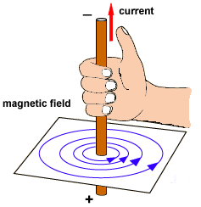

FIGURE 1.3: Magnetic Field sustaining and directing the Current

In this case too, the magnetic field acts like a command.
[When electro-magnetic waves propagate through space, magnetic field and electric field remain at 90 degrees to each other.]
“The Field is sole governing agency of the particle” – Albert Einstein.
In other words, the field is the sole commander of the particle.

1b. Soul in the Hadith

The following Hadith expresses the soul as an attractive and repulsive force:

“Prophet said: “The souls are like conscripted soldiers; those whom they recognize, they get along with, and those whom they do not recognize, they will not get along with.”” [Bukhari, Muslim]

The protons are repulsive to each other. The Strong Nuclear Force Field of an atom recognizes the protons and keeps those closed in the nucleus (fig. below). It does not recognize the electrons, so it does not pull those into the nucleus.

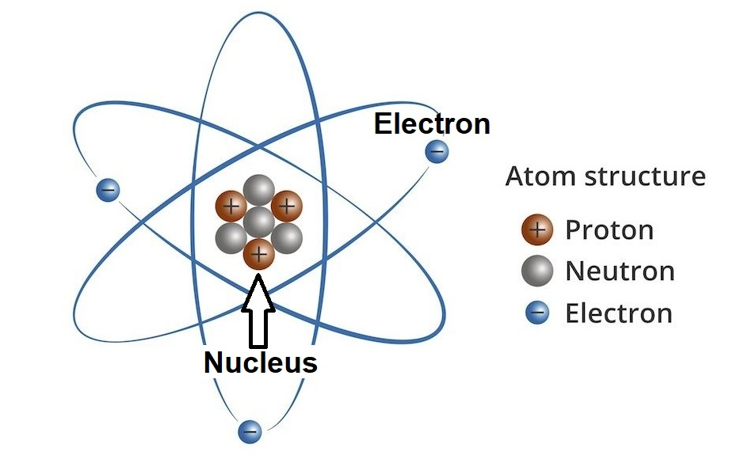

FIGURE 1.4: Atom

Therefore, in light of the Hadith too, a force field is a soul.
2. Types of Souls

At this stage, I will assume that the force field and the soul are the same things. The assumption is confirmed in subsequent discussion.
The Quran talks about two types of souls:
- Ruhh (Elementary Soul)
- Nafs (Composite Soul)

2a. Ruhh (Elementary Soul)

An elementary soul is called ruhh.
“Ruhh” is an Arabic word. It is translated as “soul”. I have used “ruhhs” in plural form.
Allah can design a force field and can make it fixed. Once an object, like the Earth, or a particle, like an electron, falls into the designed force field, it acts as intended. A designed force field is a ruhh (an elementary soul).
For example, Strong Nuclear Force Field and Magnetic Field are different kinds of ruhhs (elementary souls).
Therefore, we may define a “ruhh” (an elementary soul) as a “designed force field” that holds the intended entities and commands those to act in specific ways.

2b. Nafs (Composite Soul)

Another kind of soul is called “nafs”.
“Nafs” is an Arabic word. I write it as “nafses” in plural form.
“Nafs” too is translated as “Soul”. But there are differences between ruhh and nafs.
A nafs is a composite soul. A combination of two or more force fields (elementary souls / ruhhs) makes a nafs.
Many natural systems and all living creatures have nafses as their main souls. For example, Magnetic Force Field (a ruhh), Weak Nuclear Force Field (a ruhh) and Strong Nuclear Force Field (a ruhh) jointly make the nafs (composite soul) of an atom. The nafs of the atom holds the particles, such as electron, proton, neutron, etc., and forms the atom. The atom as a whole achieves some characters.
Therefore, we may define a nafs as a combination of two or more force fields (elementary souls / ruhhs), which sustains a system and determines its form, nature and activities.

Light and Subatomic Particles

The light is electro-magnetic force field. There are two kinds of force fields in the light such as electric field and magnetic field. So, the light is a kind of nafs.
At the beginning of the universe, the light produced the subatomic particles. So, a subatomic particle too is a kind of nafs.
A subatomic particle shows wave-particle duality—a free nafs flips back-and-forth as particle and wave. It is conscious as well. Its duality and the consciousness can be detected by the following test:
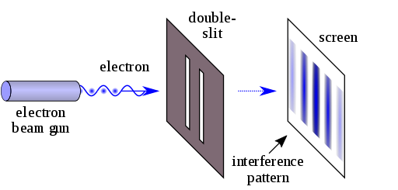

FIGURE 1.5: Double-slit Experiment

“A laser beam illuminates a plate pierced by two parallel slits, and the light passing through the slits is observed on a screen behind the plate. The wave nature of light causes the light waves passing through the two slits to interfere, producing bright and dark bands on the screen—a result that would not be expected if light consisted of classical particles. However, the light is always found to be absorbed at the screen at discrete points, as individual particles (not waves), the interference pattern appearing via the varying density of these particle hits on the screen. Furthermore, versions of the experiment that include detectors at the slits find that each detected photon passes through one slit (as would a classical particle), and not through both slits (as would a wave). However, such experiments demonstrate that particles do not form the interference pattern if one detects which slit they pass through. These results demonstrate the principle of wave-particle duality.”– Wikipedia, free Encyclopedia

Above experiment shows that when a free subatomic particle is observed, it remains as a particle; otherwise it becomes wave. So, it senses that it is being observed by a human and remains as an observable particle.
Therefore, the nafses are conscious from the basic level (from the level of light).
The ancient Persian and Greek Philosophers used to call magnetism soul of matter. Now, after observing the consciousness of particles / waves, we may think whether their naming (soul) was appropriate, or the naming (force field) of modern scientists.

4. Atom and Universe

The atoms are the basic building blocks of the Universe. Once the atoms were created, the Universe was created.
An atom is created from force fields (ruhhs) and sub-atomic particles (nafses). So, the Universe is created from different kinds of souls.

5. Nafsin-Wahidatin (A Nafs Single)

According to the Quran, Allah provided a huge nafs (composite soul) from His own nafs. He created the Universe out of the provided nafs. In the following Verses, the provided nafs is called Nafsin-Wahidatin (a Nafs Single).

“It is He Who has produced you from a Nafs Single (Nafsin-Wahidatin); so a place of dwelling and storage; we detail Our signs for people who understand.”
[Al Quran 6:98]

“He created you from a Nafs Single (Nafsin-Wahidatin), then created favorable Pairs (DNA Double Helix); and He sent down for you of the cattle eight Pairs; He creates you in the wombs of your mothers—creation after creation—three tortures (on Allah). That Allah is your Lord; for Him is the dominion; there is no god but He—then how are you turned away?”
[Al Quran 39:6]

Holy Bible too talks about the Provided Nafs (Nafsin-Wahidatin):

“In the beginning, when God created the Universe, the Earth was non-existent. The raging ocean that covered everything was engulfed in total darkness, and the Soul of God was hovering over the water.”
– Genesis 1 (1–2), Holy Bible, GNB

The Soul of God, which was hovering over the water, was not the Soul of God Himself. It was a soul (nafs / composite soul) provided by God. In a Catholic Bible it is translated as “Breath of God”, because God breathed it out from His own body:

“God, at the beginning of time created heaven (sky) and earth (land). Earth was still an empty waste and darkness hung over the deep, but already over its waters stirred the Breath of God”
– Genesis 1 (1-2), Holy Bible (Knox)

God breathed out the soul from His own body to create the Universe. The Quran mention this soul as the Nafsin-Wahidatin.
When God commanded, “Let there be light”, the light appeared in the Provided Soul (Nafsin-Wahidatin):

“…Then God said: Let there be light. And the light began”
– Genesis 1:3, Holy Bible (Knox)

It means that the Nafsin-Wahidatin, which was a composite soul (nafs), disintegrated and produced light and other force fields on command of “Let there be Light”. The divisions were Electromagnetic Force Field (Light), Strong Nuclear Force Field, Weak Nuclear Force Field, and Unknown Force Fields.
Subsequently, the Universe was created with the light and force fields at a speed looking like the Big Bang.
The light that was produced from the Nafsin-Wahidatin had tendency to form sub-atomic particles, as the universe was expanding and lowering in temperature.

Note:

The above Verses of Holy Bible talk about water. The water was created before the Universe (before the Big Bang). It may so happen that before the Big Bang, God created another Big Bang that produced the water. Probably, it was a huge ball of water floating in the Super Space (space beyond the space of this universe). The water was created for another universe called Jannaat. However, a little of that water was given to this universe (Samawaat).

The religion says that Universe was created from the Nafsin-Wahidatin (a huge composite soul provided by God), and the science says that the Big Bang (that is the Universe) originated from the GUT Force (Force of Grand Unified Theory). Then why should we not consider the Soul and the Force Field as the same thing? It is the difference in expression only.

5a. The Nafsin-Wahidatin and the GUT Force

Scientists have so far discovered four kinds of force fields. Those are: Electromagnetic Force Field, Weak Nuclear Force Field, Strong Nuclear Force Field and Gravity. They think that all forces originated from a Super Force.
“Physicists had believed that there were four fundamental forces of nature: the gravitational force, the strong and weak nuclear forces, and the electromagnetic force. Salam had worked on the unification of these forces from 1959 with Glashow and Weinberg. While at Imperial College London, Salam successfully showed that weak nuclear forces are not really different from electromagnetic forces, and two could inter-convert. Salam provided a theory that shows the unification of two fundamental forces of nature, weak nuclear forces and the electromagnetic forces, one into another. Glashow had also formulated the same work, and the theory was combined in 1966. In 1967, Salam proved the electroweak unification theory mathematically, and finally published the papers. For this achievement, Salam, Glashow, and Weinberg were awarded the Nobel Prize in Physics in 1979. The Nobel Prize Foundation paid tribute to the scientists and issued a statement saying: "For their contributions to the theory of the unified weak and electromagnetic interaction between elementary particles, including, inter alia, the prediction of the weak neutral current". In the 1970s Salam continued trying to unify forces by including the strong interaction in a grand unified theory” – Wikipedia, the Free Encyclopedia

The scientists think that above 10³⁵ degree K, the forces cannot remain separate; they unify into one force. As the Universe expanded and cooled, the forces separated from one another.

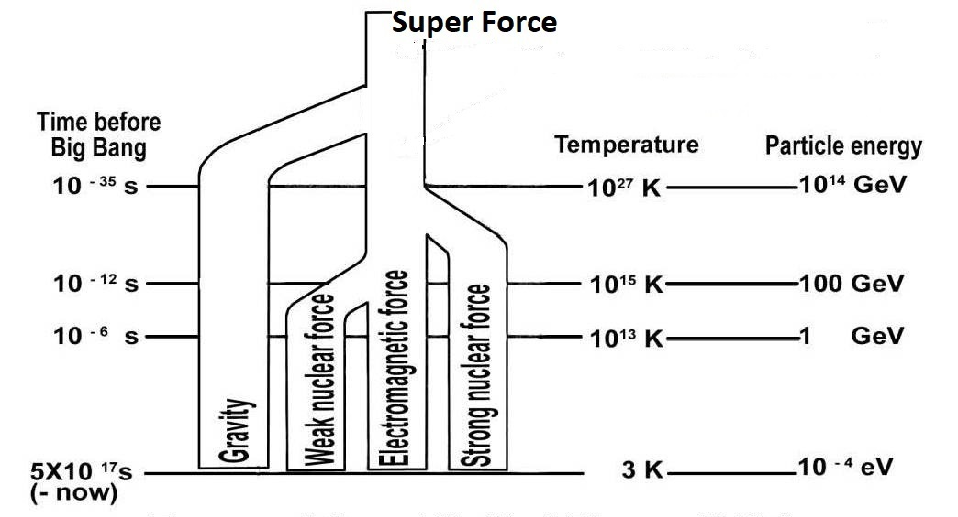
FIGURE 1.6: Super Force

Scientists think that the Gravitational Force separated when the temperature was above 10³⁵ degree K.
They predict that when the temperature of the Universe dropped to 10²⁸ degree K, the Strong Nuclear Force Field separated.
They find out that when the temperature dropped to 10¹⁵ degree K, the Weak Nuclear Force Field separated from the Electromagnetic Force Field (light).
The scientists consider three of above forces, except gravity, as the Forces of Grand Unified Theory (GUT). They exclude the Gravitational Force. In view of the Quran as well, the Gravitational Force is not from the Nafsin-Wahidatin. The Gravity is a Force of Allah (it is discussed in the next Chapter). So, the Nafsin-Wahidatin can be called GUT Force, because the gravity is not included in the GUT Force too.
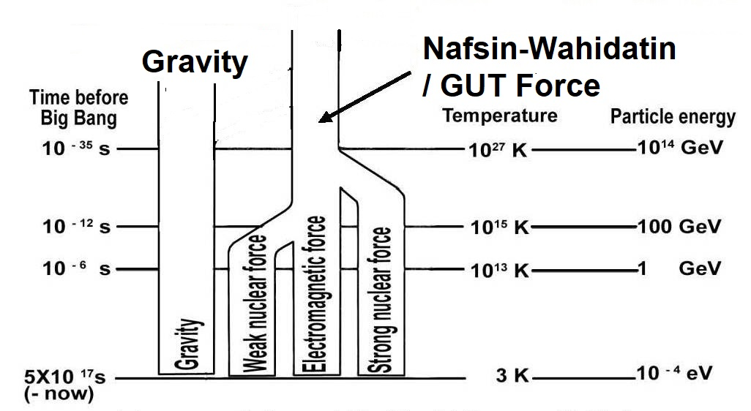
FIGURE 1.7: Gravity is not from Nafsin-Wahidatin / GUT Force

The Nafsin-Wahidatin was a huge composite soul (nafs). It was divided. The divisions are different kinds of souls that we call Strong Nuclear Force Field (ruhh), Weak Nuclear Force Field (ruhh) and Electromagnetic Force Field (light / nafs). The Forces were fragmented and recombined to produce the atoms / the Universe.

5b. Unknown Force Fields

Scientists have so far discovered four kinds of force fields (souls) such as Electromagnetic Force Field, Weak Nuclear Force Field, Strong Nuclear Force Field and Gravity. But, there are many kinds of unknown force fields too, which are not yet discovered.
Scientists do not know all force fields because all force fields do not interact with other things rapidly, or in the way the scientists expect and arrange detection. For example, if magnet would not attract ferromagnetic materials, like the other elements it does not attract, then how difficult it would be to understand the existence of magnetic force!
An angel, or a jinni, or a human, or a beast has a nafs (composite soul). The nafs of a living creature is a combination of known and/or unknown force fields (elementary souls / ruhhs).
The unknown force fields that were needed to create the nafses of living creatures originated from the same Nafsin-Wahidatin.
So, the Nafsin-Wahidatin produced many unknown force fields (elementary souls / ruhhs) as well.
Therefore, the Nafsin-Wahidatin should be called GUT Force + (plus), and the above figure should be re-drawn as under:
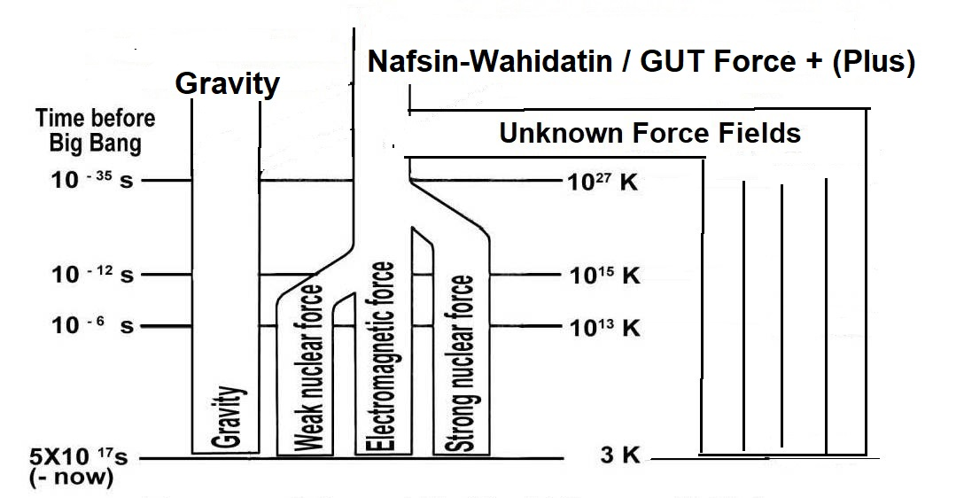
FIGURE 1.8: Nafsin-Wahidatin included many unknown force fields (elementary souls / ruhhs).

Note:

Each human has a special ruhh, directly given by Allah just after his/her birth. The ruhh makes a baby conscious, and he/she cries for the first time. This ruhh is not from Nafsin-Wahidatin. The ruhh helps produce the mind (qalb). The ruhh is deliberately discussed later in this book.

6. Concluding the Basic Idea about Soul

In light of the Hadith, the Nafsin-Wahidatin [GUT Force + (Plus)] was divided as under:
- The known and unknown force fields (elementary souls / ruhhs) that were needed to create the nafses (composite souls) of living creatures were extracted from the Nafsin-Wahidatin [The nafses are preserved and sent into the eggs or wombs in due times].
- The force fields that were needed to produce the Kursi were extracted from the Nafsin-Wahidatin.
- Force Fields that were needed to produce the Computer (that includes the Pen and Lawh-Mahfuz) were extracted from the Nafsin-Wahidatin.
- The leftover part was used to produce the Big Bang / this Universe (Samawaat).

The water that was floating in the Super Space and the Arsh are separate creations. Allah did not create those from the Nafsin-Wahidatin.
CHAPTER 2: Presence of Allah

In light of the Quran and the Hadith, Allah sits in the Kursi (Thorne). The Kursi is located in the Arsh. The Arsh exists beyond this universe (Samawaat).
If Allah sits in a Kursi, He has a form. We know from the Quran that Allah has eyes, ears, face, hands, legs, etc. Holy Bible talks about His shape:

“And Elohim created the man in His own image; in the image of Elohim He created him; He created them male and female.”
– Genesis 1:27, Holy Bible

So, 'Allah in form' looks like a human.
The Head Quarters of Allah is established in the Arsh where His appearance in the Kursi fulfills the command requirements.
'Allah in form' remains in a particular domain of the Arsh. He does not come out openly, because a normal creation gets burned and destroyed due to His immense power and light. 'He in form' moves beyond His domain by extending His Kursi:

“…Extends His Kursi (Thorne) into the 'Skies and Lands' (Samawaat-wal-Ard / this universe), and He feels no fatigue in guarding both of them (Samawaat and Jannaat); for He is the Most High, the Supreme.” [Al Quran 2:255]

'Allah in form' comes into the universes to monitor the activities of the angels. The Kursi protects a normal creature from His extreme light and power, but it has limitations. Even its highest degree of protection cannot protect an object like the Earth. The hill of Moses was burned.
Therefore, Allah has a form. He looks like a human. His Kursi (Thorne) is in the Arsh. He extends His Kursi into the universes.
Our thoughts encompass the idea of matter, energies and several kinds of force fields only, because Allah has created the Universe with these things. But Allah may have many elements in His body, which He has not given to the creation. He is beyond our comprehension. He is highly intelligent, wise and eternal. He has no weakness.

1. Allah Everywhere

Allah has a form. At the same time, He is present everywhere:

“Seest thou not that God doth know that is in the Skies and on earth? There is not a secret consultation between three but He makes the fourth among them, nor between five but He makes the sixth, nor between fewer nor more, but He is with them where-so-ever they be. In the end will He tell them the truth of their conduct, on the Day of Judgment; for God has full knowledge of all thing.”
[Al Quran 58:7]

Allah knows what we are thinking. He is closer to us than our jugular veins:

“It was We Who created man, and We know what dark suggestions his soul makes to him, for We are nearer to him than (his) jugular vein. [Al Quran 50:16]

Therefore, in light of the above Verses, Allah is present everywhere. There are many Verses that give the same indication.

2. How Allah exists Everywhere?

Allah has a form. He stays in the Araf. At the same time, He is present everywhere, down in the universes.
How?
If Allah is present everywhere, He should be formless. But, He is not formless. I have discussed in the following how Allah, having a form, is present everywhere:
The nafs (composite soul) of Allah is a combination of many known and unknown force fields (elementary souls / ruhhs). His nafs permeates His body in form. He has extended several force fields of His nafs beyond His body in form. He has designed the extended force fields, at His will, to act in fixed patterns and has infused (did istawa) those into the space to sustain and evolve the creations.
We view several effects of His infused force fields as natural laws. One of such force fields is gravity. It sustains the deposits of matter in the space.

Note:

The creations, such as molecules, atoms, subatomic particles, forces and energies given to the creations, are also designed by Allah to act in fixed patterns that also are called natural laws. The creation should not be mixed up with God.

Allah sees and hears everything. He has power over everything. A few of His infused elementary souls (force Fields / ruhhs) are described below in the following sequence:
- Gravity
- Dark Energy
- Vacuum Energy
- Quantum Force Fields

2a. Gravity

The Quran says that Allah holds the flying birds. He rotates the Earth. He moves the stars:

“Do they not see the birds, controlled in the atmosphere of the Sky (Samah)? None holds them except Allah; most surely, there are signs in this for a people who believe” [Al Quran 16:79]

“Do they not observe the birds above them, spreading their wings and folding them in? None holds them except (God) Most Gracious: Truly, it is He that watches over all things.”
[Al Quran 67:19]

A bird flies in the air by spreading and folding its wings. But, it would be weightless and off-balanced if it were not held by gravity through its center of gravity (CG). The holding of birds by gravity is expressed in above Verses as an act of Allah, and Allah only.
Allah drives the astral objects too. The following Verse talks about the act:

“He covers the night with the day, seeking it rapidly, and the sun and the moon and the stars controlled by His deed.” [Al Quran 7:54]

Allah holds the birds. He covers the night with the day (rotates the Earth). He drives the astral objects, like the stars. So, the gravity is a force of Allah.
A force field in a living being (Allah) should be called soul. So, the Gravitational Force Field is an elementary soul (ruhh) of Allah. The elementary soul must be extended from His nafs (main / composite soul), permeating His body in form.
Allah has designed the extended elementary soul (gravitational force) to sustain the objects, and infused it (did istawa) into the space. We view its effects as the laws of gravity. Its force exposes through the deposits of matter. So, we find that the Earth is holding the birds. Actually, it is Allah Who is holding the birds through the Earth. He is the Sustainer.
A ruhh (elementary soul / force field) should act on the will of its owner. But Allah has designed the ruhh (Gravitational Force Field) to act in fixed patterns. But, He is always in control. He can change it at will.
The gravitational force looks like an inert universal force. But, the Universe is perfectly designed, which proves that the force belongs to an intelligent entity (Allah).

“Do they not look at the sky above them? How We have made it, and adorned it, and there is no flaws in it?”
[Al Quran 50:6]

The Universe is fine-tuned. Think about the Moon, how perfectly it is designed, placed and moved to make it a perfect natural calendar and tide producer. A perfect Sun in perfect distance is giving perfect light and heat to produce proper current in the air and seas. And the tiny yachts are sailing through the seas.

“And the Moon, We have ordained for it phases till she returns like the date-stalk the old.
It is not permitted to the Sun to catch up the Moon, nor can the Night outstrip the Day, but all are in a ship* (Milky Way Galaxy) they are floating.
And a Sign for them is that We bore their race in the loaded Ark (of Noah); And We have created for them similar (vessels) on which they ride.”
[Al Quran 36:39-42]

[*Arabic “falakin” means “a ship”. Its trilateral root “falak” means “astronomy”. A galaxy is like a 'star carrying space ship'. The sun and the moon are floating in this ship. So the 'ship', mentioned in above Verses, is the 'Milky Way galaxy']
Allah established Himself (did istawa) into the early universe by infusing the elementary soul and concentrated the smoke to form the heavier elements. The heavier elements produced the dusts and the asteroids (ard / lands) as it is said in the following Verse:

“Moreover (He) established Himself (did istawa) into the Sky (this universe) while it had been smoke. He said to it (smoke) and to the lands (formed after He established Himself into the Sky), “Come ye together, willingly or unwillingly.” They said, “We do come in willing obedience.” [Al Quran 41:11]

Notice in the above Verse that when Allah established (did istawa) Himself into the Sky, there was smoke only. But when He called, there were lands too.
So, the lands were created after He established Himself into the Sky. So, He infused (did istawa) the elementary soul (gravitational force field) at that stage, which concentrated the smoke and produced the heavier elements to form lands (dust and asteroids / initial planets).
Allah alone is sustaining innumerable objects of the universes. But, He does not need to remain concentrated to do it. His extended elementary soul (gravitational force) is designed to act in fixed patterns, and the objects of the universes are configured to react as intended.
He designed the laws and configured the initial Universe on a 'Day of Law' (Yawm-id-Deen). He is Master of the Day of Law (Malik Yawm-id-Deen).
Thus, the evolution of the Universe is fixed, and Allah is involved. He is sustaining and evolving the creations.
But, the scientists explain the creation without God. So, they come up with half-hearted theories. The complex motions of the universal objects cannot be explained by simple force of attraction. So, they explain these as the acts of Time.
According to Einstein, the gravity is not a force like other forces. It is felt due to the tendency of matter to move along the curved space-time.
“The General theory extends relativity to gravitational fields. Einstein concluded that the presence of matter distorts space and time, space-time must be regarded together as curved.”
– To the Edge of Eternity by John Gribbin in The Encyclopedia of Space Travel and Astronomy, edited by John Man

When a metal ball depresses a soft rubber sheet, the smaller objects at close proximity tend to roll down toward the metal ball. Similarly, the presence of matter curves the space.

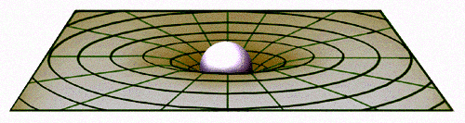

FIGURE 2.1: Curvature of Space

Above picture shows the curvature of two-dimensional space. It is possible to visualize the curvature in three-dimensional space. Einstein considered time as the fourth dimension.
If the space was three-dimensional, the Moon would fall into the Earth directly, but it does not fall because of “Time”. The Time has curved the space further. It has wrapped the space around the Earth. In four-dimensional space-time, the Moon is coming straight to the Earth; in three-dimensional view, we see it rotating around the Earth (the Moon is closing toward the Earth in the process of rotation, but the rate of closing is very small).
So, Einstein related time with space as the fourth dimension. He explained gravity as the tendency of matter to move along the curved space-time.
The curvature of space-time has been proved by observation that the light passing through the side of a massive object (like the sun) bends.
To explain further:
The speed of light is constant. If one is driving a car putting the headlights on, the speed of the light does not increase, that is the speed of car does not add up to the speed of light, the driver’s watch moves slow; thereby the speed of light remains constant to the driver as well. So, motion makes the Time slow. However, in our day-to-day speeds the effect is very less, and it is not detectable by a normal watch.
The motion does not make the watches only to move slowly; it makes all actions and reactions slow. If a chemical reaction takes one minute at rest, it will take longer time in a moving space ship—but it will be one minute in the watches of the space ship, because the watches of the space ship will be running slowly. A man in motion will age slower than a man in rest.
Actually, the motion makes the space compact, and everything moves slowly in compact space. The phenomenon is practically proved: The atomic watches of the GPS satellites orbiting the Earth need correction for accurate navigational fix. The Special Relativity predicts that the on-board atomic clocks on the satellites should fall behind the clocks on the ground by about 7 microseconds per day because of the slower ticking rate due to the time dilation effect of their relative motion.
The presence of matter too makes the space compact. On the surface of the Earth, time moves slower than on the top of a mountain, because the space is more compact on the surface of the Earth (the amount of slowing down is so less that it is not detectable by a normal clock). The space around a black hole is extremely compact, so time is extremely slow over there.
The GPS satellites are in orbits, high above the Earth, where the curvature of space-time due to the Earth's mass is less than it is at the Earth's surface. A calculation using the General Relativity predicts that the clocks in each GPS satellite should get ahead of ground-based clocks by 45 microseconds per day.
The combination of these two effects means that the on-board clocks of GPS Satellites should tick faster than identical clocks on the ground by about 38 microseconds per day (45-7=38)! This sounds small, but the high precision required of the GPS system requires nanosecond accuracy, and 38 microseconds is 38,000 nanoseconds. If these effects were not taken into account, a navigational fix based on the GPS constellation would be false after only 2 minutes, and errors in global positions would continue to accumulate at a rate of about 10 kilometers each day! The whole system would be utterly worthless for navigation in a very short time.
So, the presence of matter curves the space-time. Free moving objects follow the curvature. The tendency of matter to move along the curved space-time is felt by us as gravity.
The Earth affects the space-time in such a way that a free-falling meteorite has to follow a curved path to hit the ground.
It is what Einstein taught us. In Einstein’s view, the distribution of matter has curved the space, so the Sun, the Moon, and the Earth perform their complex movements precisely, instead of falling on each other directly. The curved space-time is driving the galaxies.
But I do not give any credit to the matter in respect of curving the space in a logical way. How the Earth could know, exactly how the space should be curved to make a perfect orbit for the Moon?
Could an accidental distribution of matter evolve this fine-tuned universe? Hawking’s initial configuration of uncertainly principle is a weak story. Actually, some acts of Allah are explained by the scientists as the acts of time.

“Praise be to Allah the Cherisher and Sustainer of the Universes. Most Gracious; Most Merciful; Master of the Day of Law” [Al Quran 1:1-4]

Allah infused (istawa) several of His elementary souls (force fields / ruhhs) into the space to sustain and evolve the creations. He set the laws and configured the creation in the beginning on the Day of Law. He is the Sustainer and Evolver. We view some of His acts as the acts of time.

“On the authority of Abu Hurayrah, who said that the Messenger of Allah said, Allah says: “Children of Adam inveigh against Time; I am Time; I change the day and night”
[Hadith-e-Qudsi, Bukhari, Muslim]

The deeds of Allah are continuously changing the Universe, so we feel the flow of Time.

“He covers the night with the day, seeking it rapidly, and the sun and the moon and the stars controlled by His deed.” [Al Quran 7:54]

Allah distributed the matter and designed the space into Skies:

“Moreover He established Himself (did istawa) into the Sky, while it had been smoke. He said to it (smoke) and to the lands (formed after His establishment into the Sky), “Come ye together willingly or unwillingly.” They said, “We do come in willing obedience”. So, He completed them as Seven Skies in two Days, and He assigned to each Sky its duty and command. And We adorned the lower sky with lights, and with guard. Such is the Decree the Exalted in Might, Full of Knowledge.”
[Al Quran 41:11-12]

The Skies are super-giant waves of space, one inside another—like the peels of onion. There are Seven Skies. Allah curved the paths of the astral objects. He is the Evolver. He is Time.
The fine turned (flaw-less) Universe proves the existence of God.

“He Who created the Seven Skies one above another. No want of proportion will thou see in the Creation of Most Gracious. So, turn thy vision again: Seest thou any flaw? Again, turn thy vision a second time—vision will come back to thee dull and discomfited, in a state worn out” [Al Quran 67: 3-4]

This fine tuned universe could not evolve through an accidental distribution of matter. Allah has formed the Universe.
Though, the Universe is designed as a system, running all objects together is a huge job; monitoring is required. Allah says that He alone can do it; He is a One-Man-Army:

“Do they not observe the birds above them spreading their wings and folding them in? None holds them except (God) Most Gracious. Truly it is He that watches over all things. Or who is it that could be an Army for you to aid you other than the Most Merciful? The disbelievers are not but in delusion”
[Al Quran 67: 19-20]

2b. Dark Energy

In 1990’s, “1A Supernova Cosmological Project” and “High-Z Search Team” discovered that the expansion of the Universe was accelerating. On the basis of their observation, scientists deduce that the Universe possesses “Dark Energy” that is causing the acceleration.
On the other hand, the Quran says that Allah created the Sky with Support, and He is the Expander:

“And the Sky, We constructed it with Support, and indeed We surely are Expanders” [Al Quran 51:47]

The Dark Matter is known by its likely gravitational effect on the matter, and the particles, with which it may be made of, have measurable evidence of its existence. By contrast, the Dark Energy remains in complete mystery. The name Dark Energy refers to the fact that some kind of stuff must fill the vast reaches of mostly empty space in the Universe in order to be able to make space accelerate in its expansion. In this sense, the Dark Energy is like a magnetic field working as a repulsive force to accelerate the expansion of the Universe.
So, the force of expansion, which is known as the Dark Energy, may be an extended elementary soul (force field / ruhh) of Allah, which He has infused into the space as a support. According to the above Verse, Allah is the Expander.
Or, the Dark Energy is held in one of the extended elementary souls (force fields / ruhhs) of Allah.

2c. Vacuum Energy

In Inflationary Theory, scientists predict the presence of “Vacuum Energy”.
“Vacuum Energy is an underlying background energy that exists in space throughout the entire Universe” – Wikipedia, the Free Encyclopedia
The Vacuum Energy is highly intense (10¹¹³ joules per cubic meter), but it does not destroy us; it is zero in our dimension.
Many Atheists argue that the Universe could be created from nothing, because the empty space possesses energy. But it may be the light of Allah permeating the Skies (Samawaat / this Universe):

“Allah is the light of the 'Skies and Lands' (Universe)…” [Al Quran 24: 35]

The light is extremely energetic, but it does not burn everything. It may be held in one or more of His extended elementary souls (force fields / ruhhs). Or, the light itself may be an extended elementary soul (force field / ruhh) of Allah.

2d. Quantum Force Fields

The creations are sustained in the extended elementary souls (force fields / ruhhs) of Allah. Everything is dependent on Him for its very existence. All subatomic particles are devotedly obedient to Him—He says, “Be” and it is:

“To Him is due the primal origin of the Skies and Lands; when He decrees a matter, He says to it, "Be", and it is!”
[Al Quran 2:117]

So, many of the force fields, predicted in the Quantum Mechanic, may be His extended elementary souls (ruhhs).
But, one should not mix up creations with Allah. The Nafsin-Wahidatin (GUT Force+) became a separate entity. Subsequently, it was fragmented, designed and recombined to create the elements of the Universe and the nafses of the living creatures. The products of the Nafsin-Wahidatin are creatures. They do not mix up with the extended elementary souls (force fields / ruhhs) of Allah.
His extended elementary souls (force fields / ruhhs) sustain and drive mainly. They do not produce subatomic particles. For example, the Light of Allah permeates the entire Universe (Allah is the light of the Skies and Lands - Al Quran), but the light does not spill out from His extended elementary soul(s) and produce subatomic particles.
On the other hand, the light provided to the creation, which produced from the Nafsin-Wahidatin (GUT Force +) on the order, “Let there be light”, forms subatomic particles. The particles are sustained in the elementary souls (force fields / ruhhs) of Allah, but they remain separate.
Therefore, do not mix up creations with Allah.

2e. Overall Activities

The experiment carried out by Alain Aspect and his Team in 1982 provides strong evidence that even at great distances subatomic particles remain connected to one another—they are entangled. If two subatomic particles are emitted from the same source, one influences the other instantly, whatever is the distance. So, modern Quantum Mechanics suggests that the Universe is not made of separate elements, but it is an unbroken singular entity.
It seems that the entanglement is caused by the extended elementary souls (force fields / ruhhs) of Allah. His extended elementary souls (force fields / ruhhs) are unbroken singular entities. So, He comes to know everything instantly.
But, again, do not mix-up the creation with Allah. The extended elementary souls (force fields / ruhhs) of Allah sustain the creations produced from the Nafsin-Wahidatin (discussed in Chapter-1). The products, such as an electron, send signals to Allah and to the sister components by appearing and disappearing dances / spins / vibrations; thus they remain entangled.
For example, an electron emitted from an atom keeps on informing its location and state. The disturbances produce disturbances in the extended elementary souls (force fields / ruhhs) of Allah, which is received by the sister electrons, and they acts.
Many extended elementary souls (force fields / ruhhs) of Allah are unknown and unimaginable to us. Allah sees and hears everything. He has power over everything.
Allah alone sustains and evolves the inert Universe. None can help Him in this aspect—an atom is too small to help, and the Universe is too big.

"It is Allah Who sustains the Skies and Lands (Universe) lest they cease, and if they should fail, there is none, not one, can sustain them thereafter. Verily, He is Most Forbearing, Oft-Forgiving.”
[Al Quran 35: 41]

He alone can do it, because He is evolving the inert Universe in a single time-scale, starting on a Day of Law:

“Praise be to God, the Cherisher and Sustainer of the universes; Most Gracious, Most Merciful; Master of the Day of Law (Yawm-id-Deen).”
[Al Quran 1: 2-4]

However, the living creatures have diversified activities. So, He had predicted their fates and invested angels to monitor them.
To monitor the angels, Allah in form comes down into the First (Innermost) Sky every night by extending His Kursi. But the angels say, ‘You already know what they have done’ (or words to that effect), because, though 'Allah in form' is in the Kursi, He is in the deepest of the depths as well, with His extended elementary souls (force fields / ruhhs), permeating the entire creation. Allah says, ‘Even then you say what they have done’ (or words to that effect). It means that Allah checks the activities of the angels.
How the fates were determined and monitored is discussed in Chapter-4.

3. Conclusion

3a. Dissimilar Physical Body

A human physique is created from the atoms that are created out of force fields (ruhhs) and light. His body is expression of genome code. His nafs is a combination of known and/or unknown force fields (ruhhs).
'Allah in form' may be similar. But, He is eternal, extremely intelligent and capable. His nafs may include many force fields (ruhhs) that He has not given to the creation or has not infused into the space. His ‘body in form’ may include many elements that He has not given to the creation. He is unimaginably high.

3b. Dissimilar Soul (Nafs)

The soul (nafs) of a human is a combination of known and/or unknown force fields (elementary souls / ruhhs). But, sitting in a room, a human cannot extend one or more of his elementary souls (force fields / ruhhs) into a side room and see what is happening there.
But several elementary souls (force fields / ruhhs) of Allah are extended all over the creations. He is the sustainer and evolver from the level of sub-atomic particles. He says, “Be,” and it is!

3c. Hands of Nafs and Physical Body

The elementary souls (force fields / ruhhs) are constituents of His nafs, permeating His body in form. He has extended several elementary souls of His nafs like hands / wings extending from a body. He sustains the Samawaat (this Universe) with His right hand extension, and He sustains the Arsh and the Jannaat (another Universe) with His left hand extension.
For example, if the nafs of Allah is created with 99 elementary souls (force fields / ruhhs), he may have extended 9 to 12 souls as His left and right hands to sustain and evolve the universes.

Note:

According to the Hadith, all hands of Allah are right hands. The Hadith is from the perspective of this universe. In the Jannaat, all hands of Allah are left hands.

The elementary souls (force fields / ruhhs) extending like hands / wings are designed to act in fixed patterns. We view some of their actions as natural laws. These are hands of His nafs. His body in form also has hands that are like human hands.

3d. Unfixed Extended Elementary Souls

Most likely, He has extended a few of His elementary souls (force fields / ruhhs) through His forehead and chest, which are not designed. He sees and hears a thing instantly by these elementary souls, irrespective of distance, and can act as He may will. The Universe spans billions of light years across. He has absolute control on every point of the Universe.

3e. His Control on His Nafs

Allah has immense control on His nafs. Otherwise, He could not extend the elementary souls (force fields / ruhhs) beyond His body in form. If Allah has so much control on His nafs, He should be able to change His material body (body in form) at will, and He should be able to retract His extended elementary souls into His Body. So, do not be surprised if Allah appears on the Land of Judgment in a casual human shape. According to the Hadith, on the Day of Judgment, initially He will come as a normal human. But, humans will not accept Him as Allah. Then, He will return and will come back ceremonially by extending His Kursi, after the marshalling of angels, jinns and humans will be completed.
At present, Allah lives in a special domain of the Arsh. He cannot be approached due to his extreme light and power, because the universes are evolving and His extended elementary souls are thrusting with extreme power. But, on the Day of Judgment, the universes will be small and close to each other, and the thrusting power of the extended elementary souls will be low, so He will be approachable and clearly visible.

3f. He on His Path

It is likely that Allah was a simple eternal nafs in the time before the creation. A nafs is conscious by nature to some extent. He developed Himself gradually to a state where He had a form.
There was absolute darkness all-around. It was a painful experience for Him. Thus, to Him 'darkness' and 'torture' (zulum) is synonymous. He created a huge quantity of water (now given to the Jannaat mainly). But, the water could not remove the darkness.
So, He separated a part of His nafs (Nafsin-Wahidatin) and commanded, “Let there be Light”. The nafs (Nafsin-Wahidatin) disintegrated and the light exposed. Thus, the creation of this Universe (Samawaat) began. He created the Pen, the Kursi, the nafses of living creatures, and the Samawaat from the Nafsin-Wahidatin.
The Arsh, the Water and the Jannaat are not from the Nafsin-Wahidatin. He created those from a separate source, provided by Him, through some other process.
Allah initialed the creation at a suitable stage of His personal development. Today, He is the creator, sustainer and evolver of the giant universes, spanning billions of light years across. He is a successful God indeed. He is one and only.
So, Praise be to Allah, the Creator, Sustainer and Cherisher of the Universes (Alamin); Most Gracious, Most Merciful; Master of the Day of Law.

3g. Absolute Creation

Allah exists forever. He was never created. He separated a part of His nafs (Nafsin-Wahidatin) and transformed it into the Samawaat. So, it was creation by transformation; it was not an absolute creation. Absolute creation is not possible for Allah [It is a positive quality of Allah].
Nothing can be annihilated as well. A thing can be transformed only. Absolute annihilation is not possible for Allah even. If Allah destroys an entity absolutely, the ultimate products (photons) go back to Him, to join Him [It is a positive quality of Allah].
If absolute creation or annihilation were possible, the question, ‘how God was created’ could be asked.
We are humans; we take birth; we view creation as the way of coming into reality. Though we are repeatedly told that Allah was never created or He did not take birth, a question remains in the deep of our hearts: ‘Is it true?’ We cannot perceive the reality. Allah is Eternal. The creations have beginnings and ends in respect of transformation into different forms and entities.

3h. One and Only

According to the Hadith, Allah cannot send a thing beyond His creation. There is no space beyond His creation where He could push a thing out. If it were tried hard, the thing would return to its originality and join Him. A creation cannot survive without being sustained by Him [It is a positive quality of Allah].
Finally, human mind cannot perceive the greatness of Allah. So, believe what are clearly taught in the Quran.
CHAPTER 3: Allah and His Creations

The Chapter gives further knowledge about the Presence of Allah. The subject is discussed in the following sequence:
1. The Universes
2. The Samawaat (Skies / this Universe)
3. The Jannaat (Another Universe)
4. The Arsh
5. The Kursi
6. Disposition
7. The Barzakh
8. Allah
9. Conclusion

1. The Universes

Humans are destined to live in two different universes: one is Samawaat (this universe) and another is Jannaat (another universe). The Jannaat is known as paradise as well.

2. The Samawaat (Skies / this Universe)

In the Quran, this Universe, where we are living now, is called Samawaat (Skies). It is called Samawaat-wal-Ard (Skies and Lands) as well. The Skies are full of galaxies.
The stars are not haphazardly scattered throughout the space. They are grouped into systems called galaxies. A few images of the galaxy are given below:

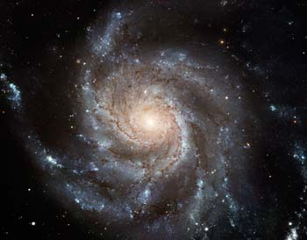

FIGURE 3.1: A Spiral Galaxy

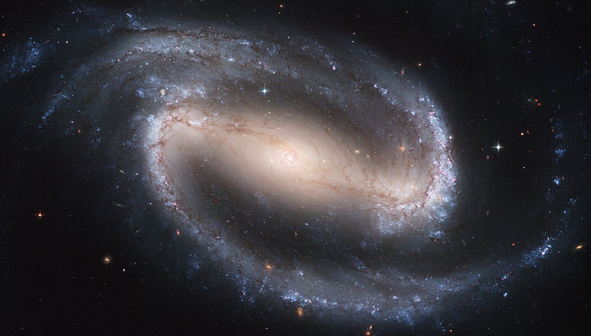

FIGURE 3.2: A Barred Spiral Galaxy

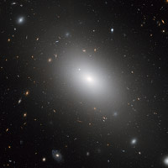

FIGURE 3.3: An Elliptical Galaxy

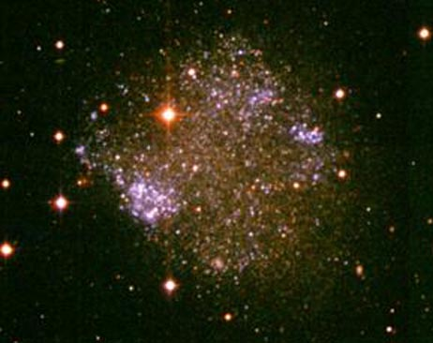

FIGURE 3.4: An Irregular Galaxy

In the Quran, the galaxies are called, “mawaqin-nujumi”:

“But nay, I swear by the mawaqin-nujumi. And, indeed it surely a swear if you know great (structures).”
[Al Quran 56: 75–76]

“Mawaqi” means “houses” and “nujumi” means “stars”. So, “mawaqin-nujumi” means “houses of stars”. Only the “galaxies” can be called “houses of stars”. So, “mawaqin-nujumi” means “galaxies”.
In the Quran, a galaxy has been called a “ship” as well—they are like space-ships carrying the stars:

“It is not permitted to the Sun to outstrip the Moon, nor can the Night outstrip the Day. And all are in a ship (falakin / Milky Way galaxy) they are floating.”
[Al Quran 36: 40]
“And it is He who created the night and the day and the sun and the moon; each in a ship floating” [Al Quran 21: 33]

“Fulki” means the “Ship”. In above Verses, “Falakin” should mean something like the ship. Its trilateral root “falak” means “astronomy”. So “Falakin” is translated as “Space Ship”.
In the following Verse too, the galaxies are called “the ships”.

“So verily I swear by the receding ships disappear, and the night as it departs, and the dawn as it breathes.”
[Al Quran 81: 15–18]

In above Verses, the “receding ships” means the “receding galaxies”. We now know that all distant galaxies are receding (Hubble’s Discovery).
As the galaxies are receding, the Universe is expanding. The light and heat emitted by the stars are fading out in the expanding space. Thus, the galaxies are disappearing.
The light has no destruction. The scientists calculate that if the galaxies were not receding, the Universe would be forty thousand times brighter than the sun at noon—there would be no night, no sunlit day (relate the Olber’s Paradox).
So, the above Verses say: “So verily I swear by the receding ships disappear, and the night as it departs, and the dawn as it breathes”.
The expansion shows that the Universe started from a great original explosion, known as the Big Bang:

“Do not the unbelievers see that the Skies and the Lands were joined together, before We clove them asunder”
[Al Quran 21:30]

The space of the present Universe has been curved into seven spherical waves, one inside another—like peels of onion. These seven super-giant waves of space are Seven Skies. The galaxies are distributed in the Skies as Groups, Clusters, Super-Clusters, Walls and Filaments.
We do not understand from the well-protected Earth how violent the Universe (Samawaat) is! The fluctuating high-pitch sounds we hear while tuning a radio-set originate from the gigantic explosions occurring in distant galaxies and quasars. The entire space of this Universe is showered with harmful radiations. Here nothing can remain unchanged. It is a dangerous place indeed.
The Universe (Samawaat) is hell; the galaxies are objects of hell—the Earth is specially created and protected for our exile living.
The Universe is natural living place of the Jinns and similar creatures that are created from invisible dark matter. They are not earth-bound creatures. They fly through the Skies. The Jinns are original Sons of the Skies (Universe).
Adam and Eve were from the Jannaat. Humans will have salvation after the Judgment. But, the sinners will continue living in this Universe. A sinner will get a complete galaxy. He will be a Vicegerent of God over that galaxy. But he will be a forgotten Vicegerent. He will be in pain due to the inherent nature of his galaxy.

“Allah created the Skies and Lands (this universe) for just ends, and in order that each soul may find the recompense of what it has earned and none of them be wronged.” [Al Quran 54: 22]

“We created not the Skies and Lands and all between them (this universe) merely in sport. We created them not except for just ends. But most of them do not understand. Verily, the day of sorting out is the time appointed for all of them.”
[Al Quran 44: 38-40]

"Taste ye then- for ye forgot the Meeting of this Day of yours, and We too will forget you - taste ye the Penalty of Eternity for your (evil) deeds!"
[Al Quran 32: 14]

3. The Jannaat (Another Universe)

The Jannaat is a different universe altogether. It is known as paradise as well.
Primarily, Adam and Eve were settled in the Jannaat. It means that humans are created suitable for the Jannaat. The Jannaat is our home universe. Following Verses give us the location of Jannaat:

“Be quick in the race for forgiveness from your Lord and for a Jannaat whose width is that of the Skies and Lands (this universe) prepared for the righteous…”
[Al Quran 3:133]

“Be ye foremost forgiveness from your Lord, and the Jannaat, the width of which is as the width of the 'Skies and Lands' (this universe)” [Al Quran 57:21]

If two things are equal in width, one cannot remain inside another. According to the above Verses, the width of Jannaat is equal to the width of Samawaat. So, the Jannaat and the Samawaat are two different universes.
Holy Bible talks about a separate universe as the place of Salvation.

“Because only a few will be saved, God has created two universes instead of only one”
– 2 ESDRAS 7:50, Holy Bible, GNB

Scientists would tell that there is nothing beyond the Big Bang; that the Time began at the Big Bang; that the Universe has no outside, etc., because they do not know. Allah is ever-living, and He has other creations at the outside of this Universe.
3a. Two Separate Creations

The following points indicate that the Samawaat and the Jannaat are separate creations:
Firstly, one cannot go from one universe to another without through special channels.

“O ye assembly of Jinns and men! If it be ye can pass beyond the boundary of Skies and Lands (this Universe), pass ye! Not without authority shall ye be able to pass!” [Al Quran 55:33]

Secondly, from the Big Bang, the Samawaat has been created, not the Jannaat.

“Do not the unbelievers see that the Skies and the Land (this Universe) were joined together before We clove them asunder” [Al Quran 21:30]

Therefore, the origins of two universes are different.
Thirdly, this Universe (Samawaat) will collapse being rolled up when its objects will perish.

“On the day when We will roll up the Skies (this universe) like the rolling up of the scroll for writings; as We originated the first creation, We shall reproduce it—a promise on Us; surely We will bring it about.” [Al Quran 81:104]

“All that on it will perish. But will abide the Face of thy Lord, Full of Majesty, Bounty and the Honor.”
[Al Quran 55: 26–27]

But the Jannaat is everlasting. The Jannaat being an everlasting creation cannot exist in this Universe.
So, the Samawaat and the Jannaat are separate creations altogether.

3b. General Appearance of the Jannaat

The Jannaat is full of habitable and peaceful planets (objects). The planets of Jannaat are scattered in eight layers of space (Space of Jannaat).

"One in the lower level of Jannaat will observe the higher one like a rising star in the eastern or western horizon of the sky." [Bukhari]

In the Jannaat, a person will see a planet of other person like a bright star, as we see planet Mars, Venus, etc., as bright stars.
The planets of Jannaat are big; the smallest one is ten times bigger than the Earth.

“The poorest in the Jannaat will own an area, ten times bigger than the Earth”
[Hadith]

There is no night and day in the Jannaat. Even after a long period of time, people will feel that they have entered the Jannaat shortly. People will not be tired in the Jannaat. They will never be old. Their orders will be materialized instantly—plants, animals and physical objects will obey their orders.

3c. Large scale Structure of the Jannaat

According to the Hadith, the planets of Jannaat are scattered in eight layers of space (Space of Jannaat). The names of the layers are as follows:

1. Firdaws | 2. Nayeem | 3. Mawa | 4. Makam
5. Karar | 6. Salam | 7. Adan | 8.Khuld

In this Universe, one Sky surrounds the inner Sky the way the white part of a boiled egg surrounds the inner yellow part. But, the layers of Jannaat do not surround each other; they stand side by side—as all layers fall directly under the Arsh:

“All Jannaat have single roof that is the Arsh of Allah” [Hadith]

The Layers of Jannaat stand side by side, but in ascending order—as it is mentioned in the following Hadith:

“The Layers of Jannaat are laid out like the steps of a staircase” [Hadith]

From the Hadith, we know that the Jannaat is a vast creation. Nobody knows how big it is? The distance between two layers of Jannaat is like the distance between two Skies. There must be billions of planets in each layer of Jannaat. Each human being will be given one or more of those planets.

4. The Arsh

The Arsh exists beyond the Samawaat (Skies / this Universe). It is bigger than the Universe. Following Hadith indicates the location of Arsh:

“After traveling Seven Skies, I was raised to the extreme height. I reached a smooth plain land, where the Noise of Pen only was being heard.” [Bukhari]

From the Hadith, we know that the Pen is located in the Arsh. So, when Prophet (pbuh) heard the sound of Pen, he was already in the Arsh. And he reached over there after traveling the Seventh Sky. It means that the Arsh is located beyond the Skies (Samawaat / this Universe).
The Arsh is located beyond the Jannaat as well. It can be understood from the following Hadith:

“All Jannaat have single roof that is the Arsh of Allah” [Hadith]

Therefore, the Arsh exists beyond the Samawaat (this Universe) and the Jannaat (another Universe). The Arsh can be considered as the Third Universe.
The Arsh is improbably huge. To express the vastness of Arsh, it is compared with the Kursi—the Kursi is much bigger than this Universe (Samawaat):

"In comparison to the Arsh, the Kursi is no more than an iron ring thrown in a vast desert" [Hadith from Tabari Tafsir]

There are many angels in the Arsh. In general, they are called “Angels of Arsh”. They do not come down into the Samawaat (this Universe). Each of these three domains, Arsh, Samawaat and Jannaat, has dedicated angels.
Events of the Samawaat and the Jannaat are controlled from the Arsh. It is the Headquarters of Allah. So, the Arsh must be holding many things. We know about important three: the Kursi, the Computer, and a part of Sidratul-Muntaha.

5. The Kursi

The Kursi is the Throne of Allah. It is in the Arsh. The Kursi is much bigger than this Universe (Samawaat). None can estimate its vastness.

"In comparison to the Kursi the Seven Skies (this Universe) are no more than seven dirhams (old Arabian coin) set on a shield." [Hadith]

Allah extends the Kursi into the universes (Samawaat and Jannaat) as well.

"…extends His Kursi into the Skies and Lands (this universe) and He feels no fatigue in guarding and preserving both of them (Samawaat and Jannaat), for He is the Most High, the Supreme"
[Al Quran 2: 255]

6. Disposition

The disposition of the Samawaat (Universe), the Jannaat, and the Arsh is not given in the Quran or Hadith. But it creates an impression in mind, which is depicted below:

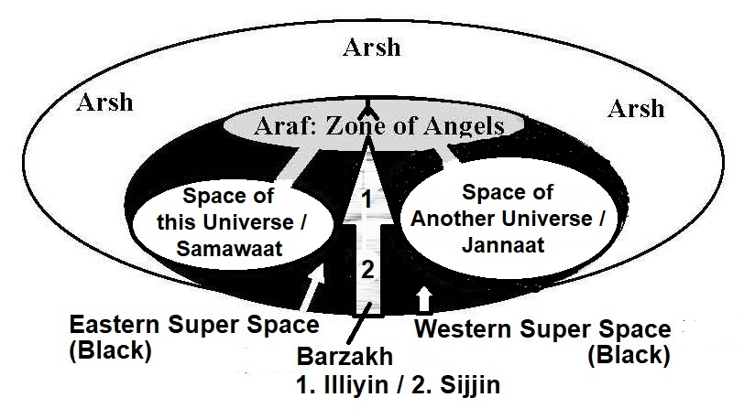

FIGURE 3.5: Disposition of Overall Creation

7. The Barzakh

“Barzakh” means “Barrier”. The Barzakh separates Samawaat and Jannaat. Probably, the Barzakh is a space with different nature. Matter cannot survive in the Barzakh except in specific zones.
However, light can pass through, as it is said in the Hadith that the objects of Jannaat are visible from the Seventh Sky like stars in the horizon.
We know about two domains that are located inside the Barzakh. The domains are: Illiyin and Sijjin. These are discussed later in this book.

8. The Cycle

8a. The Universe (Samawaat) is shaped into seven spherical waves, one inside another—like the peels of onion. So, we see the galaxies forming walls in the central spheres of the waves.
These ‘seven super giant waves of space’ are ‘Seven Skies’. We are in the Innermost (First) Sky.

8b. The Quran says that the Universe has been expanded to create the darkness of nights.

“What! Are you more difficult to create, or the sky? He has constructed it. He has raised its thickness and proportioned it. Its night does He endow with darkness, and its splendor does He brings out...”
[Al Quran 79: 27–33]

There are innumerable stars, emitting light. The energy has no destruction. If the thickness of Sky were not raised, the Sky would be full of light, thousands of times brighter than the sun at noon. The darkness would not exist; there would be no night and no sunlit day.
The phenomenon was observed by a German astronomer, Wilhelm Olber, and has become known as the “Olber’s Paradox”.

8c. One of the reasons for which the Quran talks about the evolution of Universe is to present the idea of Resurrection and Final Judgment in a realistic framework. The Quran says that on the Day of Judgment, the Skies (Universe) will be rolled up in the Hand of Allah.

“On the day when We will roll up the Skies like the rolling up of the scroll for writing; as We originated the first creation, We shall reproduce it—a promise on Us; surely We will bring it about.” [Al Quran 21: 104]

The scientists suggest a similar Model. The Universe originated from a Big Bang. It may collapse into a Big Crunch and may get re-initiated through another Big Bang (Big Bang-2).
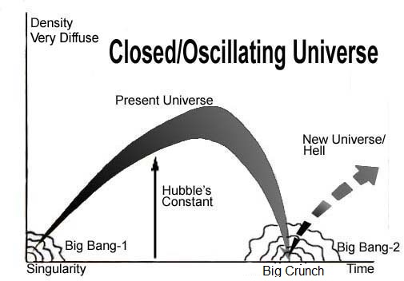
FIGURE 3.6: Cyclic Universe

“But it is also possible that expansion will be reversed by the pull of gravity, that all matter will collapse once again into a super-dense ‘singularity’ and that another universe will be born in another Big Bang a cycle that could be repeated forever.”
– To the Edge of Eternity by John Gribbin in The Encyclopedia of Space Travel and Astronomy edited by John man.

Note:

The Quran does not support that the Universe being cyclic existed forever. Allah created it at the beginning of this cycle, or at the beginning of a short preceding cycle (the universe might have had a Big Bounce to produce elements up to silicon).

Singularity, Big Bang and Big Crunch are the same things. The Singularity at the beginning of the Universe is called Big Bang; the Singularity at the end of the Universe is called Big Crunch. It is a super hot, super dense point of space-time where all natural laws break down.
The Quran says that the Universe will be squeezed to an extent that the matter will disappear.

“All that on it will perish. But will abide the Face of thy Lord, Full of Majesty, Bounty and the Honor.”
[Al Quran 55: 26–27]

Allah created the Universe from the forces and light provided from His own body. So, when the matter will disappear due to extreme gravitational contraction, the Universe will return to the Face of God.
To understand the state of the universe on the Face of God, we may discuss what happens to an object when it undergoes extreme gravitational collapse:
If a space ship is falling into a black hole, it is elongating like spaghetti due to the difference between gravitational force on its tip and its tail. The ship, elongated like spaghetti, will wrap around the spinning black hole. Eventually, its particles will gain energy from gravitational field and join to the accretion disk and the anti-particles (neutrons) having opposite momentum will fall into the Black Hole.
Eventually the light of the space ship will be frozen in the compact space circling around the event horizon. The light can never fall into the black hole because the more it approaches the black hole, the slower the time is. Thus, the complete information (photons) of the ship will be preserved.
Thereby, matter will be annihilated, but the ship will exist as information (commands).
The Big Crunch will preserve all information of the past universe like the ship fallen into the black hole is preserved. If Time flows in reversed order, the objects will revive to their previous shapes. And Allah is the Sustainer and Evolver—He in action is Time:

“On the authority of Abu Hurayrah, who said that the Messenger of Allah said, Allah says: “Children of Adam inveigh against Time; I am Time; I change the day and night”
[Hadith-e-Qudsi, Bukhari, Muslim]

The Big Crunch can be compared with a super-massive black hole. It is a point of extreme gravitational force. The gravitational force is an extended elementary Soul (Ruhh) of Allah. The information (photons) of the universe will be wrapped around the point as commands. Thus, the Big Crunch can be called the Face (Exposed Point) of God.
Or, when there would be no matter to sustain, the gravitation force field may cease into ‘Allah in form’ and the forces and light given to the creation may fall into His Face, as a spot on His fore head.
Or, the Universe may collapse like a scroll for writing:
The Universe is structured into Skies. If the Universe collapses by rolling-up the Skies, the galaxies may not join with each other to form a Big Crunch (Singularity). The galaxies may collapse into their central super-massive black holes as super-dense singularities, preserving all information. They may remain in their relative positions in the super-compact space even when the Skies would be rolled-up compactly.
According to the Quran and Holy Bible, the Skies will be rolled-up like a scroll for writing. Here the space is represented by a piece of paper. The galaxies should be represented by the dots on the piece of paper. Mathematically, a Singularity is a dot preserving all information.
In the end, when everything will return to the Face of God, the galaxies would look like bright spots on His Forehead.

“And call not besides God on another god. There is no god but He. Everything will perish except His own Face. To Him belongs the Command (Information), and to Him will ye be brought back.”
[Al Quran 28:88]

Allah will have vision of the next Universe, and He will re-program the collapsed universe accordingly.
Allah will re-fix the natural laws and re-configure the initial universe as a system to revive. So, He is the Master of the Day of Law (Malik Yawm-id-Deen).
Our fates of the next cycle will be designed on that Day, and some will be destined to the hell:

“And indeed, the wicked surely in Hellfire. They will burn it.
The Day of Deeni (Law)! And they are not absent from it.
And, what can make you know what the Day of Deeni (Law) is!
Then, what can make you know what the Day of Deeni (Law) is!
The Day not will have power a soul for a soul, anything, and the command that Day with Allah”
[Al Quran 82: 14-19]

8d. From that extremely compact state, the re-programmed universe will move out and achieve mass. The Universe at that state is called “Thaqal”. “Thaqal” means “Heavy Mass”.
From the Face of God, the reviving universe will be moving back into the right hand of Allah when the Thaqal will form, and the resurrection of the dead will occur:

“And when the Land is enlarged and casts forth what is within it and becomes empty—and hearkens to its Lord, and it must need” [Al Quran 84:3-5]

The Super-Mass (Thaqal) will throw out resurrecting creatures and the matter of Solar System. The ejected matter and the resurrecting creatures will form the Land of Judgment (a Satellite Thaqal) in the Super Space.

“On the Day, the Land (Main Thaqal) breaks away from them, quickly; that will be a gathering together (in the Satellite Thaqal / Land of Judgment) quite easy for Us.” [Al Quran 50:44]

“And not they honored Allah—true honor—while the Land (the Land of Judgment / Satellite Thaqal) is assembling in His hand on the Day of Resurrection and the Skies (Main Thaqal) rolled-up in His Right Hand. Glory be to Him! And high is He above what they associate.” [Al Quran 39: 67]

Thus, at the time of Judgment, there will be two Thaqals in the Super Space: one is the reviving Universe (Main Thaqal), and the other is the Land of Judgment (Satellite Thaqal), halted in the junction point of the Channel (As-Sirat / the Path).
The Channel connects the universes (Samawaat and Jannaat) via Araf and has portals at desired points.
The evolution of the Universe will be temporarily halted for Judgment and Salvation:

“And among His signs is this that the Sky (Super Sky) and Land (Main Thaqal) stand-still on His command. Then when He calls you by a single call from the Land (Land of Judgment)—behold ye come forth (for Judgment).”
[Al Quran 30:25]

“Soon shall We attend to you, O both ye Heavy Masses (Thaqalani)! Then which of the favors of your Lord will ye deny?”
[Al Quran 55: 31–32]

The Thaqals (Main Thaqal and Satellite Thaqal) will be in the Eastern Super Sky (Eastern Super Space).

“The Day the land will be changed—other land and the Skies—and they will come forth before Allah, the One, the Irresistible” [Al Quran 14:48]
[Al Quran 30:25]

8e. The Quran and Holy Bible mention that beyond this Universe there is another Universe named Jannaat (Paradise), greater than this Universe.

“Be quick in the race for forgiveness from your Lord and for a Jannaat whose width is that of the Skies and Lands (this Universe), prepared for the righteous…”
[Al Quran 3:133]

“Race to forgiveness from your Lord and the Jannaat, the width of which is as the width of the Sky and Land”
[Al Quran 57:2]

“Because only a few will be saved, God has created two universes instead of only one”
- 2 ESDRAS 7:50, Holy Bible, GNB

After the Judgment, a part of mankind will be shifted to the Jannaat where they will live forever in peace and satisfaction as empowered Vicegerents of God. Their verbal orders will be materialized instantly.

8f. The sinners will be left on the Land of Judgment (Satellite Thaqal). Subsequently, they will be thrown into the Main Thaqal.
The halted Universe (Main Thaqal) will re-start unrolling and expanding. It will grasp the Land of Judgment (Satellite Thaqal) at one stage. The compact galaxies will re-start reviving just by gaining the volumes of space. Each galaxy, reprogrammed on the Face of God, will capture one sinner allotted to her (galaxy’s) lot.
A sinner will live in his galaxy forever in disasters and pains, as forgotten Vicegerent of God. He will not have any divine power.

“Allah created the ‘Skies and Lands’ (this Universe) for just ends and in order that each soul may find the recompense of what it has earned and none of them be wronged.” [Al Quran 54:22]

“We created not the ‘Skies and Lands and all between them’ (this Universe) merely in sport. We created them not except for just ends. But most of them do not understand. Verily, the day of sorting out is the time appointed for all of them.” [Al Quran 44:38–40]

Eventually, the unrolling universe will take the form of today, but with ever living sinners scattered in the galaxies.

That will be the beginning of an endless life either in this universe (Samawaat) containing the objects of hell (galaxies), or in another universe (Jannaat) containing the objects of paradise full of hoorain (maidens with lustrous eyes, restraining their glances), gold, precious stones, fruits, meats and rivers of wine.

“Then, he whose balance will be heavy will be in a life of good pleasure and satisfaction. But he whose balance will be light—their mother will be endless-hole (black hole); and what will explain to thee what this is—a fire blazing fiercely.” [Al Quran 101:6–11]

All creatures of matter and anti-matter will be resurrected and assembled on the Land of Judgment. One will see dinosaurs walking on the land. After the resurrection, there is no death. According to Hadith, the animals will be merged with the land, which means that they will be scattered in the objects of the recreated Samawaat. If one wants to live with dinosaurs, demons and jinns, one may follow a sinful life and live here in the Samawaat forever. And the resurrected scorpions will be something to reckon with. And there will be extreme fire, heat, and boiling water, surging.
Thus, follow the Book of God to attain Salvation to Jannaat. Gold and silver are common building materials over there. Precious stones are falling like rubbles on the streets.

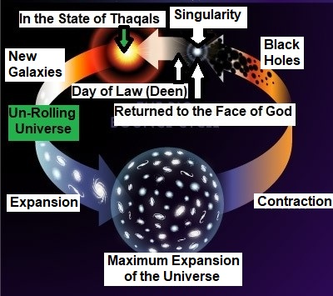

FIGURE 3.7: Moving into the Next Cyclic of Life

8g. It is the Master Plan of Allah: To create, develop and delegate His vicegerents (human beings) all over the creations with a view to infuse life in the universes, deploy intelligence and freedom of thought in the creations, and open a flexible and interesting way of ruling.

9. On the Earth, humans are undergoing test (and development). A human is not empowered here as a Vicegerent of God, and he has not got his ‘Area of Responsibility’. Only a fool would lose in the test of this short earthly life.

“Behold! in the creation of the Skies and Lands and the alternation of night and day—there are indeed signs for men of understanding; men who celebrate the praises of Allah standing, sitting and lying on their sides, and think on the creation in the Skies and Lands: “Our Lord, Not for naught hast Thou created this! Glory to Thee! Give us salvation from the penalty of the fire. Our Lord, any whom thou dost admit to the fire, truly Thou cover with shame, and never will wrong doers find any helpers”!”
[Al Quran 3:190–192]

If one is here, one will be there too—there is no doubt what-so-ever. We are creatures of a Mighty Arrogant Creator. Nobody except Him can help on the Day of Deen!
CHAPTER 4: Angel

Allah sustains everything from sub-atomic particles to giant universes. We see our Universe (the Samawaat) and its inert entities systematically evolving. We view all-embracing grip and performances of Allah as Time. No human or angel has way to interfere in this spectrum—an atom is too small and a universe is too big to interfere.
Allah is one. The Universe and its inert entities are evolving in a single time-scale. Allah is enough to sustain and evolve them. But, He has created many living creatures too. The living creatures have diversified activities. Allah being one can concentrate on one point at a time, though He sees everything and hears everything, and He is a fast thinker. So, He has got the fates of living creatures written and has invested angels to monitor them. The angels monitor according to the fates written in a Saving Disc (Lawh-Mahfuz).

"...There is not a moving creature, but He has grasp of its fore-lock. Verily, it is my Lord that is on a Straight Path”
[Al Quran 11:56]

The Empire of Angel is automated by a huge cybernetic system. The head of the cybernetic system is a supremely developed computer located in the Arsh.
The cybernetic system is discussed under the following headings:

1. Scope of Control
2. The Head of the System
3. The Writing of the Fate
4. Records
5. Barzakh (Barrier)
6. Cybernetic System of the Universe
7. Ruhh (Soul)
8. Angels
9. Reporting back to the CC
10. Reporting to Allah
11. Several Chief Angels
12. Conclusion

1. Scope of Control

Allah is Merciful Creator—He is closer to us than our Jugular veins. He is with one in danger and disaster, though hardly He can help on the spot. Take the example of a baby who is dying, and his mother is crying. Allah is extremely sad, because the baby is dying, but He cannot help on the spot (though He has power to help). The fates were written. The universe has born with necessary arrangements. The system with angels is deployed to monitor. A single change of today needs the series of changes in the past and future, which is abnormal to do, and does not bring out a better output in overall theatre.
Moreover, we opted to be His Vicegerents. So, tests are necessary to justify our eternal destinations. We are sometimes tested by pains, losses and difficulties.

2. The Head of the System

The Head of the Cybernetic System is a Computer. It is clearly understood when we discuss the Head. It has three major components: the Pen, the Disc and the Mother Board.

2a. The Pen

From the Hadith we know that Allah got the fates of all living creatures written by an automated Pen.

Hadith: “The first thing that was created by Allah was the Pen. Allah then ordered the Pen to write. The Pen asked, what should it write? Allah ordered to write the fate of everybody. The Pen wrote all those would happen from the beginning to the end." [Tirmizi]

It was a Pen that asked question—what should it write? And when it was ordered, it could write the fate of everybody, from the beginning to the end.
Therefore, the Pen must be a part of an intelligent entity, something like an absolutely developed super computer. It seems that it has been called “Pen” to make it understandable to the people of the old times.
It is already written, when a leaf will grow, and when and how it will fall. The angels monitor the compliance:

“…Not a leaf does fall, but with His knowledge…” [Al Quran 6:59]

The Pen extracted our fates from the Master Plan made by Allah. It is discussed subsequently.

2b. The Disc

The Pen did not write on papers, it wrote in a Disc (Lawh).

"Nay, it is a glorious Quran in a Disc Protected (Lawh-Mahfuz)"
[Al Quran 85: 21–22]

“Lawh” means “Plank / Tablet / Disc”. “Mahfuz” means “Protected / Safe”. So, “Lawh-Mahfuz” means “Disc-Protected”. It may mean “Disc that Protects” or simply “Saving Disc”. According to Hadith, the Disc is very big. From the description of Hadith, it seems that it is bigger than the Earth.

Hadith: “Prophet said: At the beginning there was only Allah; there was nothing except Him. His Arsh was established over the water. Then He wrote the details of the creations in the Lawh-Mahfuz, the Place of Remembrance, and created the Skies and Lands (Universe).”
[Bukhari]

The above Hadith mentions Lawh-Mahfuz as the “Place of Remembrance”. We too use our computer CDs / Hard Discs as instruments to keep records.

2c. The Motherboard

“Ha, Mim. By the Book that makes things clear. We have made it a Recitation (Qur'an) in Arabic that ye may be able to understand. And verily, it is in the Mother of the Book, in Our Presence, high, full of wisdom.”
[Al Quran 43: 1-4]

The above Verses talk about a part of the System. It is the “Mother of the Book”. The Mother translated the Book (the Quran) into Arabic Recitation.
Or, it is the Mother of the Disc (Lawh)—the Quran may have called a file of the Disc as a book.
So, this Part (Mother of the Book) of the System is an advanced “Motherboard” having necessary circuits, components and software to control the Pen and translate the Book (the Quran).

2d. The Computer of Creations (CC)

The Pen, the Disc and the Motherboard together make a System. The System can be compared with a man-made computer. I address the “System” by the name of “Computer of Creations” or “CC” in short.
In the following, I have compared the CC with a man-made computer. However, the CC belongs to a Creator that created genome code and human brain. I have compared to develop an idea only.

2d-I. Software

The CC (Computer of Creations) has intelligence:

Hadith: Prophet said: “The first thing Allah created is my soul, and the first thing Allah created is the Pen, and the first thing Allah created is the Intellect”
[Sirr Al-Asrar fi yahtazu ilayh Al-Abrar,
Sk. Abd Al-Qadir Gilani]

According to the above Hadith, the “Pen” and the “Intellect” were created at first. The “Intellect” is the Software (Programs) of the CC.

“Read in the name of thy Lord Who created; created man out of leech.
Read! And thy Lord is Most Bountiful. He Who taught the Pen—Taught man that, which he knew not.”
[Al Quran 96: 1–5]

“He taught the Pen” means that “He programmed the Pen”.
The Pen is a Part of the CC. It has been called Pen to make it understandable to the old-time-people.
So, the CC was programmed with necessary software and data. The following Hadith indicates that the CC can act on short commands.

“After the creation, Allah wrote in His nearest book in the Arsh, “Surely My mercy prevails over My wrath.”
[Bukhari and Muslim]

In above Hadith, “Surely My mercy prevails over My wrath” may be a guidance given to the CC. Probably, it considers this guidance in the process of materializing the fates.
The CC must have systems and software, which makes it a rational and intelligent entity.

2d-II: Display System

The CC has system to display information:

“One day angels were listening to a talk of Aza’zil (now Iblis). Casually, they looked at the Arsh and saw—it was written there—the Curse of Allah is about to fall on a defiant one.” [Hadith]

Angels looked at the Arsh and saw the statement. Therefore, the CC has system to display information.

2d-III. File Inscriptions

In the beginning of some Surahs, there are some special alphabets like Alif, Lam, Ra, Ta, Sin, Mim, etc. These alphabets do not construct any meaningful word, e.g.:

“Alif, Lam, Mim, Ra—these are the signs of the Book ” [Al Quran 13:1]

“Alif, Lam, Ra—these are signs of the Book of Wisdom.” [Al Quran 10:1]

It seems that these alphabets are file inscriptions—as we use file names to save our files in the computer.
However, the alphabets may have meanings, as our file names often relate to the contents of our files. For example, a file with a name 'CB' may contain matters related to the 'Construction of Building'. Surah Qaf starts with alphabet 'Qaf', and it deals with the tricky points of the 'Qiyamah'.

2d-IV. Base Figures

The automated writings of a computer should show a mathematical order. As the CC translated the Quran as an Arabic Recitation, many important parameters of the Book are factors of 19 (nineteen).
Manmade computers work on 0 and 1. The computers do not round up unless guided by the software. It seems that the CC uses the mathematics of higher order. It does not work on the logic of True/False (0/1) only. It can think and talk; it asks questions. So, it is a supremely developed computer.

2d-V. Rational Computer

The following Hadith indicates that the CC can think and has emotion as well.

“Allah ordered the Pen to write “Muhammadur Rasulallah” after it had written “La ilaha illa Allah” at the top of Lawh-Mahfuz. The Pen did not want to write the name of a human being with the name of the Great Creator, so it delayed. Allah again ordered it to write. Out of fear, the Pen started shivering when its another mouth appeared, which wrote “Muhammadur Rasulallah”
[Hadith]

The CC did not want to write the name of a human being with the name of the Great Creator. It indicates that the intelligence of the CC is not just a programming of true and false (not based on zero and one only). It thinks and has emotion.

2e. CC in Holy Bible

In Holy Bible, the “CC” is mentioned as the “Golden Altar before God”

“The sixth angel blew his trumpet. Then I heard a voice calling from the corners of the Golden Altar before God. It said to the sixth angel who had just sounded the trumpet, "Release the four angels chained at the banks of the great river Euphrates”
–Revelation 9 (13-14), Holy Bible

The Golden Altar is positioned before God. Therefore, it is in the Arsh. The voice came out from the corner of Golden Altar. So, it is the CC; it issues predetermined commands to the angels.

Note:

One of two channels coming down from the higher Universe is called Euphrates in above Verses. It is not the river of the Middle East It is a channel through the space. The channel is discussed subsequently.

3. The Writing of the Fate

It should be clear from above discussion that Allah created a computer before He created this Universe. I call this computer CC (Computer of Creations).
A modern Engineer makes a 3D digital model of the construction, he is planning to make. He improves and corrects the design and then starts working on ground. It seems from the following Verse that Allah did the same. He planned the creation by making a complete Virtual Universe in His computer (CC):

“No misfortune can happen on earth or in your souls but is recorded in a Book; We bring it into existence beforehand—that is truly easy for God;”
[Al Quran 57:22]

How the events of misfortunes could be brought into existence beforehand without having a dynamic Virtual Universe (Master Design) in a computer? And we find that Allah created the Universe with absolute perfectness, which would support humans with predetermined designs and fates.

“Prophet said: At the beginning, there was only Allah; there was nothing except Him. His Arsh was over the water. He wrote the details of creation in the Lawh-Mahfuz, the place of remembrance, and created the Skies and Lands (Universe)”
[Bukhari]

The 'details of creation', mentioned in above Hadith, is the ‘Master Design / Virtual Universe’ indeed.
Allah ran the Virtual Universe forward and backward and perfected the design. Thus, He became ready to initiate the creation.
Allah created and updated the programs of the CC in the process of making the Virtual Universe. Thus, He taught the CC, and its Pen became an Allama.

“The One Who taught the Pen”
[Al Quran 96:4]

Allah saved the Master Design (Virtual Universe) in the Hard Disc (Lawh-Mahfuz) of the computer (CC).
We are there in the Virtual Universe. Each human Genome Code (coded in 23 Pairs of DNA Double Helix) was produced in the CC from its parent Genome Codes sequentially from Adam and Eve. Basing on the Genome Codes, the CC could produce each human in the Virtual Universe. The virtual humans had virtual brains as well, to function independently. It is indicated in the following Verse:

“When thy Lord drew forth from the Children of Adam, from their backs, their descendants (virtual descendants made from genome codes), and made them testify…" [Al Quran 7:172]

One’s soul (nafs) is a combination of known and/or unknown Force Fields. So, one’s soul could be energized with one’s virtual physique, brought out from one’s genome code, and one could be projected in a holographic Earth, produced by the CC from the Master Design (Virtual Universe). The complete Master Design could be a Holographic Universe.
Our lives were represented in the Master Design (Virtual Universe) where Allah did not guide us; we guided ourselves according to our free wills and moved ahead by interacting each other in the nature and situations evolving in the virtual world sequentially. However, Allah controlled us in some points of time to assess and clear the ways ahead. On the real Earth of today, we are controlled in the same points by the angels.
Thus, every event is already enacted in the Virtual Universe:

“…Even if ye had made a mutual appointment to meet, ye would certainly have failed in the appointment: But, that Allah might accomplish a matter already enacted…” [Al Quran 8:42]

“… He made you appear as contemptible in their eyes: that Allah might accomplish a matter already enacted…”
[Al Quran 8:44]

Our lives on the Earth are repetitions of the same enacted events. One faces the same tests and assessments. One’s physical life is a confirmation only.
When we lived the virtual lives, we opted to be the Vicegerents of Allah:

“We did indeed offer the Trust to the Skies and Lands and the Mountains, but they refused to undertake it being afraid thereof. But man undertook it; he was indeed unjust and foolish”
[Al Quran 33:72]

Thus, the test became essential to decide who deserve which of the posts as a Vicegerent of God.
At the outset, Allah took the oath:

“When thy Lord drew forth from the Children of Adam, from their backs, their descendants, and made them testify concerning themselves: "Am I not your Lord?" They said: "Yea! We do testify!"…" [Al Quran 7:172]

The testimony had been taken before one ran through the virtual life. So, who-so-ever choose a wrong path, choose it after knowing Allah to be one’s Lord.
In the virtual life, some humans showed greed for resources and adopted wrong paths to achieve those. In the afterlife, they would be destined to the universal galaxies (hell) as the Vicegerents of God. But, it does not look justified to judge a human on the basis of his virtual life. So, we are here on the Earth to confirm. Here one is placed in front of the real things on the same setting, and the angels remain with the notebooks to record.

“…Then of the People were some, whom God guided; and of them were some, upon whom the straying was justified…” [Al Quran16:36]

In the virtual life, we moved according our free wills. Allah directed in some points of time for tests and adjustments mainly. In the earthly life, a human may choose a different course, which may topple other plans and arrangements. So, monitoring is necessary. Allah decided to monitor by angels. It needed fates in written form. He ordered the CC to write down the fates.

“The first thing that was created by Allah was the Pen. Allah then ordered the Pen to write. The Pen asked, what should it write? Allah ordered to write the fate of everybody. The Pen wrote all those would happen from the beginning to the end." [Tirmizi]

Thus, the CC extracted our fates from the Master Design (Virtual Universe). Now, each human has dedicated files in the CC and necessary number of angels to monitor.
Only the fates of living creatures were written from the Master Design (Virtual Universe). The details of creations are unimaginably huge. The highly powerful CC says:

“And if all the trees on the Earth were pens and the ocean with seven oceans behind it to add to it, yet would not the words of Allah be exhausted—for Allah is Exalted in Power, Full of Wisdom”
[Al Quran 31: 27]

The CC monitors the affairs of living creatures by angels. The management of angels is automated.

“There is no moving creature on earth, but its sustenance depends on God. He knows the time and place of its definite abode and its temporary deposit. All is in a Clear Record.” [Al Quran 11:6]

The CC and angels has no control on the evolution of the Universe; otherwise, it is not capable to do it—an atom is too small and the universe is too big to control.

"It is Allah Who sustains the ‘Skies and Lands’ (Universe) lest they cease, and if they should fail, there is none, not one, can sustain them thereafter. Verily, He is Most Forbearing, Oft-Forgiving.”
[Al Quran 35: 41]

For example, if an earthquake is supposed to happen, it will happen as demanded by the nature, as fixed by Allah. The CC knew about the earthquake from the Master Design (Virtual Universe). What CC has planned in the event of the earthquake?
The CC has planned to send angels. The angels will monitor the activities of living creatures to ensure that the creatures who are supposed to die in the earthquake remain in the points of death and die as planned, and the creatures who are not supposed to die do not go into the place of death. The angels collect the souls of the dead as well. And there are many other jobs that are done by the angels according to the plan and direction of the CC.
The CC could extract the fates of living creatures from the Master Design (Virtual Universe) and could translate it as orders for the angels. So, the CC is intelligent. If the CC is compared with the Earth, a laptop computer is like a dust. In spite of that the CC is a computer. It will punish the men in hell unwaveringly by robotic angels.
The CC and the angels are in charge of hell fire. In the following Verses, ‘Over it is Nineteen’ means that ‘Over the objects of hell is CC’ that commands through nineteen Chief Angels.

“Soon will I cast him into hell-fire! And what will explain to thee what hell-fire is? Naught doth it permits to endure, and naught doth it leaves alone! Darkening and changing the color of man! Over it is Nineteen, and We have set none but angels as guardians of the fire.”
[Al Quran 74: 26-31]

Thus, the Empire of Angels is automated by the CC. If one wants to get rid of this computer (CC), one has to move to the Jannaat, where it supports as demanded.

3a. The Fate is Flexible in One Aspect

Our Earthly life is no more than a few hours in relation to the endless Afterlife. Here, on the Earth, who gets what does not matter much. But, the believers of the true God will go to Jannaat forever, and the believers of false gods will be in the hell (Samawaat / this Universe) forever. Therefore, Faith is a serious issue.
So, the scope of accepting the True Faith is kept open to one for all the times one lives on the Earth. And only in this aspect the fate is flexible.
Our fates were determined fifty thousand years before the creation of Universe. It cannot be changed by anybody except Allah. Allah normally does not change the fate. One may pray again and again, “O God, make me rich…make me rich…and so on”, but one would remain poor. But, if one gets determined to accept the True Faith, one’s fate is changed immediately. It is said in the following Verses.

“The worshippers of false gods say: "If God had so willed, we should not have worshipped aught but Him—neither we nor our fathers—nor should we have prescribed prohibitions other than His." So, did those who went before them.
But what is the mission of apostles but to preach the Clear Message? For, We assuredly sent among every People an apostle: Worship Allah and avoid Taghut (Power).
Then of the People were some whom God guided, and of them were some upon whom the straying was justified. So, travel through the Earth and see, what the end of those who denied was”
[Al Quran16: 35-36]

Above Verses mentions the case where fate can be changed, rather Allah likes to change the fate. May be, a person had been an Unbeliever in the virtual life, but on the Earth, if he wants to become a Believer, he is transferred into an alternative fate as Believer.
According to Hadith, when a person dies, an angel shows him two final destinations. If the person would ultimately go to the Jannaat, the angel says showing him the hell: ‘That is the place that was determined for you, but you will go to the Jannaat as you have done well. Vice versa, if the person would finally go to hell’.
A human does not have freedom of action, but he has freedom of thought. Faith is a matter of thought. So, he can change his faith. A person may be leading the life of an Unbeliever and heading to the hell. But as soon as he believes on one God and the Last Day, Allah (if He wills) opens an alternative fate for him, which leads him to the Jannaat. Allah is Just and Merciful.
On the Day of Final Judgment, each human will be shown his complete life history when he will understand how many times he was called to the Truth through preachers, books, situations and signs. The History of Islam is written in blood to keep the call alive.
Deeds are fixed. If a person is destined to do a sin, he will do it. But, if he repents, his sin is forgiven. The repentance too is a matter of thought.
In the above Verses, we find a part: “…some whom God guided, and of them were some upon whom the straying was justified”. Here “some God guided” does not mean that for others the path of accepting the True Faith was closed; they were given equal opportunities, but they did not come—that was how their straying were justified.
Why some were guided by Allah and some were not guided? Probably, the guided ones grew tendency to accept the True Faith. May be, they became soft hearted to the Prophet (pbuh) or to the True Faith. May be, they were thinking that they would accept the True Faith one day, but were not very serious about it. If Allah did not guide them, they would remain in the Wrong Faith, and the prediction would come true—straying would be justified in their cases as well. But Allah guided them, because He is Merciful.
Others were equally called. They had equal opportunities to accept the True Faith. But nothing could soften their hearts. They kept on hating the True Faith and the Prophets of God. Many Prophets were killed. They gave no scope to guide them. Upon them predictions were confirmed through their lives on the Earth.

3b. A Deciding Factor

Mainly one’s nature drives one to Jannaat or Hell:

"The Jannaat and the Hell argued with each other. The Hell said, ‘The arrogant and tyrant people are given to me.’ The Jannaat said, ‘What happened to me that nobody has entered inside me other than the weak, innocent and careless people?’ Allah said to the Jannaat, ‘You are my mercy; I award mercy with you to anyone I like’. He said to the hell, ‘Among my servants, I punish anyone I wish with you; you are my wrath. Both of you will be filled up with them.’ About hell, it will not be filled-up unless Allah puts His leg into it. Then it will say, ‘Enough, enough, enough.’ Then it will be filled up and its one part will come to another part. Allah will not do injustice to any of His creation. About the Jannaat, of course Allah will fill-up that with His servants."
[Bokhari and Muslim]

The nature of a human never changes. One’s nature may remain dormant until one gets freedom, power and security:

“Prophet (pbuh) said: If somebody says that a hill has been moved, I may believe; but I will never believe, if somebody says that the character (nature) of a person has changed”
[Hadith]

Mainly one’s nature drives one to hell or Jannaat. Allah remains neutral because it fulfills the demands of the creations—the objects of both the universes (Samawaat and Jannaat) are getting Vicegerents.
Humans are Vicegerents of God by birth. But, they are under test. So, they are not empowered. They will be empowered in the afterlife as the Vicegerents of God and will be posted in the dedicated domains forever. One will be so empowered in the Jannaat that one’s verbal orders will be materialized instantly.
The sinners will be deputed in the galaxies of this Universe (Samawaat). They will have no divine power. They will be in punishment for inherent nature of the Samawaat.
Allah could decide one’s eternal destination on the basis of one’s Virtual Life (life in the Master Design). But, humans would not be satisfied. So, they are put into the Physical Earth to justify.
On the Day of Judgment, people will be sent to the objects of Samawaat (hell) and Jannaat (paradise) forever.

4. Records

The deeds of a person are recorded in two places: One is the “Record of Deeds” (Amal-Nama), and another is the “Book Guarded” (Lawh-Mahfuz). The records are discussed below:

4a. Amal-Nama

The good and the bad deeds of a person are recorded in Amal-Nama. Two angels are detailed to write:

“Behold, two appointed to learn, one sitting on the right and one on the left”
[Al Quran 50:17]

After the death of the person, the angels deposit his or her Amal-Nama into Illiyin or Sizzin, where it is preserved. The Amal-Nama will be used for the Judgment.
However, Amal-Nama is not a complete record of one’s life. It is a record of sin and good deeds only. And many sins are not written. After doing a sin, if a person repents, the sin may not be written.

4b. Brain Data (Memory Data)

The brain-data (memory-data) of a person is collected every night when he sleeps. It is said in the following Verse:

“It is He who does take your ruhhs (souls) by night and has knowledge of all that you have done by day. By day does He raise you up again that a term appointed be fulfilled. In the end, unto Him will be your return. Then He will show you the truth of all that you did.”
[Al Quran 6:60]

One’s ruhh is taken out during sleep, and the brain-data of the day is copied and collected by an angel. The data is like a 3D video record of the day (sleep to sleep). The angel collects the data and sends it to the Lawh-Mahfuz where it gets preserved in one’s file.
During the resurrection, the brain-data will be used to return the memory of a person:

“What! When we die and become dust that is a return far! We already know how much of them the earth takes away; with Us is a Saving Book.”
[Al Quran 50:3-4]

The “Saving Book”, mentioned in above Verse, is a Folder of the Lawh-Mahfuz (Saving Disc) where one’s brain-data is preserved. Each human has dedicated files in the Lawh-Mahfuz.
The brain-data will not be used for Judgment and will not be exposed. Allah protects one’s honor. Even, on the Day of Judgment, a person will be called by his mother’s name. Allah prefers hiding one’s sin. Mainly, the Amal-Nama will be used for Judgment. Many sins are not written in the Amal-Nama.
However, for some heinous sinners, the Book (Lawh-Mahfuz) will be opened.

“And the Book (Lawh-Mahfuz) will be placed; and thou will see the sinful in great terror because of what is therein. They will say, "Ah! Woe to us! What a Book is this! It leaves out nothing small or great but takes account thereof!" They will find all that they did placed before them. And not one will thy Lord treat with injustice.” [Al Quran 18:49]

Ironically, one’s own brain, eyes and ears work as CCTV to hang one on the Day of Judgment.

5. Barzakh (Barrier)

The Barzakh works as a barrier. It divides the Super Space into two parts; the Eastern Super Space is for the Samawaat (this Universe), and the Western Super Space is for the Jannaat (another Universe).
The Barzakh divides the Araf as well, into two parts: the Eastern Araf and the Western Araf.
Thus, the entities of the East are the Samawaat (this Universe) and the Eastern Araf. The entities of the West are the Western Araf and the Jannaat.

“Lord of the two Easts and Lord of the two Wests. Then which of the favors of your Lord will ye deny?”
[Al Quran 55:17-18]

The Barzakh may be a space with different nature, which does not support the matter and energies. But, light can pass. Prophet (pbuh) could observe the objects of the Jannaat from the Seventh Sky (Outermost Sky of the Universe).
There are special domains inside the Barzakh where matter and energies can survive. The Illiyin and the Sijjin are such domains. The souls (nafses) of dead humans and their Records of Deeds are preserved in Illiyin and Sijjin. The souls will remain there till the Day of Resurrection

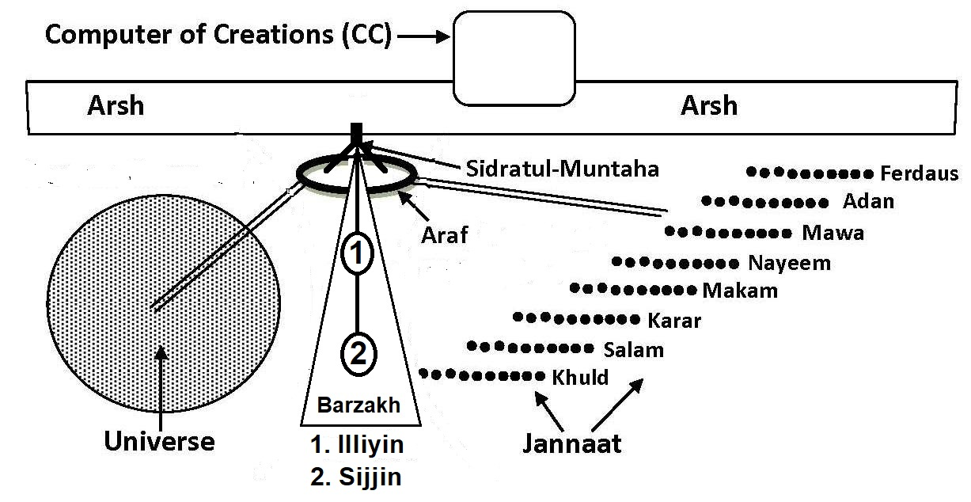

FIGURE 4.1: Barzakh, Illiyin (1), Sijjin (2)

6. The Cybernetic System of the Universe (Samawaat)

Our fates are written in the Hard Disc (Lawh-Mahfuz) of the CC. The CC monitors the materialization of fates by angels. There are innumerable angels working throughout the universes.
The CC manages the angels by a huge cybernetic system that covers the universes and the independent domains. The cybernetic system includes connecting channels and servers at different stages.
The Head (CC) of the System is located in the Arsh.

The major components of the cybernetic system are:
- Arsh
- Araf
- Sidratul-Muntaha
- CC
- Main Canals
- Axis of the Universe (Samawaat)
- Command Stations
- Fortresses
- Sakinah
The system is depicted below:

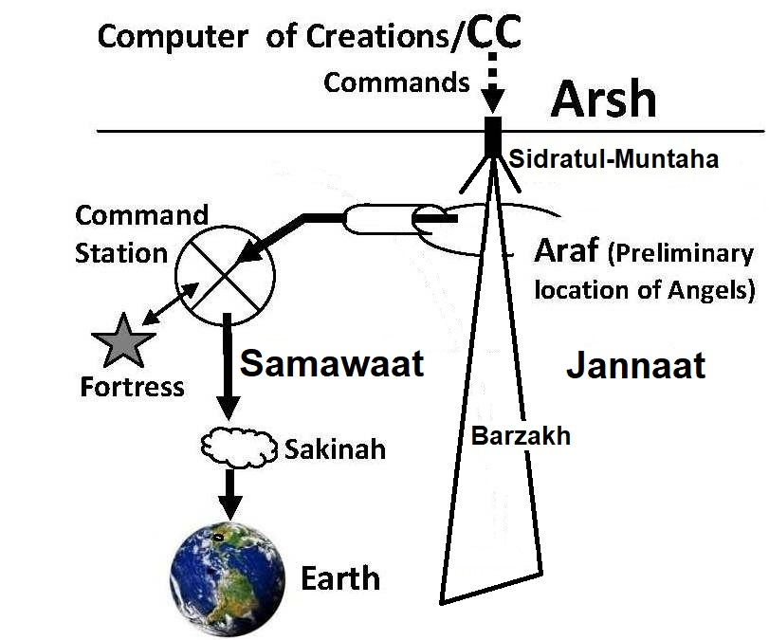

FIGURE 4.2: The Cybernetic System – the Part covering the Universe (Samawaat)

The components are discussed below:

6a. Arsh

The Arsh exists beyond the universes (the Samawaat and the Jannaat) and the Barzakh. It is bigger than the universes. The Headquarters of Allah is located in the Arsh. The CC is an element of the Headquarters.

“After traveling Seven Skies, I was raised to the extreme height. I reached a smooth plain land, where the noise of Pen only was being heard.” [Bukhari]

In above Hadith, the “extreme height” means the Arsh. So, the CC is in the Arsh.

6b. Araf

“Araf” means “Elevated Land”. It is closely below the Arsh at the point of Sidratul-Muntaha.
The Araf is the Preliminary Sanctuary of the angels. All angels were created at a time. They were accommodated in the Araf. An angel, living in the Araf, is yet to get his task. It is tasked and redesigned (programmed) by Sidratul-Muntaha and sent to the job-stations, A minor angel, sent to his job-station, cannot return; the Universe is so huge that the Dooms Day would arrive before he could return.
The Araf is divided by the Barzakh in two parts, the Eastern Araf and the Western Araf. The Eastern Araf is for the angels of the Samawaat (this Universe), and the Western Araf is for the angels of Jannaat.
There is a house of assembly in the Eastern Araf called Baitul-Mamur. Prophet (pbuh) visited Baitul-Mamur during the Night Journey (Miraj).

“Then I was taken to the Baitul-Mamur. Every day 70,000 angels visit it and never returning to it again, another (group) coming after them.” [Bukhari]

6c. Sidratul-Muntaha

During the Night Journey (Miraz), Prophet (pbuh) observed Sidratul-Muntaha from the Seventh Sky. It looks like a tree in the horizon. For this reason, it is called Sidratul-Muntaha.
The Sidratul-Muntaha looks like an up-side-down plant hanging from the ceiling. It is rooted in the Arsh and hanging over the Araf with two main branches.
The eastern branch of Sidratul-Muntaha is extended over the eastern Araf, and the western branch is extended over the western Araf.
The Sidratul-Muntaha looks like a plant, but it is not a plant. It is based on a huge server computer. It is the communication hub of the Cybernetic System; both for information and objects.
The CC controls the Sidratul-Muntaha. If the CC is considered as the Head of the Cybernetic System, the Sidratul-Muntaha should be considered as the Heart.
If one moves up through the Sidratul-Muntaha, one reaches the Arsh, but nobody is allowed to move.

“And indeed he saw him in another descent near the Sidratul-Muntaha, beyond which none may pass.”
[Al Quran 53:13-14]

“Whatever comes down from the up (from the Arsh), comes to Sidratul-Muntaha. Whatever goes up from the down (Araf), goes to Sidratul-Muntaha”
[Hadith]

The universal angels cannot go to the Arsh. The angels of Arsh also do not come down to the Araf. The orders and information move up and down through Sidratul-Muntaha.
Prophet Muhammad (pbuh) was allowed to move up. He reached the Arsh at the highest level of his journey and heard the noise of Pen (CC).

6d. CC (Computer of Creations)

The CC works as the Head the Cybernetic System. It is a standalone computer for security reasons most likely. The Scribe Angels of the Arsh read the information from the CC and write it in the root of Sidratul-Muntaha (the root is in the Arsh).

“…For, it is indeed a Message of instruction—therefore, let who-so will keep it in remembrance—in Books (Lawh-Mahfuz) held in honor, exalted, kept pure and holy by the hands of Scribes (Scribe Angels).”
[Al Quran 80: 11–15]

From the root of Sidratul-Muntaha, the information comes down to its hanging branches. The angels of the Araf (universal angels) receive the information from the branches and act accordingly.
When Prophet (pbuh) visited the Araf, he saw thousands of angels falling into the Sidratul-Muntaha. It looked like thousands of insects falling into a tree. They were falling to receive the orders.

6e. Main Canals

During Miraz, when Prophet (pbuh) reached the Seventh Sky, he saw two canals, flowing from the Araf and falling into the Universe (Samawaat). Accompanying Gabriel told that there were another two canals, flowing into the Jannaat from the Western Araf. The canals flowing into the Jannaat were not visible from their location.
These canals are not canals of water; these are channels through space. The channels have portals at different points of the Samawaat and the Jannaat. The Hadith describes the Channels as “Rivers of Light” and as “River of Darkness”:

Hadith: “In the Seventh Sky, I saw rivers of light, such that the light that was coming from them made the eyes blind. Rivers of Darkness were also there that were covered over with ice, and the sound of thunder crashing could be heard. I was busy looking at these rivers when Jibra'il (Gabriel) said to me, "O' Muhammad, be thankful to Allah for the graces and bounties that have been chosen for you."
[Bihar al-Anwar, Vol. 18]

These are main channels of communication. One pair is connecting the Samawaat (this Universe) with the Eastern Araf, and another pair is connecting the Jannaat with the Western Araf.
After receiving orders from Sidratul-Muntaha, the angels move to their destinations, in the Samawaat or in the Jannaat, through these channels.

“And by those (angels) who glide along, then press forward as in a race, then arrange to do (the jobs)”
[Al Quran 79: 3-5]

Finally, the channels run through the Axis of the Universe (Samawaat) and get divided into seven channels to connect the Skies.

“And We have made above you Seven Tracts, and We are never unmindful of creation” [Al Quran 23: 17]

The channels are divided further in subsequent stages to connect the galaxies, stars and planets.
The Sidratul-Muntaha uses the channels to transfer information, souls and angels mainly. However, information may be transferred from some points in the technique of teleportation.
None can move out from this Universe (Samawaat) without through the channels.

“O ye assembly of Jinns and men, if it be ye can pass beyond the zones of the Skies and Lands (this Universe), pass ye! Not without authority shall ye be able to pass!” [Al Quran 55:33]

Scientific community perceives such channels. They call the openings of such channels, Portals (X Points). One diving into a portal would be shifted to a huge distance in a short period of time.

6f. Axis of the Universe (Samawaat)

In the following Verse, the Quran indicates that we are in the Innermost Sky (First Sky).

“And built over you Seven Skies”
[Al Quran 79:12]

So, a man in India has Seven Skies over his head. At the same time, a man in America has Seven Skies over his head. Therefore, the Skies are spherical waves of space, one inside another—like the peels of onions. We are in the First (Innermost) Sky.
If the Skies are waves of space, it should be difficult to move into the Universe. It is likely that the Universe has an Axis, through which the channels, coming down from the Araf, enter.
Some scientists predict that the Big Bang was spinning. As the Universe expanded, the net angular momentum has dissipated among the galaxies.
If the Big Bang was spinning, the Universe has an axis, and it may be rotating now as well, relative to other universes in higher dimensional space (Super Space).
“For the past few years, Professor Longo has worked primarily in astrophysics, in particular, analyzing data from the Sloan Digital Sky Survey (SDSS). This has led to strong evidence for a cosmic parity violation in the Universe, as indicated by a statistically significant excess of left-handed spiral galaxies toward the North Galactic Pole and an excess of right-handed in the opposite direction. This also suggests that our Universe has a preferred axis and a net angular momentum. Since angular momentum is conserved this means the Universe must have been born spinning. We can't see outside of our Universe, so we'd have to assume it is spinning relative to other universes in a higher dimensional space. Presumably the Big Bang was spinning initially, and as it expanded, the net angular momentum was dissipated among the galaxies. Now we still see it through the preferred spin direction.”
– “Detection of a Dipole in the Handedness of Spiral Galaxies with Red shifts z ~0.04, Michael J. Longo, Phys. Lett. B 699, 224-229 (2011).

According to the Quran, the Universe is rolling in the process of collapse. A Universe with rolling Skies should have an Axis.
Therefore, it is likely that the channels coming down from the Araf enter the Universe through the Axis. Subsequently, the channels get divided into seven pairs of channels, and each pair move into a Sky directly.
A seven-sky-universe should be 10 to 14 billion light years in diameter. It looks bigger due to the Skies.
The Araf and Sidratul-Muntaha are located beyond the Universe. So, an angel coming from the Sidratul-Muntaha should take 5 to 7 billion years to reach the Earth if it moves at the speed of light. How the CC can interact with the earthly affairs? How the angels were coming to Prophet Muhammad (pbuh) frequently?
To answer, the angels monitor according to the preplanned fates. The angels that are coming today were released from Sidratul-Muntaha at a due time in the past. They were staged forwarded on a timescale through Command Stations, Fortresses and Sakinah, discussed below. So, the distance does not matter.

6g. Command Station

There is a Command Station in each Sky. It is said in the following Verse:

“Allah is He Who created Seven Skies and the Lands (Command Stations) an equivalent. Through the midst of them descends His command that ye may know that Allah has power over all things, and that comprehends all things in knowledge.” [Al Quran 65:12]

I call these lands Command Stations, because the lands are meant to descend the commands of God. The Command Stations should be planet-like astral objects.
An Arch Angel leads a Command Station. The Arch Angel of the First (Innermost) Sky is called Michael.
In the Quran, a “Command Station” is called “Lofty Station”:

“Also mention in the Book the case of Idris: He was a man of truth, a prophet. And We raised him to a Lofty Station.”
[Al Quran 19:56-57]

But, in this book, it is called “Command Station” to highlight its purpose.
During the Night Journey (Miraz), Prophet (pbuh) visited the Command Stations (Lofty Stations) step by step. He saw Adam in the Command Station of the First Sky, Jesus in the Second Sky, Moses in the Sixth Sky, Abraham in the Seventh Sky. He saw several other Prophets as well.
A Command Station receives, preserves, and passes on the data coming from the CC. So, a Command Station must be having Server (Computer) like systems.
The angels may carry the data and put it into the Servers.
Or, the data may be transferred through the channels and sub-channels independently.
Or, the data may be transferred by Quantum Teleportation technique. In quantum reality, in many cases two distinct physical systems are characterized by a single state in such a way that if one characterizes the state of one part, must refer to the state of the other part. So, information can be transferred instantly. If one is writing in the ‘quantum teleportation system’ of a Command Station, one is writing in its counter-part too, incorporated in the Sidratul-Muntaha, billions of light years away.
It is proved in 1982 through the experiment carried out by Alain Aspect and his team. The experiment provides strong evidence that even at great distances the atomic particles remain connected to one another—they are entangled. It shows that quantum event at one location can affect an event at another location without any obvious mechanism for communication between two locations.

It is likely that there are 19 Command Stations and Arch Angels:
  - Seven in this Universe (one in each Sky).
  - Eight in the Jannaat (one in each level).
  - Two in the Araf (Angel Malek in the Eastern Araf, and Angel Rizwan in the Western Araf).
  - One may be commanding the angels of Arsh.
  - One may be commanding the angels of CC and Sidratul-Muntaha.

6h. The Fortress

The angels, the ruhhs (command-data) and the nafses (souls of living creatures to be born) of one thousand years are sent from the Sidratul-Muntaha in one group.

“Yet they ask thee to hasten on the Punishment! But God will not fail in His Promise. Verily, a Day in the Sight of thy Lord is like a thousand years of your reckoning.” [Al Quran 22:47]

When the group comes down to the Command Station, the ruhhs are preserved in the Server, the nafses are accommodated in a special store, and the angels are accommodated in the nearby Fortresses.
The Fortresses are star-like objects, or stats. The angels are created out of light. So, they remain energetic in the star-like objects.
The following Verses reveal that the Sirius is a Fortress. The Sirius A is the brightest star among the stars visible to the naked eye:

“That He is the Lord of Sirius.
And that it is He Who destroyed the ancient 'Ad’.
And Thamud, nor gave them a lease of perpetual life.
And before them, the people of Noah, for that they were most unjust and most insolent transgressors.
And He destroyed the Overthrown Cities.”
[Al Quran 53:49-53]

The above Verses are talking about destroyed nations after mentioning Allah as the Lord of the Sirius. It means that the Sirius is a Fortress of the angels of destruction.
There are several Fortresses in each Sky. The Fortresses are led from the Command Station of the Sky.
The CC, the Sidratul-Muntaha and the Araf are located beyond the Samawaat (this Universe). Satan and his follower jinns cannot go there. But, the Command Stations and the Fortresses are in the Samawaat. The satan jinns can go to those objects. They gain hearing by stealth. However, they are driven away by the angels as soon as possible.
The jinns are interested about immediate future mainly. They pass the information to the people enemy to Islam, practice black magic, foretell future and so forth. The satan jinns whisper the information into their hearts.

“It is We who have set out Fortresses in the Skies and made them fair-seeming to beholders, and We have guarded them from every satan accursed. But any that gains a hearing by stealth is pursued by a flaming fire, bright”
[Al Quran 15:16-18]

“And that we sometimes used to sit in some places in the sky to listen. So, whoever now listens finds a fiery asteroid waiting for him.”
[Al Quran 72:9]

6j. Sakinah (Indwelling)

The angels, the ruhhs and the nafses come into a Sky in the groups of thousand years. A Sky spans millions of light years, but it has only one Command Station and several Fortresses in close proximity where they are preserved.
Subsequently, the angels, the ruhhs and the nafses are dispatched to the job stations in the groups of thousand months (83 earthly years approximately). The connected angels, harbored in the Fortresses, are returned and regrouped with appropriate ruhhs and nafses. The group of thousand months is put into a “Sakinah” and moved forward. The Sakinah is harbored near the job station, such as the Planet Earth.
From the Sakinah, the angels with ruhhs and nafses in cases move to their job destinations day-by-day individually, or in packets.
A new Sakinah comes near the Earth in a Night of Power / Destiny (Lailatul-Qadr).

“The Night of Power (Lailatul-Qadr) is better than a thousand months. Therein come down the angels and the ruhhs by Allah’s permission for every work.”
[Al Quran 97:3–4]

Sakinah means indwelling. It is an invisible domain of angels where Allah is close to direct them if needed. It is like a cloud carrying the angels.
The whole System becomes clear if we discuss how the Quran was descended:
- The Quran was written and preserved in the Lawh-Mahfuz.
- The Verses of the Quran were sent to Sidratul-Muntaha that programmed the angels to deliver the Verses.
- The angels and the Verses in the form of brain-data (ruhhs) were put into a group of thousand years. The group moved through the Channels and descended into the Command Station of the First (Innermost) Sky.
- The Command Station preserved the Verses in a Server and the angels in a nearby Fortress.
- In due time, the package of the Quran (angels and ruhhs) were put into a Sakinah, and the Sakinah was sent near the Earth.
From the Sakinah, the angels with the Verses (as brain-data / ruhhs) came to Prophet Muhammad (pbuh) day by day.

“A certain man (Sahabi) was reciting Surah Al-Kahf by his tethered horse. As he was reciting, a cloud engulfed him, which was encircling and descending, whose sight caused his horse to jump and move. When morning came, he went to Muhammad (pbuh) and informed him of what occurred. Muhammad (pbuh) replied that it was the Sakinah that descended with the Quran” [Muslim]

If a Sakinah is close to a person, he feels weak and fall sleeping. It is a security measure of the Sakinah against the jinns trying to gain information. However, the characteristic was used to calm the Sahabah after the Battle of Ohud.
After performing the assigned task, an angel goes back to the Command Station directly and enters the feedback into a Server. The feedback goes to the CC via Sidratul-Muntaha. The angel moves to a Retiring Fortress.

6k. The Observer

Minute-to-minute control is not possible by the CC due to the vastness of the Universe, but Allah personally comes to know a thing in no time and can do anything He may want to do then and there. Allah knows even before one performs an act. He is closer to one than one’s jugular vein. He knows, what one is thinking.

“It was We Who created man, and We know what dark suggestions his soul makes to him; for We are nearer to him than jugular vein” [Al Quran 50:16]

But, normally Allah does not interfere. His system comprising the CC and the angels does not fail. However, if an impromptu situation really arises and demands change, Allah does it:
When Jonah left prematurely, the people understood that their time was about to end. They repented and asked for forgiveness to Allah at the last moment, when the angels of destruction were in the vicinity. Allah forgave and lifted the punishment.

7. Ruhh (Soul)

Which ruhhs come down with the angels? What “ruhh” (soul) means here?
The soul is discussed in Chapter-1. A “ruhh” (an elementary soul) is a designed force field that controls the subatomic particles. Thus, it works as a Command of God.
We too can make ruhhs. A couple of examples are given below:
If one is talking through a mobile telephone, the electro-magnetic waves, emitting from the telephone, are ruhhs.
If an aircraft is operated by a computer, the computer sends electromagnetic command signals to the control units of the aircraft. The electromagnetic command signals are ruhhs.
Similarly, the CC produces command signals / information / instructions with electromagnetic waves, which are called ruhhs in the Verses.
The CC mainly produces two types of ruhhs depending on the jobs. The types are discussed below.

7a. Angel-programming Ruhh

The angels cannot learn. An angel is programmed (designed) with this type of ruhhs to carry out his task.
However, the major angels are created with necessary knowledge and capabilities.

7b. Task performing Ruhh

Some of the ruhhs perform tasks by themselves. For example, if one is downloading the picture of a bird from a Server, one is actually downloading series of electro-magnetic waves through the Internet. At the end, the picture is produced in one’s computer.
We can compare the up-loader computer with the CC, the Server with the Sidratul-Muntaha, the Internet with the Channel, the ‘electromagnetic waves’ of the bird with the ‘ruhhs’, and the receiving computer with the object where the action is taking place.
By this system, a picture comes down. But Allah’s system is much more powerful. The CC can send series of forces (ruhhs), energies and nafs through Sidratul-Muntaha, Channels and Servers, which can form a real bird independently or by grasping matter from the nature. Probably, the camel of Saleh was sent in this way. It was like the making of a living creature with a superfast 3D Printer.
For another example, the Verses of the Quran came as ruhhs. The ruhhs were electromagnetic waves to produce memory in Prophet’s (pbuh) brain.

“He doth send down His angels with ruhh (Verses of the Quran in the form of memory-data) to such of His servants as He pleases: "Warn that there is no god but I; so do your duty unto Me."
[Al Quran 16:2]

“And indeed, it surely is a Revelation; Lord of the universes has brought it down; ruhh, safe upon your mind, that thou may be of the Warners”
[Al Quran 26: 192-194]

Therefore, some ruhhs are designed to perform tasks.

7c. Human Nafs

Allah had created human nafses (souls) before He created the Universe. They were then fed into the CC as players in the Master Design (Virtual / Holographic Universe). After the Design was confirmed and the fates were written, the nafses were probably stored in a store related to the CC.
At an appropriate time, in a group of thousand years, related human nafses are descended into the Command Station of the First (Innermost) Sky. The Command Station may have specialized store for the nafses.
Subsequently, from the Command Station, related nafses are sent near the Earth in smaller group of Sakinah. When a female conceives, an angel comes down to the Earth with a nafs and puts it into the zygote / embryo.

8. Angels

The angels are created out of light. The Araf is their Preliminary Sanctuary.
An angel cannot learn new thing. The Sidratul-Muntaha infuses knowledge of his task into him. The Sidratul-Muntaha re-designs his structure as well, to make him suitable for his task.
A group of angels is summoned to Sidratul-Muntaha from the Preliminary Sanctuary (Araf). There are many big oval shaped leaves in the Sidratul-Muntaha. The angels sit on those leaves. Then the angels are programmed and designed to perform their tasks. All angels of a particular task are programmed at a time and sent in one group.
Therefore, the angels cannot deviate from following through the orders. They are sinless (minor angels are robotic).
Prophet (pbuh) saw the programming of angels during the Night Journey (Miraj):

“It is narrated on the authority of Anas b. Malik that the Messenger of Allah said: “Then I was taken to Sidratul-Muntaha whose leaves were like elephant’s ears, and its fruits were like big earthenware vessels. And when it was covered by the commands of Allah (ruhhs), it underwent such a change that none amongst the creation has the power to praise its beauty”” [Hadith]

“On top of each leaf, there was an angel who covered it with colors, which cannot be described. Whenever he covered it by Allah's order (ruhh), it would change.” One version says: “It would turn into sapphire and chrysolite, the beauty of which is impossible for anyone to praise according to its merit. On it were the Moths of Gold”” [Hadith]

The “Moths of Gold” or the “Fruits looking like big earthenware Vessels” is the same thing, expressed differently in different Hadith. A thing like a “Moth of Gold” remains over an angel when he sits on a leaf. Most likely, this Moth of Gold is the programming device.
The data / commands / ruhhs are delivered into the Sidratul-Muntaha from the CC. The Sidratul-Muntaha produces desired electric pulses and other things unknown to program the angels. The electric pulses are spurted through the ‘Moths of Gold’ into the angels sitting on the leaves. Therefore, when an angel is programmed, it (angel) sparkles with light rays.
After programming and tasking, the angels are packed in a group that includes Task Performing Ruhhs and Nafses in cases. The group is sent down into a Command Station through the Channels flowing from the Araf.

“By those who tear out with violence (task performing ruhhs), by those who gently draw out (programmed angels and nafses), and by those who glide along (the vehicle carrying the group); then press forward as in a race; then arrange to do (the jobs)” [Al Quran 79:1-5]

The necessary instructions are sent down to the Command Station so that Chief Angel of the Command Station can act on the group.
From the Command Station, they are sent near the job stations in smaller groups of one thousand months (83 years approximately) by the Sakinah.
It may be mentioned that final release of the angels destined for a great destruction remains in the hand of Allah; not in the hand a Chief Angel. Thus, great destructions get delayed, even may not come at all (Allah is Merciful). Noah was living for 900 years. People were hearing about the ensuing Flood, but it was delaying and delaying. The destruction of Nineveh was cancelled.
We are living in the verge of the end-time-destructions, related to the coming of Mahdi and Jesus Christ. The signs of their coming are appearing but the events are not rolling down. There are several Books of Prophecy in Holy Bible. One may read those to know the signs. Allah made the Master Plan; He can adjust.

9. Reporting back to the CC

After performing the given task, an angel goes back to the Command Station and enters the feedback into a Server. The Server sends the information to the CC where it is preserved.
An angel does not move back to the Araf—the Doomsday would arrive before he could return. He moves to a retiring Fortress where he keeps on praying for the wellbeing of human he worked for—if he found him good. He will continue praying for the person till the Doomsday.
The angels are involved in one’s day-to-day life. If a person commits a big sin, like murdering a man, the angels involved in his day-to-day life get dismayed. They disclaim the liability of the crime by cursing the person. At the end of duty, they go back to the retiring Fortress where they will keep on cursing the person till the Doomsday.
Every night, when a man sleeps, his brain-data is copied and collected. The data is sent to the CC for preservation.

“It is He who does take your ruhhs by night and has knowledge of all that you have done by day. By day, does He raise you up again that a term appointed be fulfilled. In the end, unto Him will be your return; then He will show you the truth of all that you did.”
[Al Quran 6:60]

The daily brain-data is preserved in a file of a human. It will be needed to return his memory during resurrection.

10. Reporting to Allah

In the Command Station, the returning angels report to Allah as well, before sending the feedbacks to the CC. Allah comes down into the First Sky every night. Most likely, ‘Allah in form’ comes down by extending His Kursi:

“…Extends His Kursi (Thorne) into the Skies and Lands (this universe), and He feels no fatigue in guarding both of them (Samawaat and Jannaat); for He is the Most High, the Supreme.”
[Al Quran 2:255]

Allah appears in the Bitul Izzat (the House of Assembly in the Command Station of the First Sky) and takes the reports of the returning angels.
Reporting to Allah is a formality for the angels. When Allah asks, the angels answer: ‘You already know what they have done’ (or words to that effect).
Allah says, ‘Even then you say what they have done’ (or words to that effect).
It means that Allah checks the collected brain-data and the reports to ensure that those are collected and fed into the Servers correctly.

11. Several Chief Angels

We know about several Chief Angels. In the followings, I have talked about a few of them.

11a. Israfil

Israfil is the greatest angel. He is responsible to blow the Trumpet (Soor).

11b. Azrail

According to Hadith, Azrail is sitting in the Fourth Sky. There is a tree in front of him. The names of all humans are written in the leaves of that tree. When a leaf falls down, Azrail sees the name and collects his soul within forty days. It is likely that the tree is connected to the CC. The leaves fall according to the commands of the CC.
It is narrated in the Hadith that the body of Azrail is so big that if the water of all the oceans were poured on his head, not a single drop would reach his feet.
He does not leave his seat for collecting the souls. He has dedicated hand for each human. Each hand has an eye. Azrail uses the hand to look at a person seventy times a day. It means that wherever a person goes, the dedicated hand of Azrail follows. The dedicated hand ceases after collecting his soul.
After collecting the soul of every living being, only one hand will remain, with which he will collect his own soul.

11c. Gabriel

Gabriel is messenger angel. He is a huge angel. He has many assistant angels looking like him, but small in size. The small angels are produced as Gabriel breaths. Each of them is called Gabriel. They have wings (of light) to move from one place to another.

11d. Michael

Michael is responsible for the living creatures of the First (innermost) Sky including the Earth. It is likely that he is the Chief Angel of the First Sky.

11e. Other Angels

There are numerous other angels that perform specific tasks. I have discussed how they are programmed and sent.

12. Conclusion

The whole system including CC, Sidratul-Muntaha, Araf, Channels, Command Stations, Fortresses and Sakinahs can be envisaged as a huge Cybernetic System with the CC as its head.
Though everything is enclosed in a system, Allah is always in control.

“We descend not but by the command of thy Lord. To Him belongs what is before us, and what is behind us, and what is between; and thy Lord never does forget.” [Al Quran 19:64]

Allah is the Creator, Sustainer and Evolver. He is so enormously powerful that He can instantly do or undo anything He may want to do or undo. He is Merciful. But, one that would deny His existence or attribute Partners to Him may be forsaken, and the System (the Cybernetic System) would mount on him—over him would be the “Nineteen”.
CHAPTER 5: The Jinns

According to the Quran, humans are Vicegerents of God. But they are yet to be empowered. There are two universes, the Jannaat and the Samawaat, where they will be posted after the Judgment as empowered Vicegerents of God.
Allah primarily put Adam and Eve in the Jannaat. The Jannaat is peaceful by nature. After the Judgment, many humans will be returned to the Jannaat.
The Samawaat (Skies / this Universe) is full of burning galaxies. The galaxies are violent objects—a galaxy is a hell. After the Judgment, many humans will be put into the galaxies. A human will own a complete galaxy. There will not be a second human with him. He will have many jinns as his companions:

“Allah created the ‘Skies and Lands’ (this Universe) for just ends and in order that each soul may find the recompense of what it has earned and none of them be wronged.” [Al Quran 54:22]

“We created not the ‘Skies and Lands and all between them’ (this Universe) merely in sport. We created them not except for just ends. But most of them do not understand. Verily, the day of sorting out is the time appointed for all of them.” [Al Quran 44:38–40]

“…I will fill Hell with jinns and men all together” [Al Quran 11:119]

“…I will fill Hell with jinns and men all together” [Al Quran 32:13]

The Jinns are intelligent creatures. Basically, they are creatures of the Samawaat (this Universe). The Samawaat is peaceful for them. They are sometimes called, “Sons of the Skies (Samawaat)”.
Allah is testing and developing us in this cycle of the Universe. The jinns are seriously acting to prove us unfit Vicegerents of God. They want us here in this Universe, but not as the Vicegerents.
In this Chapter, I will discuss the Jinns deliberately. The discussion will progress in the following sequence:
1. Two-in-One Universe
2. A Jinni, a perfect Universal Creature
3. The Root of Rivalry
4. The Followers of Iblis (Chief Satan)
5. Scope of Provocation
6. Why Jinns follow Iblis to Provoke Humans
7. Conclusion
8. Summary

1. Two-in-One Universe

The jinns live around us, but we cannot see them. It is commonly told that they are created out of fire. If they are created out of fire, we are supposed to feel their presence. But, we do not feel them.
We being Believers accept the idea of their existence. But, the idea may be a fairy tale to others. However, recent discoveries indicate that they (jinns) may exist:
“We now know that every particle has an anti-particle, with which it can annihilate (In case of the force carrying particles, the antiparticles are the same as the particles themselves). There could be whole anti-world and anti-people made out of anti-particles. However, if you meet your anti-self, do not shake hands! You would both vanish in a great flash of light.”
– A Brief History of Time by Stephen Hawking.

If the idea of anti-people is scientific, the idea of jinns is not an unscientific one. The universe that possesses five times more dark matter than matter, should possess creatures made out of dark matter (anti-matter is a kind of dark matter).
“However, we know that the universe must also contain what is called dark matter, which we cannot observe directly- One piece of evidence for this dark matter comes from spiral galaxies. These are enormous pancake-shaped collections of stars and gas. We observe that they are rotating about their centers, but the rate of rotation is sufficiently high that they would fly apart if they contained only the stars and gas that we observe. There must be some unseen form of matter whose gravitational attraction is great enough to hold the galaxies together as they rotate.”
– Black Holes and Baby Universes by Stephen Hawking.
“Another piece of evidence for dark matter comes from clusters of galaxies. We observe that galaxies are not uniformly distributed throughout the space; they are gathered together in clusters that range from a few galaxies to millions. Presumably, these clusters are formed because the galaxies attract each other into groups. However, we can measure the speeds at which individual galaxies are moving in these clusters. We find they are so high that the clusters would fly apart unless they were held together by gravitational attraction. The mass required is considerably greater than the masses of all the galaxies. This is the case even if we take the galaxies to have the masses required to hold themselves together as they rotate. It follows, therefore, that there must be extra dark matter present in clusters of galaxies outside the galaxies that we see.”
– Black Holes and Baby Universes by Stephen Hawking.

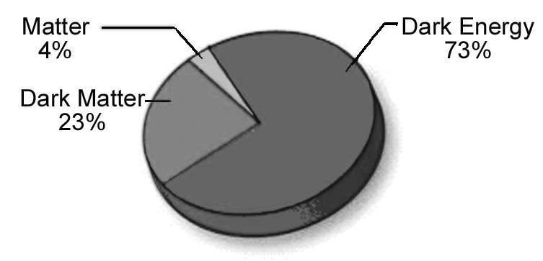
FIGURE 5.1: Percentage of Matter

The presence of dark matter is conceivable from its gravitational effect, as well as the particles with which it may be made of, such as neutrinos, have measurable evidences of their existence. It is assessed that 23 percent mass of the universe is dark matter. The Milky Way galaxy is believed to have roughly 8 times as much dark matter as ordinary matter. In most regions of the Universe dark matter and visible matter are together, proportionately balanced with mutual gravitational attraction.
Electrons, protons, neutrons produce the atoms. Similarly, anti-electrons, anti-protons, anti-neutrons produce the anti-atoms.
The collision of subatomic particle and anti-particle causes both to annihilate producing photons and neutrinos. But such collision is not seen in the space frequently. It is likely that they are protected by some kinds of force fields.
The magnetic field of a black hole makes the falling of matter difficult into a black hole. Similarly, the force carrying subatomic particles are protected. The magnetic fields protect the electrons. The strong nuclear force fields protect the protons. There may be unknown force fields as well, that protect the subatomic particles and atoms.
If another star system would pass through our solar system, hardly a planet would hit another planet, as the space of the solar system is largely empty. Similarly, even if an atom passes through an anti-atom, the chances of subatomic particles and anti-particles colliding with each other remain slim, because subatomic particles and anti-particle are very small, and the space inside an atom / anti-atom is largely empty. If an atom is compared with a football ground, the nucleus of the atom should be compared with a football.
Therefore, matter and anti-matter are invisible to each other. Every moment a huge amount of dark matter is passing through our body, but we do not feel it.
The Quran says that the jinns are created from the fire of hole (black hole):

“And the Jinn race We had created before from the fire of hole”
[Al Quran 15:27]

The Arabic word “samumi” means “hole”. But, it is normally translated as “scorching”, because when there is a small hole in the body, it scorches. “Samumi” actually means “hole”.
In above Verse, the “hole” means the “black hole”. A black hole produces fire in the accretion disk by splitting the atoms through friction. According to Hawking’s idea, the particles gain the energy from gravitational field and join to the accretion disk. The anti-particles having opposite momentum fall down into the Black Hole. The Black Hole loses its energy then.
Therefore, a black hole is a depot of anti-matter.
So, in the above Verse, the “fire of hole” means “anti-matter”.
So, according to the above Verse, the Jinns are created out of anti-matter.
About 80% of the Milky Way galaxy is dark matter. The same gravitational force binds matter and dark matter. Thus, the visible objects and the invisible objects make two different dimensions with the black holes as the connectors. With every galaxy, there may be an anti-galaxy.
Holy Bible talks about an end time event when demons will be thrown into the abyss. Abyss means deep hole. It is a black hole. A black hole makes the gate of an anti-galaxy. If a jinni is thrown into a black hole, he returns to the dimensions of dark matter and needs a thousand year to come back.
This Universe (Samawaat) is a two-in-one-universe: one is for the creatures of matter (baryonic matter), and another is for the creatures of anti-matter. We are top creatures of matter, and the jinns are top creatures of anti-matter.
Probably so, Satan (Azazil) argued with God saying that he was created from the Fire (Fire of Hole / Anti-Matter), and Adam was created from the earth (Baryonic Matter), why should he prostrate himself before Adam. It otherwise meant that an anti-creature cannot interact with a creature, why should he accept the leadership Adam?
Allah did not accept this argument, which means that inter-action will be possible one day. Probably, a human has dormant system in his body and soul (nafs) to interact with a jinni. The system will be active among resurrected people destined to the hell (the galaxies of the re-created Universe will be considered by humans as the objects of hell). If a resurrected human would not have the ability, Allah would not say the hell-dwellers to call the jinns, as has been narrated in the following Verse:

“One Day He will say, "Call on those whom you thought to be My partners," and they will call on them, but they will not listen to them. And We shall set a Crucible (Mawbiqan) between them, and the Sinful shall see the fire and apprehend that they have to fall therein—no means will they find to turn away from there.” [Al Quran 18:52-53]

A rotating magnetic field, associated to a spinning black hole, makes an Accretion Disk beyond the event horizon (an event horizon is a sphere surrounding a black hole where the value of escape velocity reaches to the value of the speed of light). In the above Verses, the Accretion Disc is called Crucible. The matter falling into a black hole swirls in the Crucible in a tremendous speed and gets destroyed due to friction. It produces devastating heat.
A Crucible, surrounding a black hole, works as a barrier as well. So, it will be difficult for a jinni to come out through a black hole.
A sinner will see the devastating fire produced in the Crucible and will always be in tension that his dwelling object might fall into the spiral of intense gravitational force and confront the crushing crucible!
However, a time will come when a human will start gaining control and the jinns will be his intimate associates.

“If then they have patience, the Fire will be a home for them! And if they beg to be received into favor, into favor will they not be received. And We have destined for them intimate companions who made alluring to them what was before them and behind them, and the sentence among the previous generations of jinns and men who have passed away is proved against them; for they are utterly lost.” [Al Quran 41: 24-25]

A human nafs (soul) is a combination of known and/or unknown Force fields. Some of the force fields may be interactive to the anti-matter, as the same Gravitational Force acts on both matter and anti-matter. So, a human may be able to interact with a jinni by his nafs.
A human developed to live in the Samawaat (this Universe) may have nafs aided vision (third eye vision) as well, to see the jinns.
A resurrected hell-dweller will be able to interact with the Jinns.

2. A Jinni, a perfect Universal Creature

Allah initially settled Adam and Eve in the Jannaat. It means that He created them suitable for the Jannaat. Humans do not look like a creature meant for this fiery Universe (Samawaat). The Earth has been made suitable for us through a long process of evolution—the Earth is a unique planet with its oceans of water, layered atmosphere, powerful magnetic shield, and innumerable living creatures.
On the contrary, the jinns look like a creature of this Universe. In the Book of Enoch, the jinns are called “Sons of the Sky”. In the Quran and Holy Bible, the Sky/Skies mean this Universe (Samawaat). So, the jinns are Sons of this Universe. This Universe is their original home.
Allah is supremely intelligent Creator. If He has created the jinns for this Universe, they must be suitable for this Universe. Their long life, food and mobility indicate that they are suitable. They are perfect universal creatures. It is discussed as under:

2a. Long Life

A jinni lives for thousands of years. A hundred-year-old jinni may be a child. This Universe (Samawaat) is good for them.

2b. Food

It seems that the jinns are not worried about their food. They may even have ability to absorb energy (anti-energy) from the nature directly—like the trees gain energy from the Sun. In addition, they may have a few kinds of foods, crude in nature, and amply available. Thus, they are not worried about their food and can persistently follow the humans to involve them in evil deeds.
In one occasion, Prophet Muhammad (pbuh) became happy on several jinns (good ones) and prayed for their food. So, they got another two kinds, bones and hairs, which would produce their foods once they had picked those up. But bones and hairs are not their staple foods; they already had regular source of energy.

2c. Mobility

They are capable to move from planet to planet, star to star, galaxy to galaxy without any space ship. Even, there are angels assigned to guard their access into the vital objects of the Skies (Samawaat / this Universe).

“It is We who have set out Fortresses in the Skies and made them fair-seeming to beholders. And We have guarded them from every satan (jinn) accursed. But any that gains a hearing by stealth is pursued by a flaming fire, bright”
[Al Quran 15: 16–18]

The satan jinns sometimes sit in some places in the Sky to steal information. They steal information from the Fortresses. The Fortresses are astral objects where angels are accommodated.
The angels are sent in groups to monitor the affairs of living creatures. A group covers a period of time (one thousand years / one thousand months). So, it is possible to know the future by hearing them and/or by seeing their shapes—the angels have different shapes depending on their nature of job.
If a jinni can know the future from a Fortress, he informs it to some of the foretellers, or to the enemies of Truth. The jinni whispers information into a human’s ears. The whisperings do not produce any sound, but it is sensed by the nafs (soul) of a human. The nafs transfers the sense to the qalb (mind / virtual brain) that in turn produces a faint thought. The brain vitalizes the thought. Adam was provoked in this way:

“Then began Satan to whisper suggestions to them, bringing openly before their minds all their shame that was hidden from them. He said, "Your Lord only forbade you this tree lest you should become angels or such beings as live forever" [Al Quran 7:20]

“But Satan whispered evil to him: he said, "O Adam! Shall I lead thee to the Tree of Eternity and to a kingdom?”
[Al Quran 20:120]

Generally, the satan jinns instigate humans to do sinful deeds. But, if a person is doing a great evil deed, such as striving against the religion of God, preaching the creed and culture of sin, etc., they help greatly with stolen information. However, the person does not understand it; he thinks that he being very intelligent has predicted it. Foresight of near future (aided by the whispers of jinns in cases) helps him find his strategy. Satans help as well to unite the evil people.

“…We made the satans friends to those without faith” [Al Quran 7:27]

For example, Prophet Muhammad (pbuh) was hiding in a cave being pursued by the enemies. The pursuing enemies came near the cave, but they did not enter thinking that there was nobody inside. If a satan jinni could know from the local Fortress that Prophet (pbuh) would be hiding in the cave, they would whisper it into the minds of pursuing people, and they would search the cave. Therefore, when Prophet (pbuh) took birth, the Fortresses of the local sky were specially guarded.

“And we (jinns) reached the Sky, so we found it strongly guarded and filled with asteroids.” [Al Quran 72:2]

But, the jinns are intelligent creatures. By seeing the enhanced guarding, some of them understood that soon a Prophet would come, or a great punishment.

“And that we (jinns) sometimes used to sit in some places in the Sky to listen, so whoever now listens finds a fiery asteroid waiting for him. And we understand not whether ill is intended to those on the Earth, or whether their Lord intends to guide them to right conduct”
[Al Quran 72: 9-10]

And some of them were very intelligent. They ultimately found Prophet Muhammad (pbuh) and met him to accept Islam.

“And as for us, since we have listened to the Guidance, we have accepted it, and any who believes in his Lord has no fear either of a short (account), or of any injustice.
Amongst us are some that submit their wills (to God), and some that swerve from justice. Now those who submit their wills, they have sought out (the path) of right conduct”
[Al Quran 72: 13-14]

3. Final Destination

Through the jinns will face the Final Judgment, there is no mention of jinns going to Jannaat (another universe). Probably, the Jannaat is not suitable for them. They would be rewarded in this Universe (Samawaat). The Universe is their original home. In this Universe, there may be better domains for them to live in, and there may be hostile domains.
However, their punishment would not be severe because Allah has not selected them as His Vicegerents.
A disbelieving human, such as an idolater, will be resurrected with a devil-human body, suitable to interact with a jinni:

“Even if the wrongdoers had all that there is on earth and as much more would they offer it for ransom from the pain of the Penalty on the Day of Judgment! But something will confront them from God, which they could never have counted upon—and will become apparent to them satan, what they earned, and will surround them what they used to mock!”
[Al Quran 39: 47–48]

“But those, who have earned the satan (jinn), will have a reward like the satan (jinn). Ignominy will cover their (faces); no defender will they have from God. Their faces will be covered, as it were with pieces from the depth of the darkness of night. They are companions of the Fire; they will abide therein!”
[Al Quran 10:27]

He will be a Vicegerent of God over a whole galaxy, where the jinns too will live, but he will be a forgotten Vicegerent; Allah would not accept his prayers:

“It will also be said: “This day We will forget you as ye forgot the meeting of this day of yours! And your abode is the fire, and no helpers have ye!”
[Al Quran 54:34]

He will suffer due to the nature of his Universe. Allah sustains the Universe and its nature. The nature nurtures the jinns mainly; it is their home. So “forget humans - nurture jinns” would be a principle of Allah in this Universe. Allah does not forget in real sense.
However, Allah will make the hell-dwelling humans robust to survive.

4. The Root of Rivalry

A long time back, the jinn increased in this Universe to a great number. There were also other kinds of intelligent anti-creatures, such as ifrit. In course of time, many of them became disobedient. Allah sent angels to suppress them. Many kinds were completely destroyed and many of the jinns were killed. Iblis (Chief Satan) was a ten-year-old jinni at that time. The angels did not kill him and took him with them out of pity. He grew up and acquired knowledge. Because of his intelligence, knowledge and prayers, he was made a leader of the angels.
He used to be called Aza-zil. Probably, his duty was related to the flashes of light (zil). We know from the Hadith that he was raised to the Arsh. Probably, he was the leader of angels working in the Arsh for Sidratul-Muntaha. The Sidratul-Muntaha hangs on the Araf from the Arsh, and it is based on a huge Server (Computer). It produces flashes of light while programming the angels. If Aza-zil was working for Sidratul-Muntaha, he has a very good knowledge on the universal cybernetic system, discussed in the previous chapter.
Allah declared that He was about to create His vicegerent on a land:

“Behold, thy Lord said to the angels: "I will create a vicegerent on a land…"
[Al Quran 2:30]

Allah created Adam and ordered the angles to prostrate themselves before him:

“When I have fashioned him and breathed into him of My ruhh (soul), fall ye down in obedience unto him.”
[Al Quran 15:29]

All angels fell down in obedience, but Azazil did not. He became jealous—he was not one to recognize Adam as a Vicegerent of Allah.
Allah cursed Azazil because of his arrogance and disobedience and called him Iblis.
Iblis (Chief Satan) was determined to prove his point—he was to prove that Adam was not suitable Vicegerent of God, that Adam could be misled easily, that Adam could disobey God, that he (Iblis) were not wrong by not accepting Adam as a vicegerent of God. He asked for the scope of his undertaking. Allah granted him the scope. He gave him a life up to the Day of Judgment. Since then Iblis is enemy to human beings.
Iblis managed to enter the Jannaat and successfully provoked Adam and Eve to eat forbidden fruit. Allah threw them out of the Jannaat, and descended them into the Earth.

5. The Followers of Iblis (Chief Satan)

Iblis (Chief Satan) was provoking Adam. He invests his followers for other humans. He has many followers from the jinns. A follower jinni also is called a satan. There is a jinni (satan) against each human being.

"After each human, there is a satan who is a bad jinni." [Hadith]

Iblis is the leader of all satan jinns. He has his throne in the ocean. At the end of the day, all of his followers (follower jinns) report to him.
It may be mentioned that all jinns are not followers of Iblis; there are many good and pious jinns as well.

6. Scope of Provocation

The jinns are created from anti-matter. So, they cannot interact with humans directly. They have specific ways of provocation that entail Watching, Whispering and Mounting. The ways are discussed below:

6a. Watching

In the Book of Enoch, the jinns are called “Watchers”. It is said in the Quran too. The Jinns can see us from their dimensions of space, where we do not see them.

“O ye Children of Adam! Let not Satan seduce you in the same manner as He got your parents out of the Jannaat stripping them of their raiment to expose their shame; for he and his tribe watch you from a position where you cannot see them. We made the satans friends to those without faith” [Al Quran 7:27]

It is likely that the nature of their souls and physiques, and/or the nature of their dimensions allow them to see us.

6b. Whispering

“Say: I seek refuge with the Lord and Cherisher of Mankind, the King of Mankind, the God of Mankind from the mischief of the Whisperer, the one who withdraws, the one who whispers into the chest of Mankind from the jinns and men." [Al Quran 114: 1-6]

A human soul (nafs) is a combination of known and/or unknown force fields (elementary souls /ruhhs). One or more of these force fields are influenced by anti-matter (like the same gravitational force influences both matter and anti-matter). So, a nafs can sense the whisper of a jinni produced from anti-matter. The nafs transfer the sense to the ruhh and brain.
A ruhh (human-ruhh) is the second soul of a human. It is a highly designed unknown force field that is given by Allah directly. It is anchored in the muscle of the chest. The ruhh with nerves and brain makes the qalb (mind / virtual brain).
The ruhh, being aided by the brain through the nerves and muscles, produces the thoughts. Sometimes the thoughts are initiated or inspired by the senses received from the nafs.

Note:

The ruhh helps to produce vision as well.
And a human has a dormant system to see the anti-creatures. The nafs has a vital point in the forehead (third eye). It can receive the radiation of anti-particles, such as positron (the way retina receives the photons). The nafs transfer the information to the ruhh. The ruhh then can produce the vision.

6c. Mounting

“A man is like a horse whose back never remains vacant; either Allah is riding on him, or a satan.” [Hadith]

A satan cannot mount on a Mumin (believer of One God); he can whisper only. Allah guards the Mumins by angels, as it is said in the following verse:

“He is the Irresistible from above over His worshippers, and He sets guardians (angels) over you. At length, when death approaches one of you, Our angels take his soul (nafs), and they never fail in their duty.” [Al Quran 6:61]

The satan jinns mount on idolaters. A jinni cannot mount on a human body directly, as he is created from anti-matter. He mounts under the covering protection of human’s nafs. The nafs works as protective clothing for a jinni. But the idolater does not understand that he is possessed.
In the mother’s womb and on the Earth, a nafs is like a cast, and a body is like a mold. Here, the nafs remains in the mode of development. So, the nafs of a possessed idolater gradually takes up a devil-human shape. His dormant systems to interact with the anti-creatures gradually mature. Thus, the program of his creation gets deformed. A nafs gets hardened during death.
The nafs will resurrect the body in a devil-human shape. During the resurrection, a body will be like a cast and a nafs will be like a mold.
A nafs develops after death as well. The nafs of an idolater is kept in the Sijjin. It is developed in the Sijjin, but its shape donot changes. It becomes robust in size and shape. It becomes efficient. The idolater will resurrect as a giant in devil-human shape.

“Even if the wrongdoers had all that there is on earth and as much more would they offer it for ransom from the pain of the Penalty on the Day of Judgment! But something will confront them from God, which they could never have counted upon—and will become apparent to them satan, what they earned, and will surround them what they used to mock!”
[Al Quran 39: 47–48]

"...They (Jinns) will say, "We have seen (them) adopt ourselves and deluded them (in) the life of the Earth, and they bear witness against themselves that they rejected faith.” [Al Quran 6:130]

A human will be left in the Samawaat (this Universe) if he resurrects in devil-human shape. His body will be evidence against him that he rejected the Faith. He will be a Forgotten Vicegerent of God in a galaxy of the Samawaat, full of violence.

"Taste ye then- for ye forgot the Meeting of this Day of yours, and We too will forget you - taste ye the Penalty of Eternity for your (evil) deeds!"

“Do ye then see what ye throw out (sperm and ovum)? Is it ye who create it, or are We the Creators?
We have decreed Death to be your common lot, and We are not to be frustrated from changing your forms and creating you in that ye know not.
And ye certainly know already the first form of creation; why then do ye not celebrate His praises?”
[Al Quran 56: 58-62]

Note:

Sometimes people suffering from mental disorder are identified as people possessed by jinns. Above discussion has nothing to do with the people having mental disorder. If a satan jinni is mounted on a human, he (human) does not feel it and does not behave irregularly, except in case of grasping the Message of God. Then, hearing he hears not, seeing he sees not, because mounted jinn is very powerful (softly powerful) on him; he (the jinn) protects his gain by distracting his mind. The person feels agitated and leaves the place where True God is discussed; he feels happiness in places where false gods are discussed.

“As to those who reject Faith, it is the same to them whether thou warn them or do not warn them; they will not believe. God has set a seal on their hearts and on their hearing, and on their eyes is a veil; great is the penalty they (incur)”
[Al Quran 2: 6-7]

“Many are the Jinns and men we have made for Hell; they have hearts wherewith they understand not, eyes wherewith they see not, and ears wherewith they hear not. They are like cattle, nay, more misguided—for they are heedless” [Al Quran 7:179]

However, in the extreme level of possession, a woman can be witched. If she is jealous of a person, the mounted jinn may harm the person by manipulating her (witched woman’s) soul—her soul is then harmed further (a jinn cannot harm by himself, directly).
Jesus could cast out devil, but now nobody can. The best way for the witched woman is to accept Islam. A Muslim woman can never be witched (He is the Irresistible from above over His worshippers, and He sets guardians (angels) over you…and they never fail in their duty – Al Quran 6:61).
A witched woman is never seen in a Muslim society, but there are many incidents of witch-hunting in Pagan Societies.

7. Why the Jinns follow Iblis to Provoke Humans

The physiques made from anti-matter may have some advantages, such as their souls may be more powerful and dynamic on them, so they may be able to change their physical shapes at wills. They live long. They can fly through the Skies. They may not need so many natural supports, such as air, water, food, etc., to survive.
But they have disadvantages as well. Their likely disadvantages are:
A human body is an instrument of enjoyment. On the contrary, the life of a jinni may be simple. We may consider the case of food. Humans have innumerable kinds of foods with different colors, aromas and tests, but the jinns may not have that. Probably, they absorb energy (anti-energy) directly from the nature and may have a few kinds of foods, crude in nature.
Actually, every kind of animal has only a few kinds of foods—lions eat meet, cows eat grass, and some even live on one kind of plant only. For instance, the koalas eat eucalyptus leaves only, the pandas live on bamboo leaves only. But humans have many kinds of foods. Sometimes humans eat food merely for enjoyment.
Humans have beautiful houses, domestic animals, cars, boats, aircrafts, dresses, travel sites, etc., to enjoy. But, the jinns have nothing in comparison to humans. Moreover, they are not honored like humans, because they are not Vicegerents of God.
A human brain is more intelligent and efficient.
Therefore, an immoral jinni would not leave the scope of possessing a human body. A satan jinn enjoys the charms of human life through the occupied person. But, the human does not feel or understand that he is possessed by a jinn.

“Said: Go thy way; if any of them follow thee, verily Hell will be the recompense of you—an ample recompense. And arouse those whom thou can among them with thy voice; make assaults on them with thy cavalry and thy infantry; mutually share with them wealth and children; and make promises to them. But Satan promises them nothing but deceit” [Al Quran 17: 63-64]

"O you assembly of Jinns! Much did you take of men." Their friends among men will say: "Our Lord! Some of us were enjoyed by others (jinns), but we reached our term, which You did appoint for us…” [Al Quran 6:128]

Iblis is very powerful among the jinns, as he has many followers. A jinni has to accept his leadership at first. Then he would allot a human to the jinni.
Think from the viewpoint of a jinni. He might have come out through a black hole and entered our dimension of the galaxy. Flying through the dark sky, full of burning objects, he might have come to the Chief Satan (Iblis) and has got a pagan (idolater) allotted to him. Still his universe is dark and crude. But, as soon as he mounts on the pagan, he enters the human world with blue sky, vast ocean, beautiful lands full of flowers and fauna. Ultimately, he shares the wealth and children of the pagan. The human body works as a means to open up the joyful human horizon to the jinni.

Note:

The Children are not genetically affected for the mounting of satan jinns on their fathers and/or mothers. All children are pure (Muslims) by birth.

8. Conclusion

8a. Demand of Universal Objects

Nothing achieves completeness without a human being. A galaxy is a huge creation, but it would feel itself neglected without a human. It has right to get a Vicegerent of Allah (a human).
One may think that we are humans, so we are feeling us important. But it is not the case. If it were known that the Planet Saturn has an intelligent life form, NASA would leave no stone unturned to reach there.
The same it is for Allah. He is more interested on objects where living creatures exist. And humans are highly developed intelligent creatures—they think and talk. Allah created them in His own image.
Allah wants to put some humans in this Universe (Samawaat), because the Universe is a huge creation.

“Assuredly the creation of the Skies and Lands (this Universe) is a greater than the creation of men; yet most men understand not” [Al Quran 40:57]

On the Day of Final Judgment, the hell (Samawaat / this Universe) will keep on asking for humans.

“The Day, We will ask hell, “Art thou filled to the full?” It will say, “Are there any more?” [Al Quran 50:30]

The following Hadith mentions the same.

Hadith: “After the Final Judgment, a group of people will be thrown into the hell (this Universe) and the hell will be asked: ‘Is she satisfied?’The hell will say: ‘Are there any more?’ Then another group will be thrown in to the hell and the hell will be asked: ‘Is it enough?’The hell will say: ‘Are there any more?’ Then another group will be thrown into the hell and the hell will be asked: ‘Is it enough?’ The hell will say: ‘Are there any more?’ Then Allah will put His leg into the hell. Then the hell will be satisfied and say: ‘Enough, Enough, Enough.’ And its one part will be squeezed with another part” [Tirmizi]

The Universe will be rolled up. The Resurrection of the Dead will occur. The Final Judgment will be carried out on a specially created Land (Land of Judgment) in the Super Space. After the Judgment, humans will be moved into the Jannaat (another universe), but not all.
The Universe (Skies / Samawaat) will be un-rolling. The galaxies reviving in the un-rolling Skies (Samawaat) will grasp the humans left in the Land of Judgment and pushed into the unrolling Universe. The galaxies are the objects of hell.
To make a righteous distribution, we have been put into the Earth to test. The persons failing in the earthly test will be left in this Universe (Samawaat). The jinns too want them here; the Universe is their home. They do not want to lose the scope of venturing out of their dimensions.
Otherwise, the jinns are not created as the Vicegerents of God. So, some humans will have to be left in this Universe. However, they will be forgotten vicegerents. A sinner will get a whole galaxy:

“It will also be said: "This Day We will forget you as ye forgot the meeting of this Day of yours! And your abode is the Fire, and no helpers have ye!”
[Al Quran 45:34]

The jinns will be allies in the hell, but they are disobedient by nature.
A sinner and a satan jinn will be together in the hell. Together, they make an effective group to explore their home galaxy. One has higher intelligence and stability, another has mobility and flexibility. But, to the jinns, the universal objects will not be as painful as it will be for the human. Rather, the universe (hell) is natural living place of the jinns; for them, it may not be painful at all.

“…We made the satans friends to those without faith.” [Al Quran 7:27]

“…I will fill Hell with jinns and men all together” [Al Quran 11:119]

“…I will fill Hell with jinns and men all together” [Al Quran 32:13]

8b. A Foolish Endeavor

The science would never develop in some subjects. We would never know the jinns, because we cannot observe or feel the dark matter; we cannot test it directly in the laboratory. The dark matter occupies different dimensions of the same space.
But, sometimes our souls feel the existence of supernatural creatures, and we make stories. There are stories in different books of religions as well. But we should not believe everything. Only the Quran tells us what we should believe—the Quran is a proven Book from the Creator. The Faiths based on the stories and the theoretical science may be severely damaging to the Faith. For example:
One might have seen someone meditating in the modern concept: Initially he thinks that cosmic energy is falling into him. Subsequently, he thinks that he is joined with the cosmic energy, and everything is energy. Finally, he thinks him in a state of oneness and tries to apply his will-power on the material world. He is otherwise trying to be a God.
In reality, the creations of this Universe (Samawaat) are sustained in the extended elementary souls (force fields / ruhhs) of Allah. He is immensely powerful, living and omnipresent; He hears and sees everything; He sustains every sub-atomic particle of this Universe; He evolves the creations—it is His domain; a human cannot intrude. A person may be divinely connected to Allah, but not to His creations as a mover by his will power or verbal command. The creations of this Universe are not free to obey, and humans are not developed to intrude and influence.
[The Jannaat (another universe) is most probably sustained and evolved by Allah differently, and a human in Jannaat would be developed to influence the creations of his region].

“God! There is no god but He, the Living, the Self-subsisting, Eternal. No slumber can seize Him nor sleep. His are all things in the Skies and Lands. Who is there can intercede in His presence except as He permits? He knows what before or after or behind them. Nor shall they compass aught of His knowledge except as He wills. Extends His Kursi over the Skies and the Lands, and He feels no fatigue in guarding and preserving them for He is the Most High, the Supreme.” [Al Quran 2:255]

So, whatever the meditating person may be thinking does not affect anything. The unusual things he may be hearing, seeing and feeling may be hallucinations created by his brain.
However, if one tries to connect God through meditation and prayers, then it is good.
There are pagan ways of meditation also; one is described below:
A nafs is the main soul of a human. It (nafs) spreads throughout one’s body with its center below the navel. A nafs is a combination of known and/or unknown force fields (elementary souls / ruhhs). It is complex and has many vital points. Generally, these vital points are identified as Chakras.
In Satanic Meditation, in the name of balancing the Chakras, satan jinns are called repeatedly through deep meditation aided by music. One of the renowned Satanic Meditations is called “Kundalini”. “Kundalini” means “Coiled Serpent” (in Holy Bible the Satan is called Serpent). Probably, a satan jinn gets into a pagan’s nafs in the shape of a serpent, because a serpent is simple in form and suitable for entering through a narrow hole.
In Kundalini Meditation, the word they chant repeatedly is “Kundalini Arohona”, which means “Serpent Mount”.

“And yet among men there are such as dispute about God without knowledge and follow every satans obstinate in rebellion! It is decreed for him that he who befriends him, then indeed he will misguide him and guide him to punishment, the blaze.”
[Al Quran 22:3-4]

Every human has a dedicated satan from the jinns who are the followers of the Old Serpent (Iblis / Chief Satan). The satan jinni can watch and whisper only, if the human is a Believer. But, in case of a pagan, it mounts.
The mounting has already happened in case of a pagan; he does not need to shout for it—his kundanilini (coiled serpent / satan jinn) is already mounted. The satan jinni is his friend on the Earth and in the hell. He may feel the serpent during meditation. And he may be able to get some petty jobs done by the satan jinni. But a satan jinni cannot act in the human dimension; he (satan jinn) does the job by convincing other humans through the other jinns.
However, in cases, a satan jinni can act by using the nafs of the mounted person. Then his nafs is spoiled further.
A human achieves nothing beyond his fate. A person befriending a satan jinni will be in the hell forever.
The scope of forgiveness remains open in the whole earthly life. The pagan should leave the satan by turning to Allah, and by asking for shelter to Him.

“Say: I seek refuge with the Lord and Cherisher of Mankind, the King of Mankind, the God of Mankind from the mischief of the Whisperer who withdraws, who whispers into the chests of mankind; among jinns and among men. [Al Quran 114]

Finally, human mind has no station. Imagination of a serpent along the backbone and head may appear in one’s mind. It is sensation of spinal cord and brain, which make the central nervous system (CNS)—it is not Kundalini. Satan cannot mount on a Believer of one God.

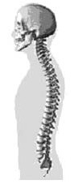

FIGURE 5.2: Central Nervous System

8c. An Unknown Endeavor

Meditation is not a prescribed way of worship in Islam. One cannot force Allah to mount on one. If Allah hates one, no meditation can help.
Why one should need meditation? A beautiful woman does not need to go to a man; rather man comes to her running. So, be beautiful by keeping the qalb and nafs uncorrupted, by gaining knowledge, by extreme sawm (self-restrain), by regular prayer (As-Salat), by extra prayer, by avoiding unnecessary enjoyment, by avoiding sins, and if there is a clear scope of struggling in the Path of Allah, then by struggling (Jihad). It is said in the Hadith that if a person is walking toward Allah, Allah is running towards him. So, He will run; not you—understand your value.
But do not be proud. Allah does not like proud people. And He has billions to choose. He is the Master of the universes.
This Universe (Samawaat) is seen expanding. The distant galaxies are receding in tremendous speeds just to make our nights dark:

“What! Are you more difficult to create, or the sky? He has constructed it. He has raised its thickness and proportioned it. Its night does He endow with darkness, and its splendor does He bring out. And the land moreover has He extended. He draws out there from its moisture and its pasture. And the mountains He firmly fixed: For use and convenience to you and your cattle.” [Al Quran 79: 27-33]

Many stars have exploded just to produce matters suitable for us. To Allah, it does not matter whether the universe was dark or bright, cool or hot. To Him, a piece of iron and a piece of gold is equally priceless.
So, each galaxy wants a human because they know that human has some importance to Allah. But, why should one be fool enough to follow the jinns and live in the hell forever? The galaxies are objects of hell.
Let one be foremost—forgiveness from one’s Lord and the Jannaat, the width of which is as the width of the 'Skies and Lands' (this Universe).

9. Summary

There are two Universes: the Jannaat (another Universe) and the Samawaat (this Universe). Basically, humans are the creatures of the Jannaat, and the jinns are the creatures of the Samawaat.
Each mighty creation (like a galaxy) has right to get a Vicegerent of God. Therefore, after the Final Judgment, adequate number of humans will be left in this Universe (Samawaat). Whoever follows a jinni (satan) will be left in the universe of the jinns (Samawaat).
CHAPTER 6: Human

A human is passing a physical life on the Earth. He has another physical life in his ultimate destination where he will be inserted through resurrection as an eternal being. In this respect, many remain in confusion. One of the causes of the confusion is that we believe having souls, but we are yet to discover it.

The basic idea of the soul is given in Chapter-1 where I have discussed that a ruhh (elementary soul) is a designed force field, and a nafs (composite soul) is a combination of two or more force fields.

I have also discussed that Allah provided a huge nafs (composite soul) from His own body to create the Universe. The provided nafs is called Nafsin-Wahidatin (a Nafs Single) in the Quran.

The Nafsin-Wahidatin looks like the GUT Force (the Force of Grand Unified Theory) that produced the Big Bang / the Universe.

However, there are unknown Force Fields, which are not yet discovered. The unknown force fields originated from the same Nafsin-Wahidatin. So, the Nafsin-Wahidatin was greater than the GUT Force. It may be called GUT Force + (plus).

The unknown force fields were needed to create the nafses (composite souls) of the living creatures.
In this Chapter, I have discussed human souls. It is the main discussion of human souls. The discussion will progress in the following sequence:
1. Human Soul
2. Types of Human Souls
3. Difference between human Ruhh and Nafs
4. Human Ruhh
5. Consciousness
6. Hearing
7. Emotions
8. Guidance
9. Ruhh and Brain-Data
10. Formation of Mind (Virtual Brain)
11. Nafs
12. The Nature of Nafs
13. The Control of Nafs
14. Development of Nafs and Resurrection
15. The Need of Guarding

1. Human Soul

Basically, humans are Vicegerents of Allah.

Behold, thy Lord said to the angels: “I will create a vicegerent on a land…”
[Al Quran 2: 30]

On the Earth, a human is undergoing test to confirm which of the lands he deserve to get as a Vicegerent of God? Is it should be an object of this Universe (hell), or is it should be an object of the Jannaat (paradise)?
A human is not only tested, his souls are developed on the Earth for his eternal destination.

2. Types of Human Souls

Each human has two souls:
- Nafs (a composite soul)
- Ruhh (a special elementary soul)
The nafs is the main soul of a human, which spreads throughout his body with its center below the navel. A nafs has several vital points. The vital points are called Chakras (Latifa).
Adam was created as a living being. He had nafs. But he was unconscious. Allah gave him ruhh from Himself, and Adam became conscious.
The ruhh is a superimposed soul, spreading in the chest and brain. A ruhh too has vital points.

3. Difference between human Ruhh and Nafs

Both Ruhh and Nafs are translated as “Soul”, but they are different:

3a. A human nafs is a combination of known and/or unknown force fields (elementary souls / ruhhs). The force fields originated from the Nafsin-Wahidatin (Allah gave Nafsin-Wahidatin from Himself. It is deliberately discussed in Chapter-1).

“He created you from a Nafs Single (Nafsin-Wahidatin) …” [Al Quran 39:6]

But, a human ruhh (a highly designed unknown elementary force field) is not from Nafsin-Wahidatin. It is given by Allah directly to each human. He breathes the ruhh into a human:

"When I have fashioned him and breathed into him (Adam) of My ruhh, fall ye down in obeisance unto him."
[Al Quran 15:29]

To the others, Allah gives ruhh just after one’s birth and one becomes conscious and cries for the first time. Allah takes his ruhh every time he sleeps and gives it back when he awakes.

3b. A nafs is given in the mother’s womb during or soon after the formation of zygote. It takes shape with the growth of physical body.
But, the ruhh remains unchanged throughout one’s life

3c. Other animals have nafs only; they do not have ruhh.

3d. The nafs is taken out from a body at the time of death. It is collected by angel Azrail:

“O nafs (soul) in rest and satisfaction come back thou to the Lord well pleased and well-pleasing unto Him. Enter thou then among My devotees! Yea, enter thou My Jannaat!” [Al Quran 89: 27-30]
But the ruhh is taken out every time a man sleeps. It is collected by Allah directly. An angel cannot collect a ruhh.

“It is He who does take your ruhhs (souls) by night and has knowledge of all that you have done by day. By day does He raise you up again…”
[Al Quran 6:60]

So, the nafs is related to life, and the ruhh is related to consciousness.

4. Human Ruhh

A human ruhh is designed to serve several purposes. The purposes and its activities are discussed under the following headings:
5. Consciousness
6. Hearing
7. Emotions
8. Guidance
9. Ruhh and Brain-Data
10. Formation of Mind (Virtual Brain)

5. Consciousness

Allah takes one’s ruhh when one sleeps. In other words, when Allah takes ruhh, one becomes unconscious and starts sleeping.
The consciousness relates to the mind.
It seems that the ruhh produces the mind (qalb).

5a. Ruhh produces Mind / Qalb / Virtual Brain

"The Mind is a set of cognitive facilities including consciousness, imagination, perception, thinking, judgment, language and memory, which is housed in the brain (sometimes including the central nervous system). It is usually defined as the faculty of an entity’s thought and consciousness. It holds the power of imagination, recognition, and appreciation, and is responsible for processing feeling and emotion, resulting in attitudes and actions.” – Wikipedia, the Free Encyclopedia
It is generally thought that the brain produces the mind through its activities. But the modern thinkers associate Central Nervous System too, with the mind. Some scientists opine that the mind spreads throughout the body; it is not limited to the physical brain only.
Mind is greater than the brain. The experiments show that mind can act independently in cases. A decision may be made in the mind before the brain is aware of the situation.
The Quran points out the chest as the location of mind:

“Do they not travel through the land so that their minds (qalbs) may thus learn wisdom and their ears may thus learn to hear? Truly, it is not their eyes that are blind, but their minds, which are in their chests.” [Al Quran 22:46]

According to the following Hadith the Qalb is a piece of flesh (muscle):

“Prophet (pbuh) said: There is a piece of flesh in the body of every child of Adam; when that is purified, the whole body becomes pure; and when that one goes wrong, the whole body goes wrong. Be informed that it is the Qalb.”
[Hadith]

Therefore, according to the above Verse and Hadith, the qalb (mind) is in the chest and it is related to a muscle.
How one’s thinking compartment (qalb / mind) can be in the chest, instead of being in the brain?
But, the mind is not the brain only:
“If minds are wholly dependent on brains, and brains on biochemistry, and biochemistry on the meaningless flux of the atoms, I cannot understand how the thought of those minds should have any more significance then the sound of wind in the tree.”
– C. S. Lewis
Here comes the need of ruhh. The ruhh forms the mind (qalb) in the chest. The ruhh is a super-imposed soul of a human, which spreads in the brain and chest.
The ruhh, the brain, the nerves and some of the muscles of the chest jointly make a mind (qalb) in the chest.
One’s ruhh is a highly designed force field (elementary soul) of unknown kind. It works as an active platform of one’s mind (qalb). So, the mind (qalb) can be called as the virtual extension of brain (virtual brain in short).
The virtual brain (mind/qalb) helps produce the mental-visions. Some of the visions get recorded in the brain; unimportant visions get erased.
When the ruhh is taken out, one’s mind gets dismantled, and one cannot think; thus one becomes unconscious and starts sleeping.

“It is God that takes the souls (ruhhs) at death; and those that die not, during their sleep. Those on whom He has passed the decree of death, He keeps back, but the rest He sends for a term appointed. Verily, in this are Signs for those who reflect.” [Al Quran 39:42]

Allah takes one’s ruhhs during sleep. When He gives the ruhh back, one’s mind becomes complete, and one starts thinking and becomes conscious.
Therefore, the mind (qalb) is a virtual brain produced by ruhh, brain, nervous system and several muscles of the chest.
The data comes to the mind directly from eyes, ears, skin, brain and nafs. A mind (qalb) can act independently to some extent, without the intense and immediate help of brain.
Other animals do not have ruhh. So, they do not have mind (qalbs) to produce mental-visions. A dog never thinks sitting in a corner that it has become the king of a jungle and commanding all other animals.

Note:

The Qalb should be translated as mind, not as heart.

5b. Ruhh and Deep Sleep

One can steel everything from a man’s house while he is sleeping, but one cannot enter a lion’s cave even if it is sleeping with stomach full. A minor vibration will break its sleep and it may attack. A beast does not have a ruhh—so, its sleep is not related to ruhh—so, its sleep is not deep.
A short sleep is enough for a beast: A horse sleeps 2 hour in a 24-hour-day, and that two-hour-sleep too may be divided into many parts.
But, a human brain is massive and extremely active. It needs proper rest that can be achieved by long deep sleep only. So, the ruhh related sleep is incorporated. To incorporate the ruhh related sleep, special changes are made in a human physique by modifying his genome code. It is said in the following Verse:

“And created you from Pairs (DNA Double Helix), and we made your sleep rest” [Al Quran 78: 8-9]

5bI. Pairs / DNA Double Helix

Here I will confirm that "Pair" means "DNA Double Helix" in the above Verse.
I will also discuss the design and activities of DNA Molecule (Pair). The discussion will be required to understand the role of nafs in the resurrection of a human.
The Quran talks about the Pair in many Verses. I have discussed the Verses below:

5bII. Noble Pair

“…And He scattered through it beasts of all kinds—We send down rain from the sky—all from Noble Pair (Min kullay zawgin kareemin)” [Al Quran 31:10]

“Do they not look at the Earth, how many we produced in it—all from Noble Pair (Min kullay zawgin kareemin)?”
[Al Quran 26:7]

The above Verses are normally translated in deviated forms where the word “zawjin” is translated as male-female-pair to make meaningful sentences of common understanding. But my translations are direct, word-to-word, in which “zawjin” (Pair) clearly point out “Double Helix DNA”.
Actually, the “Pair” (zawjin) cannot be translated in these Verses as male-female pairs, because the single-cell creatures, such as Amoeba and Bacteria, do not have male and female. They are reproduced by dividing into two equal halves through a process called Binary Fission. And the Verses are saying that all living creatures are created from the Noble Pair. So, the Verses mean "DNA Double Helix" by "Noble Pair". The picture of the “Noble Pair” is given below:

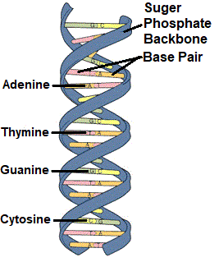

FIGURE 6.1: The Noble Pair (DNA Double Helix)

All living creatures of the Earth, from single-cell amoeba to giant blue whale, are created from the double helix DNA molecules.
Does one search for a ‘noble hen’ and a ‘noble rooster’ to produce the chickens? And human husband and wife need not to be nobles to produce an offspring.
In fact, every living creature, from bacteria to maple tree, is produced by a genuine “Noble Pair” (zawgin kareem) that is the “DNA Double Helix”.
The genome code is the program of life.
A DNA Molecule is a long linear polymer. Its structural arrangement looks like an immensely long ladder joined in the middle by weak hydrogen.
A human DNA Double Helix is about six feet long. It remains coiled in the nucleus of a cell. There are 46 DNA Double Helix in a human cell.
A DNA Double Helix contains many Genes. A gene is a region of a DNA that encodes function. A human DNA Molecule has about 23,000 genes. However, it accounts for 2 % of the DNA. The function of other 98 % is not clear.
The genes act as instructions to make proteins and enzymes. With only 20 types of amino acids, available in the cytoplasm, the DNA Double Helix can produce over 1000 types of proteins needed for a human body. It can produce over 2000 types of enzymes.
The DNA Double Helix molecules replicate and divide the nucleus. Ultimately the cell gets divided. It produces different kinds of cells. Over 250 types of cells make a human body. Every type of cell has specific programs needed to function.
The formation of a human body starts from a cell (zygote). DNA Double Helix contains body plan genes, hox genes and switches to guide and control the formation. It does not make nerve cell in the hair, or hair cell in the nerve. Ultimately, a human child is born with more than 100 trillion cells perfectly organized.
Can it be believed that the whole process of formation is guided by the code of 46 DNA Double Helix molecules that remain in the nucleus of a cell, not visible to the naked-eye?
These are highly complicated processes. So, in above Verses, the pair (DNA Double Helix) is called “Noble Pair” (Zawgin Kareem).
Allah created it personally. Its accidental creation is impossible.

5bIII. The Attractive Pair

In the Quran, the DNA Double Helix is called “Attractive Pair” (zawgin baheej) as well:

“And the earth; We have spread it out, and set thereon mountains standing firm, and grown therein every kind from Attractive Pair (Zawgin Baheej).”
[Al Quran 50:7]

A single round of DNA replication precedes all cell divisions, regardless of organism.

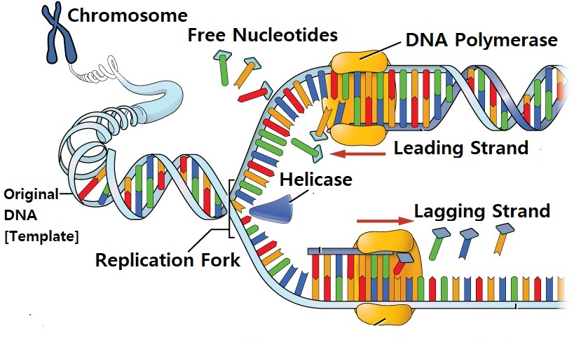

FIGURE 6.2: DNA Replication

The DNA replication is the process of producing two identical replicas from one original DNA molecule.
A DNA Double Helix remains coiled in a chromatid. It unwinds and gets separated for replication. Each strand acts as a template for the next strand. Bases are matched to synthesize the new partner strand. A perfect match is produced with free nucleotides available in the cytoplasm. The old strand attracts the new strand to produce new DNA Double Helix.
After the DNA replication, the nucleus of a cell divides. Subsequently, the cell gets divided. It produces two identical cells.

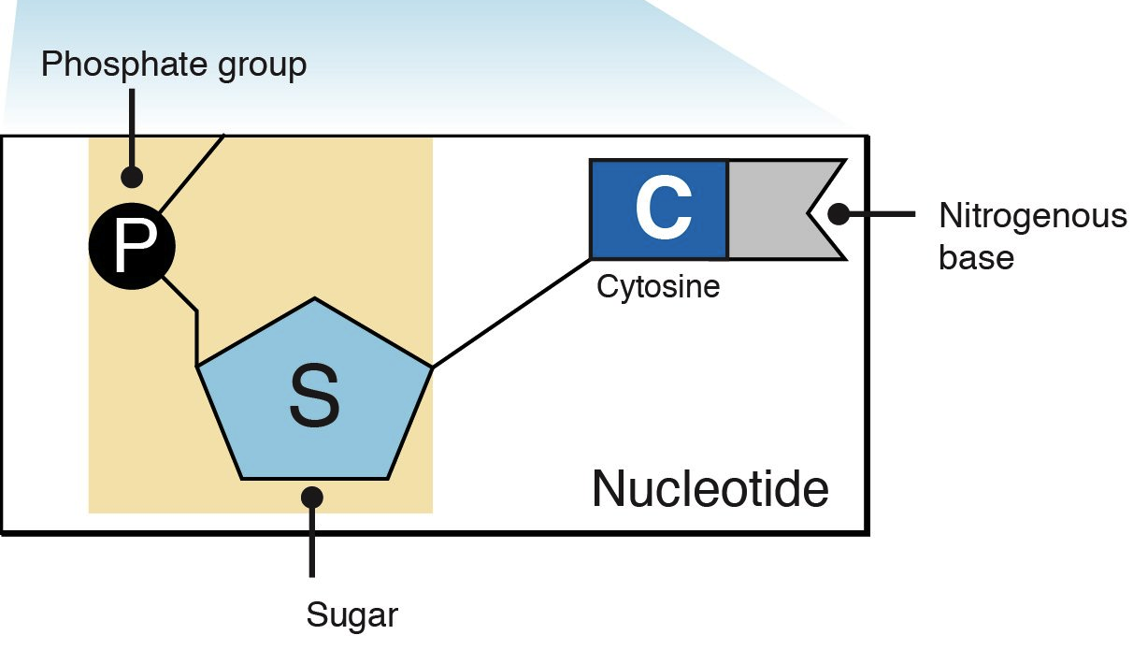
FIGURE 6.3: Nucleotide

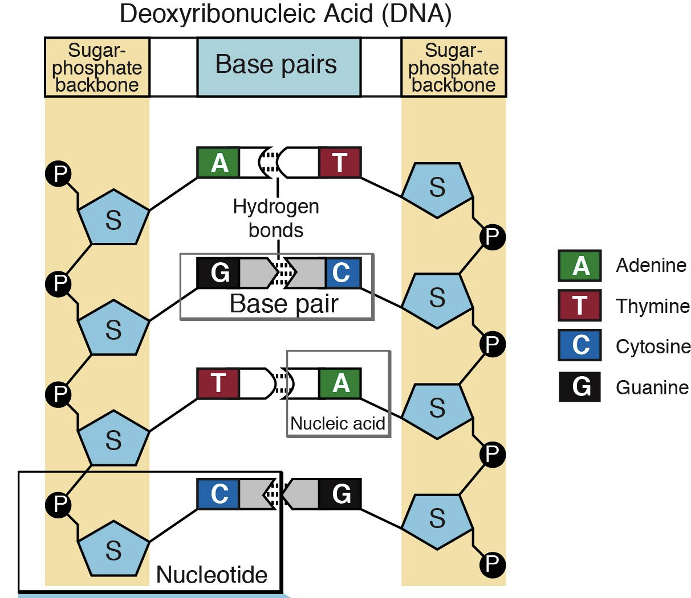

FIGURE 6.4: Double Helix Bondage

In a DNA Double Helix, the nucleotides produce bondage with weak hydrogen (see figure). The weak hydrogen does not work like glue; it attracts. So, the strands can segregate and join as needed without causing any harm to the base pairs.
A DNA material attracts correct counter-part as well, during the fusion of producing zygote.
A DNA Double Helix releases Messenger RNA (mRNA) that attracts correct amino acid in correct sequence to produce correct protein in the synthesizer (ribosome).
There are many cases when they find out correct elements from cytoplasm to produce correct products.
A DNA Double Helix is the mother of all attractors.
So, a DNA Double Helix is rightly called “Attractive Pair” (Zawgin Baheej).

5bIV. Pair and Reproduction

The DNA Replication segregates chromosomes and forms two nuclei in the cell in the process of mitosis. Subsequently, the cell divides. It produces two identical cells.
In another process (meiosis), it produces reproductive cell with haploid chromosomes. A haploid chromosome is a coiled DNA Double Helix (Pair).
The haploid chromosomes of reproductive cells (sperm and ovum) undergo fusion and produce the code of a zygote that is destined to form a specific human with hereditary traits from parents and grandparents.

“The Creator of the Skies and Lands, He has made for you pairs (DNA Double Helix) from among yourselves, and pairs (DNA Double Helix) among cattle; by this means does He multiply you; there is nothing whatever like unto Him, and He is the One that hears and sees.”
[Al Quran 42:11]

In above Verse, cattle are mentioned to clarify that the Verse is not talking about married couple (married pair); cattle do not marry.
The Pairs are created for us and from us, as the Verse says: He has made for you pairs from among yourselves.
And it is the means of reproduction, as the Verse says: by this means does He multiply you.
Therefore, in this Verse, the “Pairs” means Haploid Chromosomes that are available in a sperm. Each Haploid Chromosome contains one DNA Double Helix (Pair) with little changes in the code so that the offspring is like the parents but not exactly like the parents.
The Diploid Chromosomes are produced in the zygote through fusion of sperm and ovum, which produces the specific code of the child with hereditary traits from the parents.

5bV. Pairs and Ship

"That has created Pairs (DNA Double Helix) in all things and has made for you ships and cattle on which ye ride”
[Al Quran 43:12]

Above Verse is talking about “cattle we ride” just after talking about the “Pairs”. It means that riding cattle are genetically programmed to be obedient. A zebra cannot be tamed, but a horse can be driven to death.
Above Verse is talking about ships too, “ships and cattle on which ye ride”. In old times, the ships used to be made of wood. The plants too are created from the same DNA Double Helix.
The DNA Double Helix of plants and animals are chemically and structurally same. It is the codes they produce in the genome which varies. One code makes a horse and another code makes a tree.

5bVI. Pairs for All

“Glory to God Who created all things that the earth produces as well as their own kind and things of which they have no knowledge from Pairs (DNA Double Helix)” [Al Quran 36:36]

According to above Verse, all living creatures are created from the Pairs. We find that all creatures from bacteria to maple tree and from amoeba to blue whale are created from the double helix DNA.
Is there any other kind of “Pair” in the world, with which all life forms can be created?
It is DNA Double Helix only.
So, in the Quran, “Pairs” means “DNA Double Helix”.
However, viruses do not have double helix in their DNA. It also is clarified in the above Verse by the words, “all things that the earth produces”. The virus is not produced in the earth. It is produced in the living creatures (hosts) only. Moreover, a virus is a nonliving creature.

6. Ruhh and Hearing

“And among His Signs is the sleep that ye take by night and by day, and seeking of His Bounty; verily in that are signs for those who hears” [Al Quran 30:23]

The above Verse indicates that one’s hearing system is designed for one’s sound sleeping. The brain needs electromagnetic waves for the processing of data and sense hearing. But, the ear does not receive electromagnetic waves; it receives sound waves and transforms the sound waves into electro-magnetic waves. If the hearing system received electro-magnetic wave, one could not sleep due to colossal sounds produced by electromagnetic energy emission sources scattered all-around the Universe.
The ruhh may have a role to play in the transformation of sound waves into electro-magnetic waves. So, when the ruhh is taken out, one cannot hear and can sleep undisturbed.
An animal has no ruhh. So, its sleep is different. The sleep of an animal breaks due to minor vibration / sound.

7. Ruhh and Emotions

A human feels sorrow and joy in his chest. In extreme sorrow, the chest tends to be squeezed; and in extreme joy, the chest tends to be expanded. The emotions are felt in the mind (qalb) that is in the chest.
Therefore, sorrow and joy are ruhh related emotions. Other animals do not have ruhhs, so they do not have these two emotions (sorrow and joy). The matter is further discussed in the discussion of nafs.

8. Ruhh guides a Human

The ruhh controls one by influencing the brain. How a ruhh interacts with the brain to control a human?
Some of the muscles of the chest are connected to the brain with special nerves, which help to produce the mind. The ruhh spread in the chest and brain like a magnetic flux and work as the platform of mind (qalb).
The ruhh has vital points too. It has two vital points in the chest and one vital point in the left hemisphere of brain.

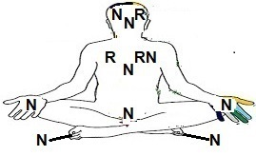
FIGURE 6.5: Several Vital Points of Nafs (N) and Ruhh (R)

A ruhh does not work like an organ of a human body. It does not have inherent knowledge of good or bad. It affects according to its fundamental nature. A ruhh may be “careless, weak and innocent” or it may be “arrogant and tyrant” by nature. Its mere presence affects the willingness or unwillingness of doing a thing.
Let us assume that a young man has seen a beautiful woman in a jungle where there is nobody around. How his brain and ruhh would act in this case?
As soon as he will see the woman, an imagination will arise in his mind aided by the right hemisphere of brain. The right hemisphere of the brain aids imagination, and the left hemisphere plans.
Let us assume that the right hemisphere of his brain has produced an imagination of raping her. But, until the left hemisphere will plan and drive his body, no crime will be committed.
Satan whispers into his chest. The nafs senses the whisper and influences the mind and subsequently the right hemisphere of brain. So, due to the whisper of satan jinni, the imagination of raping may be vitalized. However, the imagination is still an imagination only, and no crime is planned yet.
The imagination may arouse the body sexually, and the nafs may aid (the nafs is discussed subsequently).
Finally, the left hemisphere of the brain may start planning to achieve her forcefully.
Let us assume that the left hemisphere of the brain has planned to take her into a deeper jungle and rape her. The brain will arouse the person to do that sinful deed by creating joyful feelings about it; it will warm-up the nerves and muscles and will finally drive the body to do that misdeed.
Now, the reality is that the misdeeds are tough, risky, difficult and shameful—she may be clever and may not be misguided; she may have a weapon; she may be a judo expert; she may go to the police, and so on.
If the ruhh of the person is ‘careless, weak and innocent’ by nature, it will tend to collapse due to the feelings of doing tough, risky, difficult and shameful act. So, a counter drive will be produced in the ruhh. The drive will counter the planning of left brain through the vital points of ruhh. So, the execution maybe dropped.
This is the reason why the people with care less, weak and innocent ruhhs are likely to remain away from the big sins and are likely to get the Jannah after the Final Judgment, as we find in the Hadith:

“… Jannaat said, what happened to me that other than the weak, innocent and careless people nobody has entered inside me! ...” [Hadith]

One cannot stop thinking. The brain plan actions. A ruhh by its mere presence creates willingness or unwillingness to perform an action.

9. Ruhh and Memory-Data

Every night, the angels collect the memory-data of a person, after Allah has collected his ruhh during his sleep:

It is He who does take your ruhhs by night, and has knowledge of all that you have done by day…” [Al Quran 6:60]

The data are sent to the Lawh-Mahfuz for preservation. It will be required to return the memory of a resurrected person on the Day of Judgment.

10. Qalb (Mind / Virtual Brain)

According to Hadith, qalb (mind / virtual brain) of a Believer (Mumin) is the “Arsh” of Allah.

“The qalb (mind) of a Believer is the Arsh of Allah” [Hadith]

The main Arsh in the High is the Headquarters of Allah where He has a Kursi to sit. The human minds (qalb) are His forward headquarters that He controls by His fingers.

“The qalb (mind) of a Believer remains between two Fingers of Allah” [Hadith]

So, Allah can control a human’s thought and get a thing done by him.
Allah can control in any way He may want to, but the qalb is a way He has created to interface through humans to His creations.
However, Allah holds great honor and dignity. Allah may use the people that want Him. Others may be left at their own in the Jannaat and in the Samawaat.

"The Day whereon neither wealth nor sons will avail, but only he who brings to Allah a sound qalb”
[Al Quran 26: 88–89]

10a. How a Qalb can be spoiled?

There are three ways mainly, through which a Qalb can be spoiled. It is discussed as under:
Firstly, a satan jinn rides on a Pagan. So, gradually his nafs gets deformed. He will be resurrected with devil-like-body, unsuitable for the Jannaat. The qalb is based in the body, so once the body is deformed, the qalb too gets deformed. Allah may not like a deformed qalb as His Arsh. After the Final Judgment, Allah may leave such humans in the re-created universe, which will be full of burning galaxies, homes of the jinns and hell for the left behind humans. Their qalbs will be more interactive to the jinns. The matter will be clear in the discussion of nafs coming next.
Secondly, a qalb may be spoiled due to wrong knowledge and programming of brain. For example: the brain creates affection in the qalb. If one feels affection for wrong things, Allah may not like it. However, it does not make one unfit for the Jannaat.
Thirdly, the qalb may be spoiled due to excessive sins.
Furthermore, one may not be used by Allah because of one’s mental orientation. Allah holds great honor and dignity; He may use the people who want Him. Others may be left at their own. However, it does not make one unfit for the Jannaat.

10b. How Qalb can be suitable to be an Arsh of Allah?

In this respect I want to propose three points:
Point 1: The brain helps to produce the thoughts in the qalb, so brain should be full of Faith, knowledge of Allah and the Quran.
Point 2: One should want to be accepted by Allah. The urge of acceptance should come from the mind, so one should love Allah. One who loves Allah, remembers Allah. When one calls Allah, does one wants that Allah should come and sit in a chair around one? No, one may want Allah connected to one’s qalb. Once Allah likes one, He makes one’s qalb pleasant to Him and develops the connection.
Point 3: Allah is present everywhere. He is closer to us than our jugular veins. We do not see Him, because He is beyond the veils. His light is not exposed in our known three-dimensional world. A bit was exposed in front of Moses, and the hill burnt. Even the Earth cannot sustain the pressure of His light, as Hazrat Rabeya Basri, a Muslim saint, narrated. The Light of Allah can be exposed inside a human body through his nafs. A human being is a “Home of Allah” which is highlighted in the following Verses:

“Allah is the light of the Skies and Lands. The parable of his light is as if there were a niche and within it a lamp. The lamp enclosed in glass; the glass as if it were a brilliant star. Lit from a blessed tree, an olive, neither of the east nor of the west. Whose oil is well-nigh luminous though fire scarce touched it. Light upon light! Allah does set forth parables for men, and Allah knows all things. In houses, which Allah has permitted to be raised to honor for the celebration in them of His name. In them is He glorified in the mornings and in the evenings. They are such men whom neither business nor trade can drive from the remembrance neither of Allah, nor from regular prayer, nor from the practice of regular charity; their fear is for the day when hearts and eyes will be transformed” [Al Quran 24: 35–37]

According to the above Verses, the light of Allah is present everywhere. His light may be exposed inside His beloved people. In above Verses, the glass is the parable of a human body, and the flame inside the glass is the parable of the exposed light of Allah. The people with such illuminated nafses have their qalbs (mind) liked by Allah.

11. Nafs

"He is the Irresistible from above over His worshippers; and He sends guarding (angels) over you. At length, when death approaches one of you, Our angels take his soul (nafs), and they never fail in their duty. Then are men returned unto Allah, their Protector, the Reality. Is not His the Command? And He is the Swiftest in taking account."
[Al Quran 6: 61-62]

Above Verses narrates that Allah persistently guards His worshippers by angels. Why Allah guards His worshippers? What is the difference between a guarded Mumin and an unguarded idolater? We find both suffer equally from diseases and disasters. What the angels guard?
In subsequent discussion it will be clear that the angels guard the “nafs” of a human mainly.
Nafs is an Arabic word. It is the main soul of a human being.
A nafs (composite soul) is a combination of known and/or unknown force fields (elementary souls / ruhhs). It permeates the whole body with its center below the navel (umbilicus). According to the Quran, a nafs is detached from a body at the time of death only.

“O nafs in rest and satisfaction, come back thou to the Lord well pleased and well-pleasing unto Him. Enter thou then among My devotees! Yea, enter thou My Jannaat!” [Al Quran 89: 27–30]

So, the nafs sustains a human body as a living entity.
It is discussed under the following headings:
12. Nature of Nafs
13. Control of Nafs
14. Development of Nafs and Resurrection
15. Need of Guarding

12. Nature of Nafs

A nafs possesses the basic urges, the urges of survival and reproduction. So, it is the center of greed (coming from the urges of survival and reproduction). Basic human nature is the nature of his nafs.

“By the Nafs, and the proportion and order given to it, and its enlightenment as to its wrong and its right; truly he succeeds that purifies it and fails that corrupts it!” [Al Quran 91: 7-10]

Above Verses say that a nafs is given proportion and order. Most probably, it is the proportion of known and/or unknown force fields that in combination form a nafs. Each of these force fields forces one or more urges and characters by design. Some of the urges and characters are expressed as emotions.
“Emotions are biological states associated with the nervous system brought on by neurophysiological changes variously associated with thoughts, feelings, behavioural responses, and a degree of pleasure or displeasure.” – Wikipedia, the Free Encyclopedia

Psychologist Robert Plutchik states that there are eight basic emotions: joy, sadness; trust, disgust; fear, anger; surprise, anticipation.

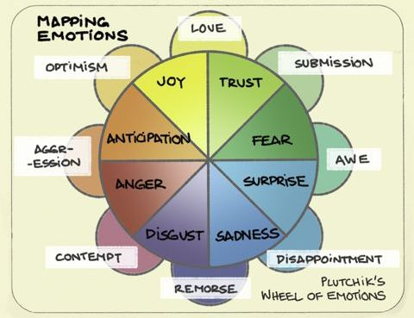

FIGURE 6.6: Plutchik’s Wheel of Emotions

The physical causes interact with the ruhh or nafs and produce a spectrum of emotions, which drives the person.
The Joy and Sadness are ruhh-related emotions. So, only a human has these two emotions. Other emotions can be possessed by every animal more or less, because every animal has a nafs.
The above Verses talk about the enlightenment of nafs as to its wrong and its right. The knowledge of wrong and right remains in the brain. The brain enlightens the nafs by electric pulses.
But all nafses do not get enlightened equally; a corrupted nafs is proactive to the wrong impulse related to the wrong thoughts. As well as it is more receptive to the whisper of a satan jinni.
The nafs may be enlightened by the light of Allah. But, Allah would enlighten one that He likes. Others are left at their own.

13. The Control of Nafs

A nafs acts on body and brain directly. It influences the mind (qalb / virtual brain) through its vital point of the left chest. Its activities are discussed under the following Headings:
a. Urges of Survival and Reproduction
b. Nafs acting directly
c. Nafs sensing anti-creatures, like jinns
d. Nafs and the Third Eye
e. Nafs and Whisper of Satan Jinni
f. Nafs and Sexual Drive
g. Nafs build Character
h. Nafs and Self-restraint

13a. Urges of Survival and Reproduction

Fear is the primary emotion of a nafs, which guides an animal. Fear relates to the urge of survival.
A brain assesses danger. So, the information of fear (electric pulses) comes to a nafs from the brain. The information spread through the nerves of the backbone. It spreads throughout the body at a fast speed.
The brain sends electric pulses of fear. But, if it were a matter of the electric pulses and muscles only, the whole body would be affected, because every cell of a body is connected to a nerve. Brain sends pulses of fear everywhere, but it is felt in the vital areas of the nafs.
The center of a nafs is below the navel. So, closely located body parts sense the fear vividly. Thus, extreme fear creates pain in lower backbone, sensation in lower stomach, shivering in legs, even urinating.
In turn, the urge of survival, imparted in the nafs by designing its constituent force fields, inspires the brain to act. Human nafses are complex and diversified, so they act differently. Some attack, some fly away, some do nothing. But animal nafses are similar, so they act similarly.
Similarly, brain sends pulses of sadness and joy throughout a body, but the senses are felt in the chest, where ruhh is located. Sadness and joy are ruhh related senses.
A beast has a nafs only. So, it feels the nafs related emotions only. It feels fear in danger, attraction to counterpart, pleasure in eating, pain in hurt, comfort in good weather and dwelling, etc. It does not have a ruhh, so it does not have the ruhh related feelings such as sorrow and happiness. If one has slaughtered a sheep in front of other sheep, they are not unhappy.
[Only dogs show the signs of happiness seeing its master. But, it is not happiness; it is the sign of love that is related to its nafs. Its sensational acts of receiving its master are acts of play that is seen among the puppies (a dog remains a puppy to its master throughout its life)]
Therefore, the waves of brain are translated and felt as fear, sorrow, joy, etc., by nafs and ruhh. And, the nafs and the ruhh inspire the brain to act according to their inherent natures.
Humans are highly developed creatures. A human brain helps by producing the hormones. For example, the brain produces a hormone that helps to withstand the fear by balancing the body and by releasing extra energy. The formation of the hormone takes time. For example, when one is flying by an aircraft, the fear of flying is suppressed after about an hour. So, the hormone needs about an hour to form and suppress the fear.

13b. Nafs acting directly

In cases, nafs can act without deliberate help of brain.
A brain needs some time to assess the danger, when a danger may be coming fast. So, a nafs is designed with some information and trained to act on minimum data from the brain. It causes fixed reflex action by using the nodal points of the nervous system. Assessment of the brain follows, when the fear is felt according to the degree and necessary action is taken.
In such case, a nafs may not need light received by the eyes even. The nafs is a combination of known and/or unknown force fields. It may sense the emitted light of an object dangerously coming from the back and move the body instantly.

13c. Nafs sensing anti-creatures, like jinns

Some force fields are interactive to the anti-matter, like gravity pulls both matter and anti-matter. A nafs is a combination of known and/or unknown force fields. Some of the force fields feel the presence of anti-creatures. So, a person may be scared in a haunted house even if he may not know that the house is haunted.

13d. Nafs and the Third Eye

A nafs has an eye on the forehead (it is one of its vital points), which is not developed in the life on the Earth. The eye will develop after death, and it will be compatible to the resurrected body. So, a resurrected human will see the angels and the anti-creatures, like the jinns.
If the third eye develops in the life on the Earth, one may see the jinns and other anti-creatures, which may be a scary affair.
In the Afterlife, the people destined to hell (galaxies of this universe) will be giants. Then, seeing the jinns and other anti-creatures will be an ordinary affair.

13e. Nafs and Whisper of Satan Jinns

The nafs being a combination of known and/or unknown force fields is affected by the whisper of a satan jinni, created from the invisible anti-matter. A satan jinni whispers through the left ear. The whisper creates sensation in the nafs. The nafs has a vital point in the left chest. So, the sensation creates vision in the virtual brain (qalb/mind).
The right hemisphere of brain may vitalize the thought. And, the left hemisphere of the brain may plan to act. If the drive of brain is not quenched by ruhh or knowledge, the sin may be committed.

13f. Nafs and Sexual Drive

The nafs inspires the brain in question of reproduction as well. The center of the nafs is below the navel. So, it is powerful on sexual acts. Remember the woman in jungle (Serial 8). Now assume that the man is good, and his ruhh is weak and innocent, but the woman is a prostitute. She is alluring the man to do wrong thing. A man, even with weak and innocent ruhh, may act in this case. But the nafs will finally affect the act. The pulses of brain enlighten a nafs. If a brain has religious knowledge, and it is habituated to act on the knowledge, it will enlighten the nafs correctly. An enlightened nafs will enhance the fear of God and seize the sexual arousal of the person. But, a person with corrupted teachings will not be scared and may commit the illegal sexual act.

13g. Nafs build Character

The general education seems to be a major factor that guides a human. But, the knowledge impacts his talking mainly, not his acts. For instance, a man of knowledge will always say that the telling of a lie is bad, whereas he may have the habit of telling lies.
It is not knowledge but character that guides a person. The nafs holds the character. The education may change the color of the character, but not its basic form.

“Prophet (pbuh) said: If somebody says that a hill has been moved, I may believe; but I will never believe, if somebody says that the character (nature) of a person has changed”
[Hadith]

The character cannot be changed, because the nafs cannot be changed. Allah has created a nafs with designed force fields (elementary souls / ruhhs) that are almost unchangeable. For example, to neutralize the Weak Nuclear Force Field, one needs a temperature of 10¹⁵ degree K.
However, strong Faith on Allah and religious knowledge can make a difference. When we learn a new thing, new nerve cells are produced in our brains. For example, if I learn, “There is no God but Allah”, it will create new nerve cells in my brain to store this information. If I use this ideology to decide my actions, it will store the data in different parts of the brain, which will create nervous connections with many other parts. The more I will use the ideology, the stronger will be connections. A time will come when this ideology will be my primary deciding factor—it being the source of strongest electric pulses in my brain. Thereby, it may neutralize a plan of misdeed. Therefore, a pious man despite having a tyrant and arrogant ruhh may remain good.

13h. Nafs and Self-restraint

A nafs has vital points on head, forehead, chest, palms, backbone, abdomen and feet, but its center is below the navel where it is most powerful.
If a brain has planned a misdeed and driving the person in doing it, then the nafs is equally responsible, because it has excited the brain to plan the misdeed with its nature, urges and emotions.
As a human grows, the drive of nafs gradually increases toward good or bad. For example, if a person is fat, and he is not hungry, his brain has no technical reason to plan for eating. But still, the man may be eating excessively, because he never controls his nafs, so it has become greedy.
So, the sawm (fasting) and self-restrain purify and develops a nafs.

14. Development of Nafs and Resurrection

The nafs is given in the mother’s womb during or soon after the conception (fertilization). The nafs takes shape as the baby grows.
When human body is like a tiny ball (microscopic) in the mother’s womb, the nafs is like a tiny ball; when the human body is like a leech, the nafs is like a leech; when the human body is like a baby, the nafs is like a baby.
The nafs continue taking shape throughout one’s earthly life. A human body is like a mold and the nafs is like a cast in the mother’s womb and on the Earth.
The nafs is a combination of known and/or unknown force fields (ruhhs). It takes shape and gets imprinted with the data of physical development. It becomes a program of formation. With this nafs and a set of DNA molecules (46), a person can be re-created:

“What! When we die and become dust that is a return far! We already know how much of them the earth takes away; with Us is a record guarding”
[Al Quran 50: 3–4]

Above Verses talk about two things, with which a human will be recreated. One is “something that the earth does not take away” and another is “record guarding”.
What is the thing that the earth does not take away?
It is the DNA Double Helix molecules. A DNA molecule survives in nature for several hundred thousand years. A Set of DNA Double Helix (46) is enough to recreate a human with the same fingerprint he had. Some scientists think that one day they would be able to re-create dinosaurs with their DNA Double Helix still available in their fossilized eggs.
However, only DNA molecules cannot reproduce a human; his nafs is necessary. If a zygote is put into a test-tube in the most favorable condition, it multiplies and forms a lump of flesh; it does not form a perfect physique.
There is nothing special in a mother’s womb. In the mother’s womb, Allah helps to shape up a human physique, because the nafs is raw at that time, it cannot help DNA to shape up the body.

“He it is Who shapes you in the wombs as He pleases. There is no god but He, the Exalted in Might, the Wise.”
[Al Quran3:6]

But the nafs of a created human is designed as a program of creation. It will assist the set of DNA molecules to form the body at the time of resurrection.
A human will be recreated with the same DNA molecules he had on the Earth so that he cannot deny him to be the same person who committed the sins.
On the Day of Resurrection, a set of DNA Double Helix molecules (46), collected from the remains of his body, will be attached to his nafs. It will form the cell (zygote) and multiply it in the way it developed in the mother’s womb. The body will develop by absorbing supplied matter in the surroundings. So, a human will be resurrecting like a plant growing on the earth, but in a high speed.

“It is He Who sends the winds like heralds of glad tidings going before His mercy, when they have carried the heavy-laden clouds. We drive them to a land that is dead, make rain to descend thereon, and produce every kind of harvest therewith. Thus, We shall raise up the dead so that you may remember.”
[Al Quran 7:57]

Indeed, the cell of a plant and the cell of an animal are almost similar—if a plant can grow in the earth, why an animal cannot?
Every person will be resurrected with their figure prints intact:

Yes, We are able to put together in perfect order the very tips of his fingers.”
[Al Qur'an, 75:4]

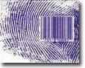

FIGURE 6.7: The Very Tip of a Finger

To resurrect a human with the same fingerprint, his Genome Code is necessary. A DNA molecule survives in the nature for hundreds of thousands of years. The Earth is our dwelling place and protecting storage:

“It is He Who hath produced you from a Nafs Single (Nafsin-Wahidatin / GUT Force +); here is a place of dwelling and storage; We detail Our signs for people who understand.” [Al Quran 6:98]

Allah preserves at least a set of one’s DNA Molecules (46).
The job of 98% DNA is unknown and thought to be junk DNA. A part of the Junk DNA may be meant to resurrect the body by forming a cell with the supplied matter.
However, the brain of a resurrected human will suffer memory loss. A nafs does not preserve the data of memory. And the ruhh is already designed and unchangeable—it cannot preserve any data.
Therefore, if one is re-created with one’s Nafs and DNA, one will suffer memory loss. Nafs and DNA re-create a human with the brain of a newborn baby, as his/her brain was just before the first cry. So, to return the memory into the brain the “Record Guarding” is needed.

“What! When we die and become dust that is a return far! We already know how much of them the earth takes away; With Us is a Record Guarding”
[Al Quran 50:3-4]

The “Record Guarding”, mentioned in above Verse, is not the “Amal-Nama”. It is another record, preserved in the Guarded Disc (Lawh-Mahfuz). The record includes complete brain-data that is collected every night when a person sleeps. So, it does not miss anything.

“It is He who does take your ruhhs (souls) by night and has knowledge of all that you have done by day. By day, does He raise you up again that a term appointed be fulfilled. In the end, unto Him will be your return. Then He will show you the truth of all that you did.”
[Al Quran 6:60]

One’s brain gets settled during sleep after preserving important data. The brain data is collected from the settled brain. It is like the video record of each day (sleep to sleep). The angels take the data and deposit it in the Server of the Command Station, related to the Earth. From the Command Station, the data go to Lawh-Mahfuz and get preserved in one’s file.
Just after Resurrection, a human will lose his sense when he will be fed with the brain-data directly into his brain. It will be like the feeding of data into a computer hard disc. When a person will regain his sense, he will know himself; he will remember everything of his earthly life.

15. The Need of Guarding

Now we can deal with the Verses under discussion:

“He is the Irresistible from above over His worshippers, and He sends guarding (angels) over you. At length, when death approaches one of you, Our angels take his soul (nafs), and they never fail in their duty. Then are men returned unto Allah, their Protector, the Reality. Is not His the Command? And He is the Swiftest in taking account.”
[Al Quran 6: 61–62]

The above Verses narrate that Allah persistently guards His worshipper by angels. The angels guard his nafs. The reasons of guarding the nafs are discussed below:
A human body is like a mold and his nafs is like a cast during his formation and development in the mother’s womb and on the Earth. A nafs records the information of the physical development. When a baby is matured in a mother’s womb, the nafs is designed and programmed to shape up the human body. It preserves the data as a program of creation. It becomes a drive to resurrect a body.
Till death, a nafs remains in the mode of development. A nafs develops and picks up the job of sustaining the body. Earthly pain and struggle develop the nafs. The more it is punished, the stronger it is; it is created to face the toughness of the Universe (Samawaat).
A nafs gets hardened at the time of death. In subsequent phase (in Illiyin or Sijjin), it grows bigger and stronger, but its design and program do not change, because its mold is dead and decomposed in the grave.
We know how much temperature is needed to dissolve electro-magnetic force field with strong nuclear force field. It is 10²⁸ degree Kelvin. One may achieve the temperature, if one can compact the whole universe into the state of Big Bang. A nafs too is a combination of force fields. So, once a nafs is hardened, it goes beyond the scope of change. It can be designed and programmed in the mother’s womb and in the earthly life only, through the passage of time—it is as such by design (Allah is the designer and has power over everything).

“By the Nafs, and the proportion and order given to it, and its enlightenment as to its wrong and its right; truly he succeeds that purifies it and fails that corrupts it!” [Al Quran 91:7-10]

How a nafs gets corrupted?
On the Earth, a nafs remains in the mode of change. Therefore, it is very important in which mold it is being molded. If it is molded in a human body, it gets programmed to shape up a human body during resurrection. But, if it is molded in a devil-human body, it gets programmed to shape up a devil-human body. A human with such nafs will resurrect in a devil-human shape.
The satan jinns mount on the Pagans (idolaters) and get connected. A satan jinn being created from anti-matter cannot connect a human’s baryonic body. So, it connects itself with the nafs of a human—the nafs works as a connector.
When a satan jinn possesses a human and merges with his nafs partially, then the joined body may be called a devil-human body. If we could see anti-matter, we would see many humans partially merged with satan jinns.
In course of time, the nafs gets designed to hold a human body (baryonic-matter-body) and a jinn body (anti-matter-body) together. The nafs becomes a program of forming a devil-human body. During the resurrection, the nafs will form the body in devil-human shape with matter and anti-matter, though the jinn will not be possessing him at that time.
The person will be a multi-dimensional being. The dimension of the jinns will be open to him. He will be able to interact with them (jinns).
After the resurrection, he will be hopeless of going to the Jannaat seeing his devil-human body. The Quran says:

“Even if the wrongdoers had all that there is on earth and as much more would they offer it for ransom from the pain of the Penalty on the Day of Judgment! But something will confront them from God, which they could never have counted upon—and will become apparent to them satan, what they earned, and will surround them what they used to mock!”
[Al Quran 39:47-48]

“But those who have earned the satan will have a reward like the satan. Ignominy will cover their (faces); no defender will they have from God. Their faces will be covered, as it were with pieces from the depth of the darkness of night. They are companions of the Fire; they will abide therein!”
[Al Quran 10:27]

“One day will He gather them all together: "O ye assembly of Jinns! Certainly, you have many of the mankind." Their friends among men will say: "Our Lord! Some of us were enjoyed by others, but we reached our term, which Thou did appoint for us." He will say: "The Fire be your dwelling-place; you will dwell therein forever, except as God wills." For thy Lord is full of wisdom and knowledge.”
[Al Quran 6:128]

After death, the nafs of the people destined to hell are kept in the Sijjin. In the Sijjin, a nafs grows very big, extremely strong and efficient, because a person destined to the hell has to be a tough giant. Allah is Merciful; He grows one in the direction one moves.
After death, the nafs of the people destined to Jannaat are kept in Illiyin. In Illiyin, some may have correction through punishment (known as punishment of the grave).
By the Day of Resurrection, each nafs will become fully matured in one direction—either to hold a devil-human body in the violence of Samawaat (this universe), or to hold a handsome / beautiful human body in the peace of Jannaat (another universe / paradise).
On the Day of Resurrection, all souls (nafses) will be released. By then, a nafs will be so developed that it will form its physical body with supplied matter and a Set of DNA Double Helix molecules (46). Mother’s womb will not be required at that time. That is the real birth of a human being, because after that birth he will never be able to die or sleep. He will never change. He will live forever. Woe to those who will be resurrected with devil shaped body, recognizable by their marks only!
If the nafs of a person is so powerful, his material body cannot be destroyed. The nafs will continue regenerating his body-parts if he falls into a process of destruction.
After the Judgment, a person with devil-human body will be a forgotten Vicegerent of God over a galaxy of this Universe (the galaxies are the objects of hell). The Universe (Samawaat) is basically created for the jinns. He will be able to interact with the jinns living in the anti-galaxies.

“Do ye then see what ye throw out (sperms that carry DNA material)? Is it ye who create it, or are We the Creators? We have decreed Death to be your common lot, and We are not to be frustrated from changing your forms and creating you in that ye know not. And ye certainly know already the first form of creation; why then do ye not celebrate His praises?” [Al Quran 56:58-62]

What happens if one is pious, and Allah is riding on him in most of the times? Does he get the shape of Allah?
To answer, he does not take up the shape of Allah, because he is already in the shape of Allah. Allah creates a human in His (Allah’s) own image. If Allah rides on a human, his nafs learns to bear the light of Allah. On the Earth, humans are weak and immature; they are in the process of development. So, Allah may immerse in a nafs very lightly; humans are not yet fit to bear Him. But, after the Resurrection, humans will be fully matured. So, on the Land of Final Judgment, many will be shining like the Sun.
However, a faint glow is at times visible on the faces of pious Muslims. It is evident in the arrival terminal of an airport because one whole-heartedly calls Allah in a flight. After the arrival, the frequency of remembrance reduces, and the light gradually reduces.

CHAPTER 7: Sufism in the Quran

The following Verse of the Quran make the foundation of its Sufi ideology:

“Allah is the light of the Skies and Lands. The parable of His light is as if there were a niche and within it a lamp. The lamp enclosed in glass. The glass as if it were a brilliant star. Lit from a blessed tree, an olive, neither of the east nor of the west, whose oil is well-nigh luminous though fire scarce touched it. Light upon light! Allah doth set forth parables for men, and Allah knows all things.
In houses, which Allah has permitted to be raised to honor for the celebration in them of His name. In them is He glorified in the mornings and in the evenings. They are such men whom neither business nor trade can drive from the remembrance neither of Allah, nor from regular prayer, nor from the practice of regular charity. Their fear is for the day when hearts and eyes will be transformed”
[Al Quran 24: 35-37]

To understand the Verses one has to understand the parables:
- What is the lamp, enclosed in glass?
- What is the glass, as if it were a brilliant star?
- What is olive tree, neither of the east nor of the west’?
- What is well-neigh luminous oil of the tree?
- How the lamp is lit with the oil?
- How it is ‘light upon light’?

The Light of Allah is everywhere, as the above Verse says, “Allah is the light of the Skies and Lands (Universe)”. But the light is in a different dimension. So, it is hidden from us. The hidden light of Allah may expose through “the lamp (flame) enclosed in glass”. Here the flame is the exposed light of Allah, and the glass is a human body.
When a human body (glass) is enlightened from inside with the light of Allah, then the human becomes a brilliant star: “the glass (human body) as if it were a brilliant star”.
So, it is “light upon light”: Here, the inner light (flame) is the light of Allah, and the outer light (enlightened glass) is enlightened human body.
A flame needs supply of oil. How the oil is supplied into a human body? In other words, how the light of Allah can cross dimensions in a human body?
To answer: These lamps are connected to the branches of the olive tree, neither of the east nor of the west. Oil comes through the branches of the tree.
What is this Olive Tree?
To answer:
Allah has a shape like a human. He sits in the Kursi.
Allah is present everywhere too, by His extended elementary Souls (Force Fields / Ruhhs).
It may be remembered that a ruhh (elementary soul) is a designed force field. And a nafs (composite soul) is a combination of force fields.
The nafs (main / composite soul) of an atom is a combination of several force fields (elementary souls / ruhhs) such as Strong Nuclear Force Field (a ruhh), Weak Nuclear Force Field (a ruhh) and Magnetic Force Field (a ruhh). Similarly, the nafs (main / composite soul) of a human is a combination of known and/or unknown force fields (elementary souls / ruhhs).
Similarly, the Nafs of Allah is a combination of many known and unknown Force Fields (elementary Souls / Ruhhs).
Allah has extended several of His elementary Souls (Force Fields / Ruhhs) beyond His body in form. He has designed the extended elementary Souls at His will to act in fixed patterns and deployed those to sustain and evolve the Universe.
We view several of His extended elementary Souls as the Force Fields permeating the entire Universe. The Gravitational Force Field is one of such extended elementary Souls.
His light is held in one or more of His extended elementary Souls, permeating the entire Universe (Skies and Lands). Or, His light itself may be one of His extended elementary Souls, permeating the entire Universe.
So, He is closer to us than our jugular veins. He sees everything and hears everything by His extended elementary Souls. The Olive Tree is the parable of this extended elementary Soul, which is deployed, but not used to sustain and evolve any creation. Thus, it is Holy (not designed) and called, “Ruhul Quddus” (Soul Most Holy).
Some says that Ruhul Quddus (Holy Soul) is Gabriel. It is wrong. Gabriel is an angel, and Quddus is one of 99 names of Allah. Giving the name of Allah to Gabriel is a sin. They talk it from the idea of Christians. They think Gabriel as Holy Soul (Ruhul Quddus) and tie up Gabriel with God in a concept of Trinity.
The parable of Olive Tree is given to match our thought, as we can easily think three-dimensional entities. The lamps are connected to the branches of the olive tree. In other words, the lamps are connected to Ruhul Quddus.
The Ruhul Quddus is an extended elementary Soul of Allah. So, the oil comes from Allah. The oil is like His body fluid. It may be a mixture of His energies, thoughts and feelings, which is interactive to a human body and mind.
The oil produces the flame, which enlightens the glass (human body). So, a human can be a Home of God, as it has been said in the following Hadith:

“When I love him, I am his hearing with which he hears, his seeing with which he sees, his hand with which he strikes, and his foot with which he walks...”
[Hadith-e-Qudsi]

To achieve this standard, one may sacrifice oneself through major jihad, and it is a hard path.
On the Earth, humans are in the process of development. Here, the light of Allah immerses in a human body very lightly, because humans are not yet fit to bear Him. But, after the Resurrection, humans will be fully matured. So, on the Land of Judgment many will be shining like the Sun.

1. Knowledge of Sufism

Allah taught Khidr, as the following Verse says:

"So, they went back on their footsteps following. So, they found one of Our servants (Khidr), on whom We had bestowed Mercy from Ourselves, and whom We had taught knowledge from Our own Presence." [Al Quran 18:65]

But, Khidr was not a Prophet. We call a person Prophet if he gets message of God through angel—the matter is formal. And a Prophet is sent to a people, but Khidr was living a solitary life.
So, Khidr had taught-knowledge, but it was not formal revelation sent through angels.
There may be different kinds of such knowledge. There was a man with Solomon who had knowledge of the Book and could bring the Thorne of Bilqis in the flick of an eye:

"Said one who had knowledge of the Book: "I will bring it to thee within the twinkling of an eye!" Then when (Solomon) saw it placed firmly before him… [Al Quran 27:40]

One start excelling in the Path of Sufism when one starts getting the love of God, because the esteem knowledge comes from God. Moreover, one needs strengthened qalb (mind) and soul (nafs) to receive the knowledge and use it. God is to improve one’s qalb and nafs, one cannot do it by oneself.
Moses wanted to learn from Khidr:

“Moses said to him (Khidr): "May I follow you on the footing that you teach me something of the Right Guidance, which you have been taught?"
[Al Quran]

Moses was given a complete Book of Law. In respect of religion, Moses had nothing new to learn. So, the knowledge of Khidr was not a matter of day-to-day religion. It was only a kind of Right Guidance that Khidr was taught.
Moses, in the last part of his life (in extended part) followed the Path of Sufism. He used to remain away from habitation, like Khidr. He used to remain under veil to keep his glowing face hidden.
Here comes the reality of “Ma’rifa”. It is a term used to mean the Knowledge of Sufism. It is special knowledge that is given to some humans.
“Traditionally what is now called Sufism was known as “Irfan”. Irfan comes from the same root as the word of “ma'rifa”, which means “knowledge”. It does not mean informational knowledge; rather it means knowledge in relation to the Creator…The goal and fruit of knowledge is explained by the Prophet's saying: "He who knows (arafa) himself, knows his Lord". As the Hadith suggests, this sort of knowledge requires a simultaneous realisation of both self-knowledge and God-knowledge”
– Fatima Fleur Nassery Bonnin

By the story of Khidr, the Quran authenticates the ‘Knowledge of Right Guidance’ that may be given to some people.
The Quran narrates that Khidr killed a boy when he was moving with Moses. As per the Laws of Moses, Khidr was punishable to death—Life for Life. But Khidr had no fault—he did it on God’s accord.
The Quran narrates that Khidr knew the future of the boat. He knew that the boat would be seized. He made the boat faulty. Thus, he changed the fates of the boat workers. Khidr knew that there was buried treasure under a wall, which the owners would get after they would be grown up. He repaired the wall.
According to the Islamic teaching, nobody knows the future, except Allah. However, in the process of monitoring the living creatures, angels come to know some future events before us. But angels were not informing Khidr. If they did, Moses would have nothing new to know from Khidr—Moses too used to get information through angels.
It seems that Allah was informing Khidr directly.
It also seems that Khidr was being driven by Allah, as the Verses say: So your Lord desired that they should attain their age of full strength and get out their treasure; a mercy from your Lord—I did it not of my own accord.
Everybody is connected to God—God is closer to us than our jugular veins. But connection of Khidr with God was more extensive. Probably, when Khidr saw the boat, he came to know its future spontaneously from God; when he saw the boy, he came to know his future; he saw the buried treasure and knew its past and future. It seems that Khidr was continuously interacting with God.
However, these are exceptions, and exceptions should not be cited as examples in the common teachings. The reality is: “…He knoweth what before or after or behind them; nor shall they compass aught of His knowledge except as He willeth…”[Al Quran 2:255]
And, God does not need a Khidr to make a boat unserviceable, or to take the life of a boy, or to repair a wall. It was, most likely, a teaching session arranged for Moses to show him higher level of connection with God. It was a surprise to Moses: He needed to go to a specific point to talk to God, but in case of Khidr it seemed that God was moving with him!
The Quran does not give out the knowledge of Khidr. It only informs his state. His story highlights that it is possible to establish connection with Allah.
Actually, a human body has the facilities of the connection. Allah can use it. He has absolute power on every human. But we do not understand what Allah is doing. So establishing connection with Allah means knowing the physical facilities and knowing what Allah is doing.
Sufi endeavor has other dimensions, which largely revolve around the love for Allah. But love is a gift of Allah.
One may love Allah, and demand the love of Allah. If Allah does not turn up, one may sacrifice everything to prove that one is calling Him only for love, not for any material gain. And one may pray for perfection. Mother loves child because of nine-month pain and the pain she undertakes to bring up the child. So, one may take pain for God so that one grows love for Him.
How to take pain for Allah? There are hundreds of ways shown by Muhammad (pbuh); start with regular prayer, go to mosque in cold dawns, pray extra in deep nights, fast in Ramadan, fast in other months as extra, remember Allah round-the-clock and participate in a Jihad if Islamic Leadership makes a scope.
I remember a story: Ibrahim Adham was a king. One day he heard some sound on his rooftop. He went on the roof and found a man searching his camel. Ibrahim Adham exclaimed, ‘You are searching your camel on the rooftop of a building!’ The man answered, ‘If you can search God lying in the palace, what is the problem with me that I am searching my camel on the rooftop?’ Next day Ibrahim Adham left kingship and moved out.
Many years later, a man saw Ibrahim Adham swing his torn blanket sitting beside a water-body. The man asked what he achieved by leaving the kingdom of Balkh. Ibrahim Adham threw his needle into the water and said, ‘I want my needle back’. Many fishes raised their heads with the needles of gold in their mouths. Ibrahim Adham said, ‘I want my needle back’. Then one fish raised its head with his needle.
Definitely, Ibrahim Adham did not leave his palace for such power; he loved God; otherwise he could not reach in the position, where he was.
Ibrahim Adham achieved Sahada while fighting a battle in the sea. It is said that Khidr is living, and he visited Ibrahim Adham twice.

2. The Demonstration

The Quran says: “Allah is the light of the Skies and Lands…” [Al Quran 24:35]. Whereas, in Holy Bible Jesus says: “I am the light of the world”:

Jesus spoke to the Pharisees again, “I am the light of the world,” he said, “Whoever follows me will have the light of life and will never walk in darkness.”
– John 8:12, Holy Bible

Actually, “I am the light of the world,” is a Word of Almighty God; Jesus was just reciting it. And the next part of the Verse: “he said, “Whoever follows me will have the light of life and will never walk in darkness.”” are words of Jesus Christ. But, both words came through the same mouth and are written together in Holy Bible.
Jesus was Qalamullah (Talk of God). The Ruhul-Quddus had free access in his body. So, at times God used his mouth to pass down His words.
Disciples of Jesus were basically monotheistic (Israelites) people. They could understand which parts were Words of Almighty God, and which parts were talks of Jesus Christ. But, European people who converted from paganism were confused and understood wrongly in cases, though Holy Bible clearly said the reality:

“…The words that I have spoken to you,” Jesus said to his disciples, “do not come from me. The Father (Alloe) Who remains in me, does his Own work.”
– John 14:10, Holy Bible

[In above Verses, some people have inserted the word “Father”. It is a corruption. Most likely the actual word was “Alloe” (Allah)]
God at times controlled the talking Jesus. Otherwise, a few day old baby could not talk. The following Verse says that Jesus could talk in infancy, as the Soul Most Holy (Ruhul-Quddus) aided him. The Verse further says that in maturity as well, he used to talk to the people being aided by this Soul.

“Then will God say: "O Jesus the Son of Mary! Recount My favour to thee and to thy mother. Behold! I strengthened thee with the Soul Most Holy (Ruhul Quddus) so that thou did speak to the people in childhood and in maturity…”
[Al Quran 5:110]

The state of Jesus is narrated in the following Verse:

“O People of the Book! Commit no excesses in your religion, nor say of God aught but the truth. Christ Jesus, the son of Mary, was a Messenger of God and His speech (Qalimatuhu)—he shined in Mary—and a ruhh from Him (Ruhun-min’hu). So, believe in God and His Messengers. Say not "Trinity", desist, it will be better for you—for God is One God. Glory be to Him above having a son. To Him belong all things in the Skies and on Lands. And enough is Allah as a Disposer of Affairs.”
[Al Quran: 4: 171]

So, God directly aided his talking by a Soul from Him (Ruhun-min’hu). The physical fasilities of connection developed in Jesus in the process of his creation in the mother’s womb. So, the Verse say: “…he shined in Mary…”
It did not make Jesus God. Jesus had an independent existence as a normal human being with his human body and human souls (ruhh and nafs). He was just occasionaly connected to a Soul of God (Ruhul Quddus). He was created as such to be an efficient Home of God. He was created as a Sign.
So, a human can be a Home of Allah. After the Final Judgment, many humans will be improved as the “Homes of Almighty God”.
But now, there are many cheaters.
However, Jesus said that if one believes and follows him, one will do what he (Jesus) was doing. Only a few Muslim Saints (Sufis) occasionally showed the signs of development in that direction.

“Jesus answered, “For a long time I have been with you all, yet you do not know me Philip? Whoever has seen me has seen the Father (God). Why then do you say, ‘Show us the Father (God)’? Do you not believe Philip that I am in the Father (God) and the Father (God) is in me? The words that I have spoken to you—Jesus said to his disciples—do not come from me. The Father (God), who remains in me, does his own work. Believe me when I say that I am in the Father (God) and the Father (God) is in me. If not, believe because of the thing I do. I am telling you the truth: those who believe in me will do what I do—yes, they will do even greater things…I will ask the Father (God), and he will give you another Helper (the Paraclete) who will stay with you forever.”
– John 14 (9-16), Holy Bible

[In above Verses, some people have inserted the word of “Father”. These are corruptions. Most likely, the actual word was Alloe / Allah (Almighty God). And there may be other corruptions as well]
In the above Verses, Jesus informs about a Paraclete (Prophet Muhammad, pbuh), who would guide further.

“But I am telling you the truth: it is better for you that I go away, because if I do not go, the Helper (Paraclete) will not come to you. But if I do go away, then I will send him to you”
– John 16:7, Holy Bible

Therefore, a common man can raise himself high by following the teachings of Prophet Muhammad (pbuh). A few Muslim Saints could bring a few dead alive by Allah’s permission. It shows that reaching to the higher level is possible by the common people in the life on the Earth.
But, it is a special path of Islam (known as Sufism). I attended a few lectures of Sufi teachers. I found their concepts similar to the concept flourished by Jesus. The concept is expressed in the following Hadith:

“When I love him, I am his hearing with which he hears, his seeing with which he sees, his hand with which he strikes, and his foot with which he walks.”
[Hadith-e-Qudsi]

According to above Hadith, when Allah loves any of His servants, He becomes his hearing, seeing, hand, foot, etc. It is not conceptual hearing, seeing, hand, or foot. The Hadith is clear in this aspect, Allah becomes his hand with which he strikes; Allah becomes his foot with which he walks. And notice that it is a Hadith-e-Qudsi. So, Allah becomes his real hand and foot. But, it does not make him God. Instead, he becomes a “Home of God”.
The Quran uphold the concept of Sufism by the story of Khidr. We know that only Allah knows the future. But in the story of Khidr, we find that Khidr too knew the future. There was no sign that angels were coming to Khidr—he was not a Prophet. It seems that he was a Home of God. He was directly connected to God, like Jesus was connected.
Why Muhammad (pbuh) has not established Sufism through practical demonstration?
Muhammad (pbuh) was establishing a religion. Actually, in the religion of Abraham there are two branches—one is the Branch of Moses with complete set of laws, another is the Branch of Muhammad (pbuh) with complete code of life. While establishing a religion for common people, the concept of Sufism (sainthood) cannot be brought in. In practice, they contradict each other.
For example: The Religion of Moses or Muhammad (pbuh) claims eye for an eye, but the concept of Jesus (Sufism) tells to forgive. One tells to do business, earn money, marry even four and fight to protect; another tells to give up everything. One tells to love wife and children; another tells to love Allah only.
How can a person love Allah?
To create love for Allah, one has to earn knowledge about Allah and remember Allah always. The person has to leave all physical enjoyment and tell his body and soul (nafs) to wait for Allah to join. Eventually, his body and soul will learn that all enjoyment comes after Allah—so he will start loving Allah, instead of loving material objects and enjoyments.
However, it is a reality that nobody loves anybody unless designed to love. So, once Allah will be happy on one’s sustained endeavor, He will create love for Him in one’s heart. Then one is successful.
One of the four major books was sent through David. One can understand his ideology by reading his songs. In many of his love songs, Allah is considered as the Loved One.
Therefore, for both the branches, there is one Jesus Christ as Sign to authenticate the Concept of Sufism. And it is the heart of the religion.
But heart cannot remain without body, so one has to be a Muslim in totality, then to adopt the Concept of Sufism.
It is not a must that one has to be a Sufi (Saint). Remaining in Sariah is enough to fulfill the religious duties. Destined people fall in love of Allah and leave everything in the process of moving forward. One cannot create love in one’s heart; it is a gift of Allah.
When one becomes a Mumin by accepting Islam, one is connected to Allah through one’s qalb, and one start feeling divine love and mercy. Now, one feels that one has achieved everything. Alas! It is only the first step! However, becoming a Mumin and remaining in Sariah is enough for a person to achieve Jannah (paradise). And it is a clear path, without doubt.
To know Sufism, one must have deliberate knowledge on the Quran; otherwise it may create harming misconceptions, as Christians have about God. And, as the Hindus have: They think Almighty God took human form (Krishna is an example) to enjoy (enjoy lots of women). Though Krishna was advising Pandabs in the war, which has ultimately formed an important Book of Hindu Religion (Bhagabat Gita), but what was his main job is difficult to understand.
Sufi ideology in Islam is purified. Several important books of Sufism are: Tazkeratul Awliya by Fariduddin Attar, Kimia Shahadat by Imam Ghazali, and the books written by Abdul Qadir Gilani.
Many Muslim religious scholars do not suggest talking about Sufism. Here boundary between Shirk (attributing partner to Almighty God) and Iman (believing in One God) is thin. Shirk is a sin that will not be forgiven; it definitely leads one to the hell. Correct perception of Sufism needs perfect knowledge on Allah and the Quran; it needs strengthened qalb and nafs as well.
People only talk; if one really wants to move into the path of Sufism, one should gain knowledge and demonstrate true love for Almighty God: One should leave all properties, stay away from Ria, never avail any amusement or luxury until Almighty God is one’s. It is the footsteps of Ibrahim Adham, Bayazid Bistami, Rabeya Basri, Abdul Qadir Gilani, and people of the same line. And then, one should wait in that state, praying, until one is accepted by Almighty God as Jesus was accepted: “I am in God and God is in me”.
The path of extreme self-restraint (sawm) and excessive extra prayer is a peacetime Jihad, as Prophet (pbuh) talked about it when he was coming back from an expedition.
Dividing Muslims by inventing new Tarikah (Path) is forbidden in Islam. Inventing new way of worship is risky too. So, Islamic Sufi Practice includes self-restraint (sawm), charity, extra salat and zikr mainly.
In Islamic concept, a man is directly connected to Allah, so a media is not needed—none comes between Almighty God and His beloved. However, a teacher (Pir) may be accepted to remain active, as praying in a group is easier and attractive; it provides scope of religious discussion as well. But the teacher should be a teacher only. He must not project him as a branch of the ‘Olive Tree, neither of the east, nor of the west’ and advocate his students to be the lamps of that branch. That is, he must not teach the student to be Fanah-fis-Shaekh or Fanaf-fir-Rasul.
Finally, Islam declares the highest achievement, Jannatin-Naimin, for Al Muttaqun (Defenders of Islam), which is a Jannaat for the Prophets mainly. On the Day of Final Judgment, Allah will be visible with the glory of being the Master of universes. Then, there will be no shortfall of love for Him. Then, the people who sacrificed sweet lives in struggles (Jihad) and wars, who bear the scars of wounds, and whose heads were fallen by the swords for His cause will go ahead. With them will go their followers who followed the Sariah strictly. On the Earth too, honor goes to them.
Jesus was a demonstration (sign). He achieved sufi-goal by birth. He should not be equaled with one who achieves through endeavor. One would not reach to his level through endeavor. For example, one may learn singing by sustained endeavor, but cannot catch up one who is gifted by birth and trying for the same. However, the gift did not make him something higher than a human.

“Christ the son of Mary was no more than an apostle; many were the apostles that passed away before him. His mother was a woman of truth…”
[Al Quran 5:75]

Following of the Path of Sufism does not release a person from his responsibilities to his family and to his society under the Imam of the Local Mosque.

3. Muslim Sufis

Muhammad (pbuh) could not demonstrate the Path of Sufism because he was put into the Path of Furqan. But he left his knowledge to Hazrat Ali. And they had a follower in the future who would streamline the Path. He wrote the books and flourished the Thought. He sent missionaries to preach Islam beyond the Home of Ummah (the Home of Ummah extends from Morocco to Himalaya). He was Abdul Qadir Gilani from Baghdad.
Abdul Qadir Gilani was born in 1077 CE. His disciples and Sufis from his School of Thought played major role in preaching Islam among Turkic People, People of Indian Subcontinent, People of Indonesia and Malaysia. There were several great Thinkers as well like Imam Al-Ghazali (who was born in 1058 CE).

Genghis Khan and his descendants tried to wipe out Islam from the face of the Earth, but Islam flourished during the time of fall as well, through Sufis.

4. Conclusion

Basically humans are Vicegerents of God. But, on the Earth, they are powerless, as they are undergoing tests and developments. In the eternal afterlife, a Vicegerent may get a complete galaxy (object of hell) as his domain. But, he will not get any divine power. He will be in pain for the nature of his abode?
However, one day a person in a galaxy (hell) would be able to gain some materialistic control over the objects. A man who does so much of struggle for this short earthly life, will he sit idle knowing that there is an endless time lying in front? Moreover, on whom all seen and unseen bounties of Allah will flow forever:

“And He has subjected to you as from Him all that is in the Skies and on Lands (this Universe). Behold, in that are signs indeed for those who reflect.”
[Al Quran 45:13]

“Do you not see that Allah has subjected to you all things in the Skies and on the Lands (this Universe) and has made His bounties flow to you in exceeding measure, seen and unseen. Yet there are among men those who dispute about Allah without knowledge, and without guidance, and without a book to enlighten them.” [Al Quran 31:20]

A person in hell will be robust physically. He will live forever. A day will come when the fire will be his home.

“If, then, they have patience, the Fire will be a home for them! And if they beg to be received into favor—into favor will they not be received. And We have destined for them intimate companions who made alluring to them what was before them and behind them, and the sentence among the previous generations of jinns and men who have passed away is proved against them; for they are utterly lost.” [Al Quran 41: 24-25]

If they have patience, in course of time they may achieve materialistic control over their surroundings (like we have on the Earth). The jinns will be their associates. One day a man in hell would be a mighty one:

“Prophet (pbuh) said, “There is a place in the hell, named hub hub, where mighty hell dwellers will live”” [Hadith]

A time may come when a hell-man may be moving around the galaxies with a space ship to find his enemies who misguided him on the Earth.

“Such is the requital of the enemies of God—the Fire. Therein will be for them the Eternal Home—a requital for that they were wont to reject Our Signs. And the Unbelievers will say: "Our Lord! Show us those among jinns and men who misled us. We shall crush them beneath our feet so that they become the vilest."
[Al Quran 41: 28-29]

After the Final Judgment, many Galaxies of this Universe will have humans as Vicegerents of Allah.
After the Final Judgment, many planets of the Jannaat (paradise / another universe) will have humans as the Vicegerents of Allah. They will be divinely empowered; their verbal orders will be materialized instantly; physical objects will obey their orders.

The End

